The Official Publication of ALOA—An International Association of Security Professionals

July/August 2005

[www.aloa.org](http://www.aloa.org)

Get the Most out of the ALOA 2005  
Convention and Security Expo  
with the Handy Guide Inside

133311333133

III Ill'll !'««■

i it tin?

i

PLUS!

Scholarship Recipients

x DOUBLE **f** Neui Products

y »#" Financial Report

ISSUE! Group 2M Locks

HPC’s Blue Shark

Rutomotiue Locksmithing and MORE!

***************$C£j 3-DIGIT 303 Breck H. Camp CML PO Box 47070 Atlanta GA 30362-0070

i 1111111111n 11111111111111111111v *11■ ■«IH t«111> 11111 f s 1111 i I

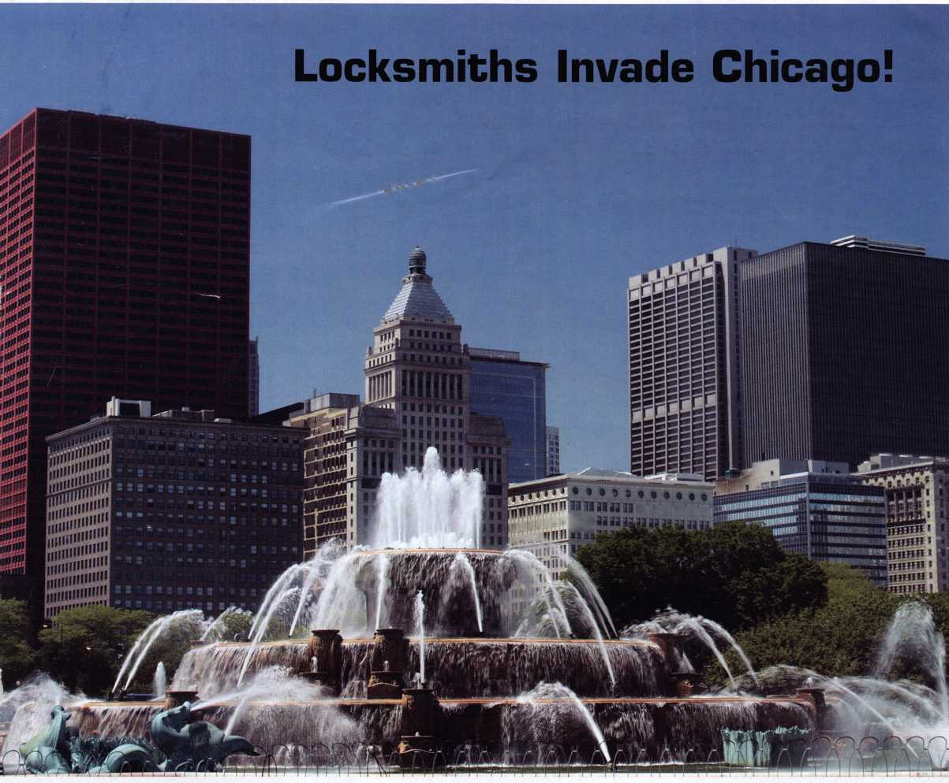

OUR STAND

IT’S **QUITE POSSIBLY YOUR MOST**

**TRUSTED SIDEKICK**

Keep it in Good Hands® with Allstate

quick certificates of insurance, ID cards, assistance with the claims process, and more. All from one of the most widely recognized names in the business,

Are you in Good Hands®?

As a small business owner, there are few things you rely on more than your vehicle to keep you going Your local Allstate agent can help protect it and your small business with services you need including

1-800-859-0247

CALL NOW TO LOCATE YOUR NEARBY ALLSTATE AGENT.

You’re in good hands.

*LOcK8MitHs*

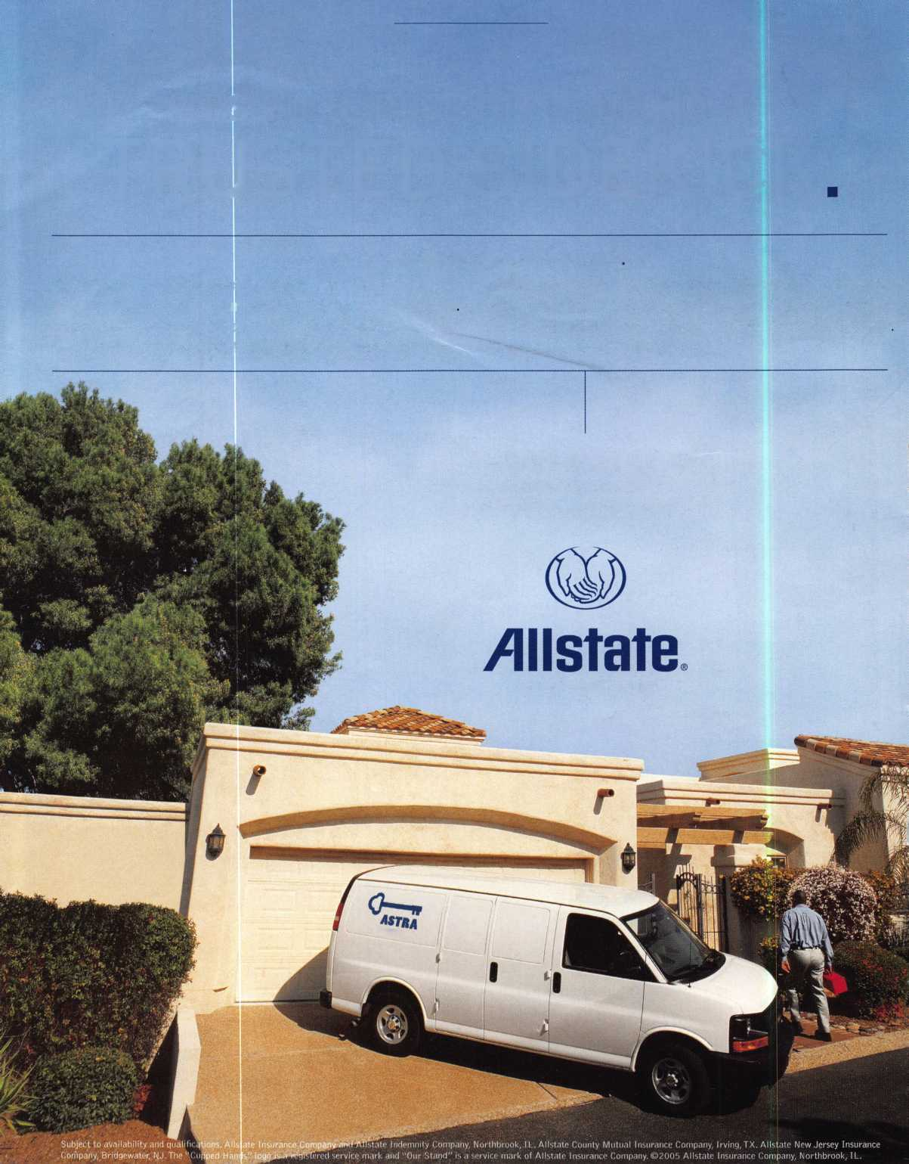

A Name You Know

As a business owner, you know the importance of a  
good name. Your name is your reputation. Your name  
stands for all that you offer in products and services.  
It’s a symbol of who you are. So, we thought you  
might like to know that Allstate, the name you know  
for insuring your personal vehicle and your home,  
also offers a business auto policy to help protect vehi-  
cles used in your locksmith business.

The following are coverages typically included in  
our business auto policy that might be important to  
you as a business owner:

Business Auto Liability coverage

* Higher limits up to $2,000,000 per occur-  
  rence.
* Protects you if you are legally responsible  
  for injuries and damages arising out of  
  the ownership, maintenance, or use of  
  business vehicles.
* Cost is based on several factors, including  
  garage location, type and use of vehicle,  
  and the violation and accident activity of  
  your drivers.
* Additional Insured coverage may be  
  required when you contract with govern-  
  mental agencies or bid on local  
  commercial jobs.
* Generally not available on a personal auto  
  policy.
* Usually is no charge to add an insured to  
  a Commercial Auto policy.

Hired Auto coverage

* Provides liability coverage for those  
  vehicles you rent, hire or borrow for  
  business use.
* The premium for hired auto liability  
  coverage is based on the estimated  
  annual rental cost.
* Tools and Special Equipment
* Provides protection to permanently  
  attached equipment on your vehicle.

0 You will need to let your agent know the  
value of the equipment to include in the  
cost of the vehicle.

You’re good at your business. Your insurance com-  
pany should be the same way.

Contact an Allstate agent to discuss your business  
auto insurance needs. To be referred to an agent,  
please call 800.859.0247 or email

**[abisO@3llstat5.com](mailto:abisO@3llstat5.com).**

Subject to availability and qualifications. Insurance coverage  
is subject to policy terms.

Allstate Insurance Company

Allstate Indemnity Company  
Northbrook, IL

Allstate County Mutual Insurance Company  
Irving, TX

Allstate New Jersey Insurance Company  
Bridgewater, NJ

allstate.com

© 2005 Allstate Insurance Company, Northbrook, IL

BETTER  
THAN EVER.

This Hawkeye® Borescope

includes all of the latest upgrades for safe and vault professionals: Optics that deliver images that rival German scopes. A new mirror technology that resists scratches from insulation, asbestos, and burrs. And a mirror protection sleeve to ward off dust.

Plus the option of the  
GRAND KIT with a fully  
configured 7” and 17”  
scope in one case. Or the  
economy minded LE model.

The red eyecup tells you  
that you have the scope  
made specifically for safe  
and vault professionals.

Available from Gradient Lens resellers to the safe and vault industry only.

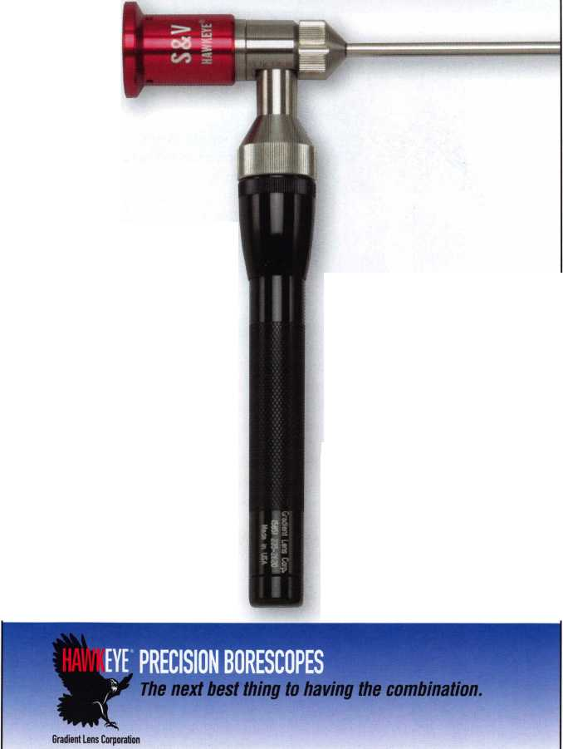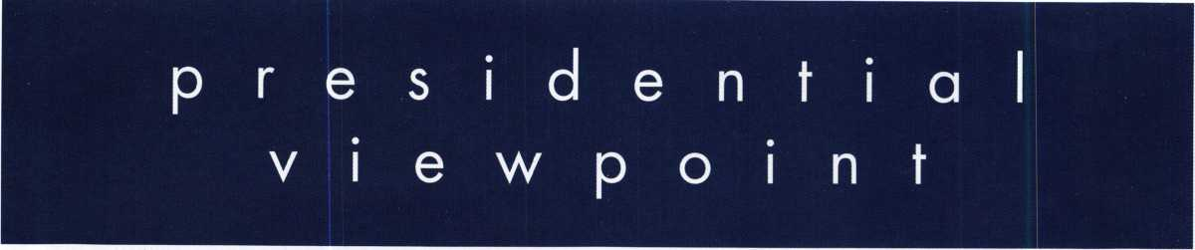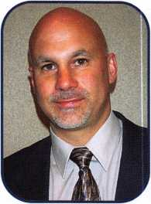

Dear Members,

This is my last message and as such, I have a lot to cover in a limited amount of space.

One of my last duties as president was to attend the "Just Cars" event for automotive securi-  
ty professionals in Fontana. A forum was arranged to discuss the problems and possible  
solutions for the exchange of information between the automobile manufacturers (referred  
to as the OEMs) and the aftermarket industry, of which we are a part. Mark Saxonberg of  
Toyota represented the OEMs, Bill Haas of the Automotive Service Association represented  
independent repair shops, and I represented ALOA and our members who are automotive  
security professionals. The three of us are members of the National Automotive Service Task  
Force (NASTF) vehicle security committee (Mark is co-chair and Bill was former co-chair)  
and we also had time to discuss the direction and issues that are facing that committee.

Two important decisions came out of the meetings and discussions that took place in Fontana. First, all of the parties involved agreed that it is the best interest of the automotive security professionals, the OEMs, and ultimately the con­sumer to focus our efforts through NASTF to come up with a working arrangement and network, as opposed to involv­ing the government through legislative efforts that at best would be costly, time consuming, and ineffective. Secondly, the committee members that were present and the attendees endorsed Dave Lanspeary to fill the vacated position on the vehicle security committee. Dave is an independent repair shop owner, has been involved with NASTF from the begin­ning, and is respected in the after market industry. As you all know, there are many factions within our industry and it was felt that Dave, as a neutral party, would be a good choice to be the one to collect and organize the information provided him by the automotive security professionals that are on the committee. I am confident that the relationships that have been established here will get the process moving and create the network that is needed to benefit all parties.

Next, on to the elections. I would first like to commend the membership for voting! The numbers are still not where we want them to be but, the number of ballots received was a vast improvement over previous years. Congratulations to Bob Mock, our president-elect. I have no doubt that Bob will be a focused leader and continue the advancements that we have made. Congratulations also to Guy Spinello and Bill Smith, your new North Central directors. I am saddened to see long time director Mark Blum finish his term and the loss of one international director as Hans Mejlshede and Joe Lee have both been assets to the board.

I cannot leave office without thanking the people that made my job easier. I am grateful to have had the privilege of serving with and being supported by a caring and talented board of directors. ALOA is fortunate to have an outstand­ing executive director in Bill Gibson and I greatly appreciate his guidance and friendship. The hard working ALOA staff has been a joy to work with and has done everything that the board has asked of them. On a personal note, I would like to thank my shop manager Rob Hoeflein and my service techs for holding down the fort when I am away on ALOA business. I also want to thank my brother, Tom, for allowing me time away from the business and for watching my dog and the rest of my family for enduring the time away from home.

I won't be passing quietly into retirement. I look forward to serving as trustee. I will continue to be ALOA's representative to NASTF and, I have been enlisted along with Scott Henke and Vince Formon to run the ALOA Open golf tournament.

Last but not least, thanks to all of you... THE MEMBERS!...for your support and encouragement. It has been a pleasure to serve you!

Sincerely,

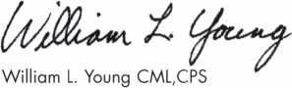

Keynotes • July/August 2005

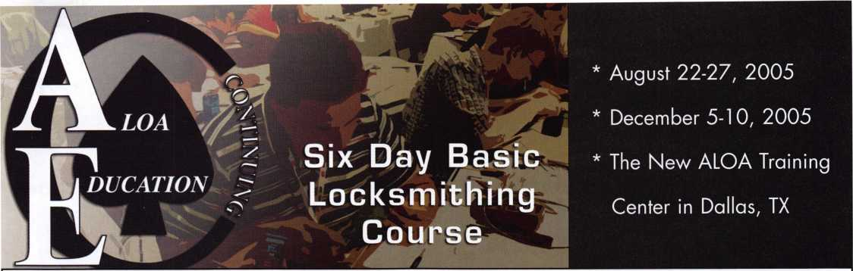

Course Description

The ALOA Continuing Education (ACE) 6-day Basic Locksmithing Course will provide you with basic hands-on knowledge of locks and security related hardware. Upon completion of this course, you will have the knowledge required to function as an apprentice locksmith who can perform the following tasks:

* identify and duplicate keys,
* service and adjust key machines,
* rekey a variety of lock cylinders,
* make original keys for a variety of locks by code, disassembly and impressioning,
* bypass and/or pick common locks,
* troubleshoot and service common cylinder and lockset malfunctions,
* identify common lock hardware finishes and functions,
* be familiar with Life Safety Codes and the ADA,
* design and key a simple master key system.

Students Receive:

* llco Key Blank Directory

PRP Resource Guide which includes the ALOA Locksmith Dictionary

* A fully illustrated 561-page reference manual.
* A Basic locksmithing tool kit that includes the following:

4-way screwdriver, soft face mallet, dial calipers, combination Tru-Arc pliers,

pin tumbler tweezers, plug follower, pin tray, shims, impressioning pliers, pippin file,

flat file, lock pick set, ice pick and universal pin tumbler pinning kit.

* An ACE Certificate attesting 48 credit hours of instruction.

An RL certificate will be issued to those who successfully pass the written test at the end of the course.

|  |  |  |
| --- | --- | --- |
| Course Dates: | Course Price: | To register contact: |
| * August 22 - 27, 2005 | $1200.00usd | ALOA Education Department |
| * December 5-10, 2005 |  | 3500 Easy Street |
| Class Location: |  | Dallas, TX 75247 |
| ALOA Training Center |  | P-800-532-2562 xlOl |
| 3500 Easy Street |  | F-214-819-9736 |
| Dallas, TX 75247 |  | [E-education@aloa.org](mailto:E-education@aloa.org) |

features

CONVENTION ISSUE 2005

10

Yesterday, Today and Tomorrow: The PRP Celebrates 20 Years!

The ALOA Proficiency Registration Program (PRP] is cele­brating an anniversary this year. It was 20 years ago that the PRP was introduced at the ALOA Convention in Los Angeles. Hundreds of locksmiths at the first evaluation were anxious to take on the PRP challenge

by Claire Cohen, CML

**14**

ALOA 2005 Convention Guide

Use this handy information pack to help you get the most out of this years convention.

by Richard C. Ensman, Jr.

22

More Automotive Complications

Automotive work can go haywire. The older the vehicle, the more it can test your patience.

by Eric Costley, CRL

**34**

Rochester Institute of Technology Key System Graduates to New Level

A new high-security key system is bringing improved securi­ty and consistent key control to more than 190 buildings on the 1,300 acre main campus of the Rochester Institute of Technology (RIT).

**44**

Dortronics Offers New High-Security Electric Key Switch

Taking the security capability of electric key switches one step further, Dortronics Systems, Inc., offers and option key cylinder for its 5240 Series Electric Key Switches.

**48**

HPC's Blue Shark

When HPC decided to take the next step in code machine  
technology, they asked the locksmith community what they were  
looking for. From this information, the Blue SHARK™ was born.

**54**

How Many People Does it Take to Make a Key to a 1934 GMC Truck?

Would you believe that it took 5 people and 1,021 miles to finally make a key to this classic truck?

by Ed Woods, CML, CPS

**60**

2005 Scholarship Winners

Meet the scholarship winners here before you meet them at the ALOA 2005 Convention and Security Expo.

**64**

State of the Association and Financial Report

In this section, find financial information and updates for proj­ects/news from the Associated Locksmiths of America.

**40**

A Couple More Group 2M Locks

Last month, we looked at a new Group 2M lock from  
LaGard. This month, lets look at its predecessor, a Group  
2M lock from Sargent & Greenleaf.

by Greg Perry, CML, CPS

**Departments**

Presidential Execu ve 5 Calendar 8 Classified 72 Legislative 70

Viewpoint 2 Applicants 6 Core 9 Associate

Members 62

Visit our NEW website at [www.aloa.org](http://www.aloa.org)

executive

Volume 51, Issue 7

Additional contact information for the ALOA Board and most Keynotes authors is  
available through "Locksmith Search'" on the ALOA Web site- [www.aloa.org](http://www.aloa.org) or by  
contacting the ALOA office at 3500 Easy Street; Dallas, TX 75247; (800)532-2562; FAX  
(214)819-9736; e-mail [aloa@aloa.org](mailto:aloa@aloa.org).

[betty@aloa.org](mailto:betty@aloa.org)

Editorial Advisor

John Cannon, CML [jcannonl@cox.net](mailto:jcannonl@cox.net)

Advertising Sales

Kim Hammond voice: 817-645-6778

Fax: 817-645-7599  
e-mail: [adsales@aloa.org](mailto:adsales@aloa.org)

Executive Director

Charles W. Gibson, Jr., CAE [charlie@aloa.org](mailto:charlie@aloa.org)

Associate Executive Director

David Lowell, CML, CMST [david@aloa.org](mailto:david@aloa.org)

Convention & Meetings Manager

Jo Anne Mims [joanne@aloa.org](mailto:joanne@aloa.org)

Operations/Membership Manager

Mary May [mary@aloa.org](mailto:mary@aloa.org)

Director of Creative Services

Betty Henderson [betty@aloa.org](mailto:betty@aloa.org)

Contributors

Jerome Andrews, CML Ray D'Adamo, CML

Paul Chandler, CRL Billy Edwards, CML

Claire Cohen, CML Dan Graffeo, CRL,CMST

Brian Costley, CML, CMST Jim Hancock, CPL

Eric Costley, CRL Jeff Nunberg, CML, CMST

Mission Statement: The Associated Locksmiths of America, Inc. is dedicated to enhancing the professionalism, education and ethics among  
locksmiths and those in related sectors of the physical security industry. With approximately 10,000 members in the United States, Canada and the  
freeworld, ALOA is poised to help members obtain the knowledge, the strength, and the confidence to perform their role in the physical security field  
with pride and dignity. But it is only through active involvement and participation that ALOA can fully achieve its potential—and can help members to  
achieve theirs.

Policies: **Keynotes**® is the official publication of the Associated Locksmiths of America, Inc. (ALOA). **Keynotes**® acts as a moderator without approving,  
disapproving, or guaranteeing the validity or accuracy of any data, claim, or opinion appearing under a byline or obtained or quoted from an acknowl-  
edged source. The opinions expressed by the authors do not necessarily reflect the official views of ALOA. Also, appearance of advertisements and  
new products or service information does not constitute an endorsement of products or services featured by the Association. The Association does not  
accept responsibility for the inaccuracy of any data, claim, or opinion appearing in this publication, due to typographical errors on the part of the  
authors, Association staff or its agents.

Editor's Note: This publication is designed to provide accurate and authoritative information in regard to the subject matter covered. It is provided  
and disseminated with the understanding that the publisher is not engaged in rendering legal or other professional services. If legal advice and other  
expert assistance is required, the services of a competent professional should be sought.

Authors' Payment: Payment for eligible submissions to Keynotes will be based on the following criteria: topic, time spent and past contributions. Authors who  
regularly submit to **Keynotes**® are generally paid a higher rate. The latter is especially true of authors who write to fit specific editorial needs and submit said copy  
by **Keynotes**® deadlines. As a general guideline: Average payment for a 750 word, business or 'light' technical article would be $200. Payment for a 1500 word  
article involving significantly higher time and research efforts would be $400.

Payment will not be offered for articles submitted by ALOA employees or members of the ALOA Board of Directors (unless material is of a technical  
nature), nor for articles submitted by a company that promote that company's products or services. ALOA reserves the right not to pay for articles sub-  
mitted by an individual(s) that promote a particular company's products or services.

Disclaimer: The Associated Locksmiths of America, Inc., (ALOA), reserves the right to refuse any article for any reason. Additionally, ALOA reserves  
the right to edit, amend or modify any article submitted for publication in order to preserve technical accuracy, clarity, fairness or grammatical cor-  
rectness. ALOA will make the best efforts to notify the author of any changes. The extent of ALOA's liability for any article or information contained  
therein will be a notice of correction or retraction in the next possible issue.

**Keynotes**® (ISSN 0277 0792) is published monthly except for the combined June/July issue by The Associated Locksmiths of America, Inc.,  
3500 Easy St., Dallas, TX 75247-6416. Telephone: (214) 819-9733; FAX (214) 819-9736; e-mail [aloa@aloa.org](mailto:aloa@aloa.org). Subscription rates for  
members—$15.00 per year. Periodical class postage paid at Dallas, Texas. POSTMASTER: Send address changes to: Keynotes, 3500 Easy St., Dallas,  
TX 75247-6416. © Copyright 2003, All rights reserved. No part of the contents may be reproduced or reprinted in any form without prior  
written permission of the publisher.

IT Operations Manager

Greg Jackson [greg@aloa.org](mailto:greg@aloa.org)

Comptroller Kathy J. Romo

Membership Coordinator Shelly Jett

Convention & Meetings Assistant Karen Lyons

PRP/Education Coordinator Hope Rodriguez

Mail Room Coordinator Kevin Wesley

Creative Media Specialist Bryan Dease

Accounting Coordinator Katie Romo

Administrative Assistant Jen Gilson-Gilliam

Executive Assistant Sue Langford

Assistant Education Manager Bob Stafford

Randy Simpson, CML, CPP Tom Seroogy Robert Stafford, CML Charles Stephenson, CPS

Dave Thielen, CML Dennis Watanabe, CML, CMST

Greg Perry, CML,CPS



Editor

Betty Henderson

President

William L. Young, CML, CPS  
(610)647-5042

[president@aloa.qrg](mailto:president@aloa.qrg)

Secretary

John Soderland, CML, CMST  
(414) 327-5625  
[secretary@aloa.org](mailto:secretary@aloa.org)

Directors, Northeast

Robert E. Mock  
(856) 863-0710  
[nedirectdr@aloa.org](mailto:nedirectdr@aloa.org)

Peter Sarailian, CRL  
(973)890-9797  
[nedirector@aloa.org](mailto:nedirector@aloa.org)

Vernon Kelley, CPL  
(609) 771-3126  
[nedirector@aloa.org](mailto:nedirector@aloa.org)

Directors, Southeast

Tom Gillingham, Jr., CML, CPS  
(615)264-0747  
[sedirector@aloa.org](mailto:sedirector@aloa.org)

Ken Kupferman, CPL  
(813)961-5784  
[sedirector@aloa.org](mailto:sedirector@aloa.org)

Director, North Central

Mark E. Blum, CML, CPS  
(517) 482-5809  
[ncdirector@aloa.org](mailto:ncdirector@aloa.org)

Director, South Central

CD Lipscomb, CML, CPS  
(903)874-3522  
[scdirector@aloa.org](mailto:scdirector@aloa.org)

Directors, Southwest

Gordon R. Racine, CML  
(719) 384-4707  
[swdirector@aloa.org](mailto:swdirector@aloa.org)

Julie McCluney, CRL  
(714) 636-5652  
[swdirector@aloa.org](mailto:swdirector@aloa.org)

Director, Northwest

Jim Jeffries, CPS  
(208)743-1101  
[nwdirector@aloa.org](mailto:nwdirector@aloa.org)

Director, European

Hans Mejlshede, CML  
(453)539-3939  
[eurdirector@aloa.org](mailto:eurdirector@aloa.org)

Director, Asian

Joe J. Lee, CRL  
(215)289-2404  
[asiandirector@aba.org](mailto:asiandirector@aba.org)

Director, Associate

Paul M. Justen  
(800)333-6953  
[asdirector@aloa.org](mailto:asdirector@aloa.org)

Trustees

[trustees@aloa.org](mailto:trustees@aloa.org)

Randy Simpson, CML  
(281)240-5959

John J. Greenan, CML, CPS  
(773) 486.2030

Dallas Brooks

Past Presidents

2001 -2003 Randy Simpson, CML  
1999-2001 John Greenan, CML, CPS  
1997-1999 Dallas C. Brooks  
1995-1997 David Lowell, CML, CMST  
1993-1995 Breck Camp, CML  
1991-1993 Henry Printz, CML  
1989-1991 Evelyn Wersonick, CML, CPS  
1987-1989 Leonard Passarello, CPL  
1985-1987 Joe Jackman, CML  
1983-1985 Stanley Haney, CPL  
1981-1983 Louis LaGreco, CPL  
1979-1981 John Kerr, RL  
1977-1979 Clifford Cox, CML  
1974-1977 Charles Hethermgton  
1972-1974 Gene Laughridge  
1970-1972 William Dutcher, RL  
1968-1970 Constant Maffey, RL  
1966-1968 Harold Edelstein, RL  
1964-1966 William Meacham  
1962-1964 Robert Rackltffe CPL  
1960-1962 Edwin Toepfer, RL  
1956-1960 Ernest Johannesen



Keynotes • July/August, 2005

AK

GA

Fairbanks

Amber L. Engle Callie Jagels

AL

Aliceville

John Ball

Thornsby

Anthony J. Doody

Sponsor: Donny W. Rudd CPL

*CA*

Camp Connell

Peter Ouding

Granite Bay

Kane Wilkin

Mountain View

Matt D. Resnick

Sponsor: Frederick R Collier

DE

New Castle

Mike Healey

Sponsor: David J. Healey

FL

Davie

Nathan Delcamp

Sponsor: Glenn J. Corrigan

Gainesville

Chris Roberts

Sponsor: Leonard P. Solt

Hallandale Beach

Henry Mosquera

Atlanta

Marshall W. Jones

Sponsor: Tim W. Mealer

Oakman

Carl Jackson

HI

Honolulu

Joseph Salz

Sponsor: Herman Salz CPL

Mark Yealey

Sponsor: Herman Salz CPL



Des Plaines

Rick Kulbersh

Loves Park

Chad A. Kahle CRL

Skokie

Kevin E. Guertin

Sponsor: Les H. Kutchins CPL

Seth London

Sponsor: Les H. Kutchins CPL

Somonauk

Joe Dillett

Sponsor: Allen J. Pante

Wauconda

Bryan Krist

IN

Argos

Nathan Mersch

Boonville

Mark Mayer

Evansville

Arthur W. Osborne

Sponsor: William L Felts RL

Lafayette

James A. Cornell

Sponsor: Kenneth B. Smith

Luke Collins

Sponsor: Kenneth B. Smith

Noblesville

Mark A. Wooster

Ml

E Lansing

Wendy Fullwood

Monroe

Charles F. Shy

Sponsor: Michael K. Moore CRL

MN

Brooklyn Park

David Ogard

Sponsor: Thomas P. Freehling CML

Red Wing

Seth Morgan

Sponsor: William P. Naseth CRL

NE

Omaha

Philip A. Armstrong

NJ

Avenel

William M. Barry

"Sponsor: Peter M. Ballotta CML., CPS"

Wall

David P. Rible

Sponsor: Hans Mejlshede CML

These applicants are scheduled for clearance as members of ALOA. The names are published for member review and comment within 30 days of this Keynotes issue date,  
respectively, to ensure applicants meet standards of ALOA's Code of Ethics. Protests, if any, should be addressed to the Membership Department and must be signed. Active  
Membership applicants (a) have worked in the industry two or more years. Allied Membership (AL) applicants are not locksmiths, but work in a security-related field.

Apprentice Membership (AP) applicants have worked in the industry less than two years.

Keynotes • July/August 2005

NV

TX

Canada

Quarry Bay



Las Vegas

John Gain

Sponsor: Gary W. SchaffCRL

Ryan Johnson

Sponsor: Gary W. SchaffCRL

OH

Grove City

William R. Blackburn

Sponsor: Carl H. Zipf III, RL

Northfield

Scott L. Hinton

Sponsor: Richard Ryai

PA

Pittsburgh

Scott Pantanella

Rl

Westerly

Brad Patrick

Sponsor: John K. Humphreys CRL

TN

Antioch

Kenneth R. Stewart

Sponsor: Eric Roberts

Arlington

Michael S. Conti

Austin

Brian Harris

VA

Harrisonburg

Harry S. Higgins

Manassas

Randy Root

Sponsor: Gary D. Quick CPL

wi

Cudahy

Kristeen Griffith

Sponsor: Randy J. Griffith CPL

WY

Jackson

Mark L. D'Addario

Belgium

Beyne Heusay

Claude Humblet

Sponsor: Hans Mejlshede CML

Toronto

William Basztyk

ON

Port Hope

Peter Brittain

Sponsor: Robert E. Mock

Great Britain

Peterborough, EN

Terry K. Harris

Sponsor: Ken Dale

Great Britain

Crawley W Sussex

Andrew Buckle

Sponsor: Ian T. Burns

David Heffernan

Sponsor: Ian T. Burns



Kowloon

Kevin Man

Sponsor: Basil W. Shannon CPL

Kam Tong leong

Sponsor: Kwok-kei Leung

Singapore

Poh Kheng Hoe

Sponsor: Francis Lum

St. Kitts and Nevis

Basseterre

O'mari Browne

Sponsor: Shane M. Varney CRL, CPS

Sweden

Gothenborg

Jan R. Thorner

Sponsor: Rex E. Parmelee RL

Benny T. Jansson

Sponsor: Hans Mejlshede CML



**u p c o m**

events

i n g

|  |  |
| --- | --- |
|  | 17-24 ALOA2005 Convention |
| >] | and Security Expo |
|  | 70 Full Day classes |
| —* | 35 half day classes & evening |
|  | seminars - 3 days of exhibits |



22-27 Six-day Basic Locksmithing Course at the ALOA Training Center. Contact: ALOA Edu Department 800-532-2562 xl 6

25 Clark Security Show Anaheim, California Contact: Joan Emrick 619-718-7308

UPCOMING ACE CLASSES

9/08/2005 Thursday 9:00 am • Dallas, TX • ALOA

Hope Rodriguez 800-532-2562

|  |  |  |
| --- | --- | --- |
| 7/17-24/2005 | Rosemont(Chicago), Illinois • ALOA 49th Annual Convention & Security Expo • David Lowell, CML,CMST 800-532-2562 xl8  70 full day classes • 35 half day classes & evening seminars | 9/25/2005  9/25/2005 |
| 8/22-27/2005 | Dallas, Texas • ALOA ACE Program  Hope Rodriguez 800-532-2562 xl04  6 day basic locksmithing course | 10/02/2005 |
| 9/30-10/1/2005 | Carlsbad, NM • Associated Locksmiths of New Mexico  Basic Transponders  Life Safety Codes w/L-07 PRP | 10/02/2005 |
|  |
|  | Basic Access Control  Roy Haynes, CRL, • 505 746-2133 | 10/09/2005 |
| 10/11-15/2005 | Portland, Oregon • Pacific Locksmths Association  Bill Botek, CRL 503-644-9881 | 10/13/2005 |
|  | Life Safety Codes w/L07 PRP  Fundamental Locksmithing (2 days)  Servicing Aluminum Storefront Doors  Safe Combination Lock Servicing | 10/14/2005 |
|  | Basic Electricity w/L13 PRP  Advanced Shop Management  Professional Impressioning Techniques | 10/30/2005 |
| 11/2-5/2005 | Sturbridge, MA • Yankee Security Convention (9 classes)  Jack Hobin, CPL, • [info@yankeesecurity.org](mailto:info@yankeesecurity.org) | 11/5/2005 |
|  | 800-209-8266 | 11/10/2005 |
| 11/12/2005 | Detroit, Michigan • Locksmith Security Association • Robert C.  Nobel, CML 810-385-9329 Large Format 1C w/L-39 PRP | 11/12/2005 |
| 12/5-10/2005 | Dallas, Texas • ALOA ACE Program  Hope Rodriguez 800-532-2562 xl04  6 day basic locksmithing course | 11/13/2005 |
| UPCOMING PRP SITTINGS | | 12/08/2005 |

7/22/2005 Friday 6:00 pm • Rosemont, IL • ALOA 2005

Hope Rodriguez 800-532-2562

8/1 1/2005 Thursday 9:00 am • Dallas, TX ALOA

Hope Rodriguez 800-532-2562

Sunday 8:00 am • Anaheim, CA • Clark Security Products Joan Emrick 619-718-7308

Sunday 8:00 am • Houston, TX • Houston Safe Extraveganza Ed Stites 979-240-9083

Sunday 8:00 am* Des Moines, IA • Iowa Locksmith Association Harry Russell 319-338-8735

Sunday 10:00 am • Carlsbad, NM • Associated Locksmiths of New Mexico • Roy Haynes, CRL • 505-746-2133

Sunday 9:00 am • Orlando, FL • SERLAC 2005 James Bamhardt, RL 813-689-5979

Thursday 9:00 am • Dallas, TX • ALOA Hope Rodriguez 800-532-2562

Friday 6:00 pm • Portland, Oregon • Pacific Locksmiths Association Bill Botek, CRL • 503-644-9881

Sunday 10am • Mt Laurel, NJ • GPLA Robert Schuetrumpf, CRL 856-486-9280

Saturday 9:00 am • Sturbridge, MA • Yankee Security Convention Jack Hobin, CPL • 800-209-8266

Thursday 9:00 am • Dallas, TX • ALOA Hope Rodriguez 800-532-2562

Saturday 8:00 am • Cary, NC • North Carolina Locksmiths Association Granger L. Marley, CML 919-859-6060

Sunday 8:00 am • Baltimore, MD • Clark Security Products Joan Emrick 619-718-7308

Thursday 9:00 am • Dallas, TX • ALOA Hope Rodriguez 800-532-2562

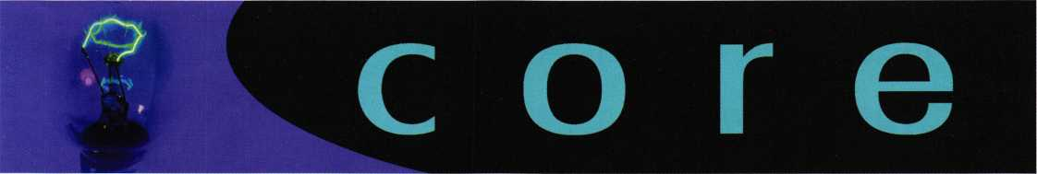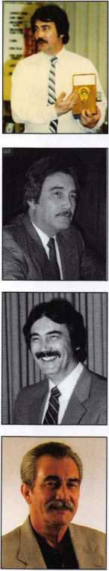

Kaba's Vice President Of  
International Sales  
Announces Retirement

WINSTON-SALEM, NC, May 13, 2005 - With nearly 30  
years of devoted service in the Keyless Lock industry, Tom  
Nazziola, Vice President of International Sales for Kaba  
Access Control has announced that he will retire effective  
June 30, 2005.

In 1976, Tom embarked on his career working for Unican  
in Montreal. He was given the territory of Northern New  
Jersey and Metropolitan New York selling the Unican  
1000 locks, as well as Alarm Enunciators and Cams, but  
his focus was on the Unican. Within seven months time,  
Tom was in charge of seven states and was responsible  
for 75% of the 1000 lock sales. Once Unican and  
Simplex merged, Tom was promptly hired and given the  
New England territory for Simplex and Unican.

In his new position, Tom recognized an obstacle with lock-  
smiths that prevented true growth of the product. He  
quickly developed an educational program to remove any  
fear from locksmiths about the complexity of the Simplex  
product line. He instituted free one-hour seminars across  
the United States. Soon these became four-hour seminars,  
only to increase to eight hours in time. Through his semi-  
nars, Tom managed to train an estimated 14,000 lock-  
smiths over the years.

Eventually Tom was promoted to National Sales Manager  
servicing 19 States. While projecting a subtle, low-key  
image and a simple philosophy of 'Make a good product  
and service the customer's needs better than anyone else,'  
Tom helped guide Simplex into becoming the keyless lock  
industry standard.

Videx Announces CyberAudit-Web - Access Control on Demand

Strategic Security Sales presents new product  
release : UNICORN - Automotive High Security  
Wafer Decoding Tool.

Professional locksmith and inventor, Allen D. Murphy of A.D. Murphy Co., Butler  
Wl. has developed a precision device for decoding high security automotive lock  
cylinders. Mr. Murphy is credited with prior designs such as the HPC Tubular Key  
Adapter and the LaGard Harness offered by Lockmasters, Inc. Providing a univer-  
sal design concept to apply to a variety of vehicle manufactured brands the new  
"Unicorn", measures the internal dimensions of the locks wafers utilizing a spe-  
cially cut key blank and a standard dial micrometer. A recent focus group demon-  
stration during the IAIL Convention in Baltimore MD on June 10, 2005 demon-  
strated the UNICORN'S ability to decode both the VW 2 Track, Mercedes 4  
Track & Lexus 4 Track systems without leaving any substantial tool marks. The  
sophistication of the locking systems utilized on these vehicles prevented a rapid  
key generation process without vehicle disassembly. Providing reality based  
opportunities for the service technician, the Unicorn eliminates the need for such  
service methods, and provides a working key without a possibility of damage or  
liability. Joint exhibit viewing and purchase opportunities will be available at the  
Strategic Security Sales ([www.sx3online.com](http://www.sx3online.com)) and American Auto Lock  
([www.americanautolock.com](http://www.americanautolock.com)) booths during the ALOA Convention and Security  
Expo 2005 in Rosemont IL.., on July 22 - 24.

Ernie Kaufman—A Detex Icon • 1933-2005

Detex Corporation regrets to announce the passing of a

long-time employee and friend to many in the door-

hardware and guard-tour verification industries.

Ernie Kaufman passed away on June 23, 2005.

In 1951, more than 54 years ago, Ernie came to  
work for Detex Corporation in New York, as a  
Watchman's Clock Repairman. In the early  
1960's, Detex introduced its Security Door  
Hardware Division, which incorporated exit  
alarms, exit control locks and remote indicating

panels. Ernie became an integral part of this new  
company direction.

Videx announces CyberAudit-Web, a browser-based software program that uses cellular communication to remotely program user keys in the field, anywhere and anytime. Access authorization can be sent to keys via a cellular phone, provid­ing on-demand access and eliminating unauthorized entry and security risks from lost keys. CyberAudit-Web is ideal for small localized businesses, geographically widespread enterprises with multiple locations, or companies that need to grant access to mobile employees, such as service technicians and delivery people.

CyberAudit-Web is used in conjunction with CyberLock electronic keys and lock cylinders. These cylinders install inside traditional mechanical door hardware, and do not require batteries or wiring. In addition, the locks cannot be picked, and the keys cannot be duplicated. There are over 80 different types of cylinders available, which can be used in a wide variety of applications including doors, safes, server cabinets, and padlocks. Besides providing access on demand, CyberAudit-Web provides a comprehensive report of user activity.

With a diploma from RCA Institute and two years of study in Brooklyn College, Ernie served as Sales and Service Manager for the company's New York office, a position that allowed him to expand on his natural ability to work with Detex rep­resentatives and distributors on the customers' behalf. He was promoted in 1981 to Regional West Coast Manager where his knowledge of that area's sales and distribution grew along with sales of the new products he so eagerly presented. In October 1982 Ernie returned to New York as the East Coast Regional Manager.

Over the years, Ernie initiated a series of training seminars and certification class­es covering Detex door hardware equipment. These seminars proved to be very popular and as a result, his title was changed to National Education Manager which coincided with his move to Reno, Nevada in 1989 with his wife Loretta.

Ernie once said, "While the industry has changed in many ways, my feeling is that the people have remained the same." To that feeling, Ernie remained true.

He was dedicated and loyal to Detex, our industry, his many friends and the cus­tomers he served for 54 years.

Keynotes

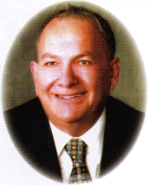

Yesterday, Today and Tomorrow

The PRP Celebrates 20 Years

by Claire Cohen, CML

F A i

' JBk

Keynotes • July/August 2005

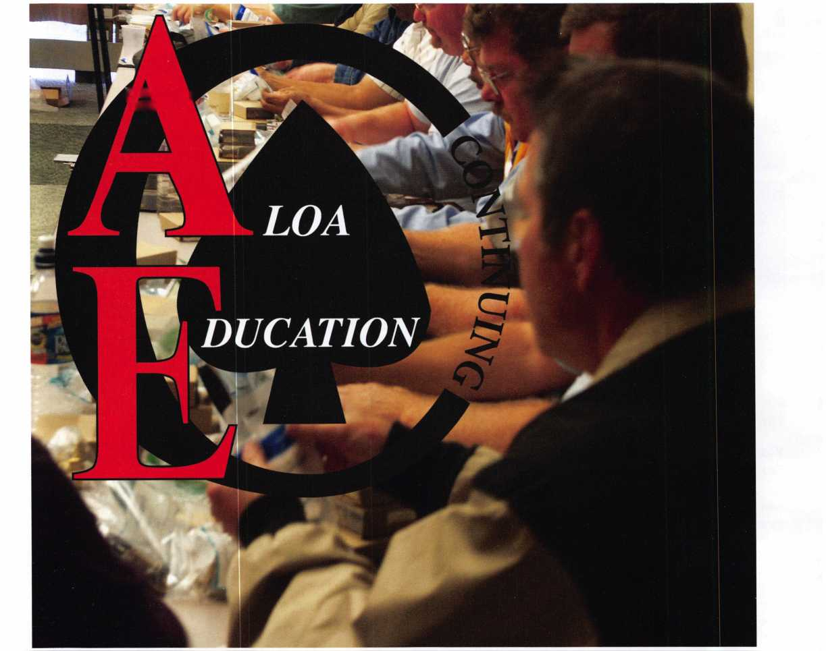

The ALOA Proficiency Registration Program (PRP) is cele­brating an anniversary this year. It was 20 years ago that the PRP was introduced at the ALOA convention in Los Angeles. Hundreds of locksmiths at the first evaluation were anxious to take on the PRP challenge.

For several years prior to the introduction of the PRP, a dedicated group of ALOA members discussed the idea of self-education and training as well as a method to test the educational and technical competence for locksmiths. They felt that through testing locksmiths could be made aware of what they knew and what they didn’t know about the industry. The issue of state licensing for locksmiths was on the horizon, and ALOA certification would be presented to states considering locksmith licensing as a viable alterna­tive. In addition, the group thought it would be beneficial to improve pubic awareness that the locksmith they hired to provide security needs was qualified. The original tests were developed by a group of experts in their individual fields, and the PRP was born.

YESTERDAY....

In 1985, the PRP was made available to all in the lock­smith industry, regardless of ALOA affiliation. The origi­nal PRP consisted of a mandatory section (with 10 basic categories) and a wide range of locksmith-related subjects in 27 elective categories. The test contained both true/false and multiple-choice questions. To achieve the first level of certification and become a Certified Registered Locksmith (CRL), a member had to pass the mandatory portion and two elective categories. Some ALOA mem­bers, through length of membership, were “grandfathered” into the PRP and given the designation of Registered Locksmith (RL).

The PRP race was on! For a short time, Dan Ellis was the first Chairman of the PRP Committee. Breck Camp, CML then assumed the role and the fearless leader of the PRP initiative overseeing the administration of this huge program. Hank Printz (former ALOA President) became the first CML! With the growing popularity of the PRP, additional full time staff was needed to be called upon to handle the vast number of details. David Lowell, CML, CMST having served as PRP Chairman from 1992 - 1995, became the full time PRP/Education Manager in 1997 and has been in charge of the program since then.

Soon new initials, CRL (Certified Registered Locksmith), CPL (Certified Professional Locksmith) and CML (Certified Master Locksmith) became the “buzzwords” of the profession.

A PRP Study Guide / Resource Guide was created. Small in size compared to todays new Guide, it contained sample questions (without answers), a glossary of master keying terms and suggested article reference guide as a basic intro­duction to the evaluation. Realizing the educational value of this certification, locksmiths joined others in the indus­try to share in their areas of expertise and learn from others in order to prepare for certification testing.

David Lowell, CML, CMST, ALOA’s Director of Training and Certification, was one of the first 20 CMLs. In the early years, he notes that “there were a lot of CMLs out there.. .they just needed to be identified by taking the test.”

TODAY...

We’ve come a long way since the initial testing was begun 20 years ago. There are over 4,100 locksmiths who have received a level of certification, with another 2,900 who are in the early stages of certification. According to ALOA, the PRP has its own separate database, so no exact statistics are available regarding the number of current locksmiths with certifications (i.e. some who hold certifications may be deceased, no longer an ALOA member or are no longer in the industry). Currently in the PRP database there are: 709 CMLs, 694 CPL’s and 2703 CRL’s.

ALOA conducts training to achieve certification in many different formats, including over 100 classes at ALOA’s annual Convention and Trade Show, at Regional conven­tions, and at many locally-sponsored weekend seminars throughout the year. As an ALOA member benefit, many of ALOA’s classes are “PRP Certified” which allows the class participant to take a particular PRP elective at the conclusion of the class. ALOA provides a bookstore where industry-related books, CD’s and videotapes on a wide variety of locksmith subjects can be purchased.

Tests are given many times during the year at locations all across the country, and even some throughout the world. With more than 45 sittings scheduled each year, in addi­tion to the large turnout at the ALOA convention, partici­pants have an opportunity to test at more convenient loca­tions, and a the time of their choice. This expansion is partially due to the fact that “Proctors” for the tests are taken from a large pool of CMLs and not just ALOA board members.

ALOA provides the PRP or a derivative in the form of a customized exam to several state licensing agencies as their locksmith licensing exam. In addition, ALOA’s PRP exam is recognized as meeting the requirements for licensing in several states.

li

Keynotes • July/August 2005

Each year some PRP evaluations are held outside the U.S.

- this year we provided exams in the Marshall Islands, the Northwest Territory, and in Mexico City. The written evaluation for the group in Mexico City was translated into Spanish.

The number of tests and content has evolved over time. In 1992 there was a major revision to the test, with some cat­egories combined, and some split. Subcommittees for each subject revise the tests on a regular basis as technology changes.

The original PRP Resource Guide has been updated and expanded many times. The current guide contains about 200 pages. Ranging from registration procedures to sam­ple questions and answers, the resource guide is a must for everyone. The reference to individual magazine articles was removed, as many members are new to the industry, and do not have access to older publications. They have added more listings for reference material, a sample exam (with answers), articles and much more. The Glossary has been expanded tremendously, with more than 100 pages of locksmith terminology.

With ALOAs expanded website, all PRP test site dates and locations are listed. By “clicking” on the evaluation date, a form for a particular PRP sitting can be printed, and a member can register—what could be easier!

The content of the tests has gone through a “psychometric evaluation” by an outside consulting firm. This evaluation studies the relative difficulty of the test wording, the multi­ple-choice answers, insures that there are no “trick” ques­tions, and that questions are not too easy. The number of questions on each elective has been standardized to a mini­mum of 25 and a maximum of 30.

The test has been translated into Spanish and Korean. The Resource Guide has been translated into Korean. When the test was given in Japan, an interpreter read the ques­tions verbally. Individual arrangements for an oral exam have been made in the case of special needs.

Two additional levels of certification are now offered. In 1992, a Certified Professional Safetech (CPS) certification was introduced. Demonstrated proficiency in 17 safe and vault-related categories enables the participant to achieve this certification level.

In 2000, Certified Master Safe Technician (CMS)—was introduced. This highest level of certification is gained by successfully demonstrating advanced proficiency in safe and vault related categories. A Safe Technicians Reference Manual for those who are preparing for either level is avail­able and recommended.

TOMORROW...

A big change to the PRP will come in 2006, with the ALOA By-law changes, which were voted on and approved by ALOA members recently. With this change, within a period of time all existing ALOA members will need to have a PRP certification. Also, new members will have a certain timeframe to achieve a PRP certification

Currently being developed are five new PRP elective cate­gories: CCTV, Electronic Safe Locks, Padlocks, High Security Automotive, and Lockshop Management.

Public awareness of the program is growing as the number of certifications expands into the U.S. and other countries and is communicated to government agencies and con­sumers through verbal and written communication.

THE SECURITY PROFESSIONAL CHALLENGE...

Some ask, why get certified? The answer is that to remain as competitive as possible today, it is beneficial to attain a certification. The standards have been raised in the securi­ty profession and employers are now taking additional steps to ensure that they work with the most skilled and knowledgeable individuals in the business. Professional certification from ALOA offers them another screening tool—one that has the backing and credibility of the pre­eminent professional society in the world for those who are responsible for security.

Certification is an investment in your career, and your future. There are many challenges we face in life—one challenge for the locksmith is the PRP. If you are already involved in the program—congratulations—you are on the road to adding more knowledge and success in your future. If you are “out of the loop” now is the time to be aggres­sive, be smart, and take on the PRP challenge!

**12**

Keynotes • July/August 2005

|  |  |
| --- | --- |
| '' ‘ -  ft 1 * | mnwwi fit |
|  |  |

|  |  |  |  |
| --- | --- | --- | --- |
|  | f $1 !' | '■ J’J |  |
|  | 1  'i m |  | fr |



**April 5-9, 2006**

**Visit beautiful Venice, Italy while learn­ing the latest techniques for security professionals, presented by world-wide expert masters in the field. ELF Convention classes will be held in both English and Italian.**

**During the convention, you 11 have the opportunity to visit the special exhibi­tion with the latest developments and products from major companies active in the security industry.**

**And don’t miss the Gala Dinner where the charm of Venetian nights and famed Italian cuisine will will make this evening unfogettable!**



European Locksmith Federation

[www.ersi.it](http://www.ersi.it)



ALOA 2005 Convention Guide

Get the Most out of This Year’s Show

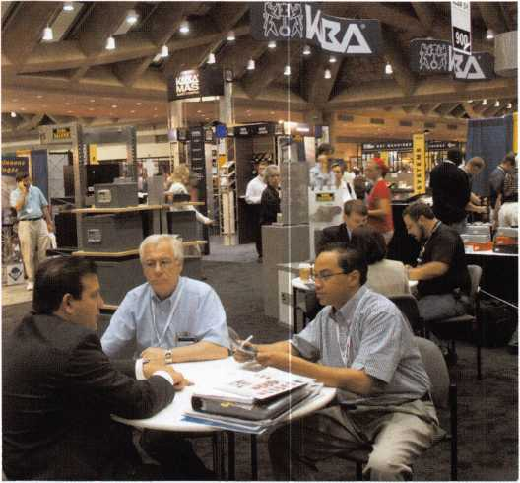

Well, it's convention time again. Time to brush up on the  
latest developments in locksmithing, renew old acquain-  
tances, and take in a bit of relaxation at the same time.

Ever wonder, though, whether you're getting the most out of the ALOA show? If so, use these handy suggestions to help you take advantage of the tremendous opportunities the event can offer you:

* Share your convention plans with your family. Let your family know why your convention is important - and what you'll be doing each day of the event. Family separation can be hard, even though it's only for a few days, so make plans to call home at least once a day. And if you've got any unresolved needs at home-like a teacher's conference or an overdue repair job-handle them before you leave.
* Make appointments with colleagues you want to see. If you want to talk shop with colleagues you haven't seen in a while, call them beforehand and arrange to meet for lunch or coffee sometime during the event.
* Review all transportation arrangements well in advance. Make your travel plans carefully. Shop for the best price and the most relaxing mode of transportation. And, since your return trip may involve dif­ferent arrangements than your arrival trip, be sure you plan-and understand-the right travel schedule.
* Bring "show and tell" items. If you've had any unusual accomplish­ments or successes over the past year, bring "show and tell" items along: samples of manuals, ads, posters, and other materials you can pass around to your colleagues.
* Learn about your destination. You'll probably have an opportunity for some travel and sightseeing when you reach Chicago. So put your hands on a few travel brochures before you leave, and develop a

simple

itinerary of the things you'd like to see and do in your free time.

Conduct a personal "needs analysis." Think about the problems and challenges you've faced over the last year-and keep these in mind as you select workshops and seminars during the convention.

Prepare a master convention portfolio. Your master portfolio or folder should contain a convention schedule, a map of the facilities, notepa- per, samples of items you're bringing along, and any other informa­tion you might need regularly. Carry your folder with you throughout your convention.

Read about presenters before you attend their workshops. Read about workshop and seminar leaders in your convention bulletin. Learn about their backgrounds and interests, and you'll better pre­pare yourself for their presentations.

Sit in a strategic location during workshops. Sit where you can gain a clear, unobstructed view of the speaker-and where you can offer the speaker nonverbal feedback during her presentation. For most people, this means sitting near the front of the room.

Bring a sweater to workshops and meetings. Most convention work­shops are held in "climate-controlled" rooms, which are occasionally too warm or too chilly. With a sweater, you can dress to match your personal comfort level.

Ask questions. ALOA classes will always leave you brimming with new information and ideas. But remember: classes and workshops also give you the opportunity to ask questions of experts and col­leagues, and add even more value to the gathering.

Don't take too many notes. That's right: watch out for excess note­taking. Your natural inclination during a convention seminar might be to take notes on just about everything you hear. But notebooks overly packed with data and information will only end up in your file cabi­net or closet. Take notes on key points only. These brief, power- packed notes will be useful to you when you're back at your desk.

Keep an idea log. Your idea log should be separate from your gener­al seminar notes. In this log, enter useful "action strategies," or items to research or follow up on. Carry the log with you at all times, even when you're not in formal seminars -- and enter useful ideas as they're triggered by someone's comments. Later, you can use the log as an action resource.

Meet as many speakers and presenters as possible. Perhaps you can converse with a speaker for a few minutes after her talk. Or arrange to meet her for lunch. Keep your personal "needs analysis" in mind as you discuss issues with the speaker. Listen for one or two great ideas or suggestions during these conversations.

Visit exhibitors twice. During your first visit, take casual notice of the products and services offered by exhibitors. Pick up literature. Ask a few questions. Later, study the material you pick up, make a list of more detailed questions, and plan for a return visit the next day - when you'll be prepared to study specific products in greater depth.

Always wear your name tag. The more you're noticed, the more opportunities you'll have for interaction with your peers. Better yet, if you have a distinctive name tag of your own, bring it with you and wear it. A unique tag will stand out.

Keynotes • July/Augusst 2005

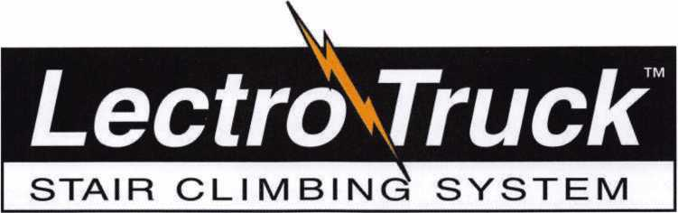

Three strong “grab points” to make handling the stair climber easier.

Detachable battery pack makes swapping batteries simple.

Lectro-Truck nameplate means you get 35 years of product experience.

Break-back bar enables the user to be able to move the heaviest of loads.

Electric Brake stops the drive screw from spinning - no matter how heavy the load.

1-1/2 Hp motor provides the lifting power you need to move up to 1500 pounds.

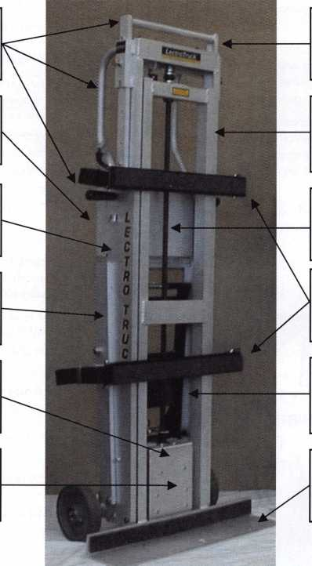

10” extension handle to give the user extra leverage on taller loads.

Heavy duty, aluminum construction makes the unit lighter, yet durable.

3/4” drive screw will not bow - even with loads of up to 1500 pounds.

Two adjustable strap bars allow the user to adjust specifically to each load.

Built-in steel tripod makes moving products down hallways easy.

24” or 30” toe plate width to accommodate individual customer’s needs.

**Model LTA6512E**

Mention this advertisement, and you are eligible for the trade show discount  
that we will have in effect at the ALOA Expo in Chicago July 22-24, 2005.

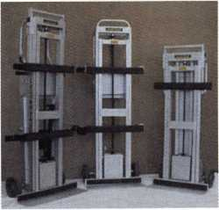

Call us at:

1-800-619-0625

or visit us on the internet at:

[www.lectrotruck.com](http://www.lectrotruck.com)

Innovative Moving Systems, Inc.  
310 South 10th Street  
P.O. Box 700169  
Oostburg, Wl 53070

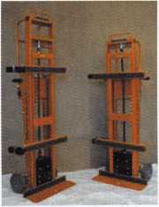

**See us at the ALOA Security Expo - Booth 501**

Stand in a strategic spot during coffee breaks and receptions. "Strategic spots" might include a location 15 or 20 feet from elevator doors, near the entrances to meetings, or near the restroom corridor -- wherever a large number of people are likely to pass or congre­gate. Here, you'll have the opportunity to meet and talk with a large number of people.

Carry an ample supply of business cards. You never know when you'll have the opportunity to discuss a business deal, acquire infor­mation from an acquaintance, or set up post-convention business. From your handy supply, you can hand out cards to anyone who might need or want your address and telephone number later. And don't forget: a personal note or reference you jot on a business card will be kept much longer than a note your acquaintance writes on a piece of scrap paper.

Bring along your appointment calendar. You never know, too, when you might have the opportunity to set up an important meeting with a vendor or colleague. If you do carry your appointment calendar, be sure it fits in your pocket; that's the best way to guard against its loss.

Save receipts. Most convention expenses are tax-deductible (includ­ing meals, which are partially deductible). Save all receipts to docu­ment your deductions. When you don't get a receipt, say for a taxi ride or admission fee, make a diary note of the expense and its pur­pose.

Get enough rest and exercise. Don't kid yourself: almost any change in your routine can be tiring, even stressful. Conventions, which are

so full of stimulation and physical activity, can be doubly tiring. Try to maintain as close to a normal work schedule as possible. If your hotel offers exercise opportunities, take them. And be sure to get as close to a good night's sleep as possible each day of the convention.

Make action notes. When you hear a tip that you can put into prac­tice, or a followup suggestion from a colleague, write yourself an "action note" - and place it in your wallet or appointment calendar. Your action notes will become an important part of your post-conven­tion agenda.

See the sights. Conventions give you the opportunity to see places you've never visited before. Hopefully, you've already identified the key sights and tourist attractions at your destination. When you arrive, carefully budget your time for local travel.

Share your knowledge and insights with others. Before you leave for home, make a list of key insights you've gained - and resolve to share them with colleagues back in the office. The result: you'll get an even greater return on the time and money you invested in the convention, and you'll build goodwill among your colleagues.

Your convention can bring you personal and professional renewal. Seize the opportunities your convention offers, and it will bring you tremendous benefits long after you return home.

WORKING THE TRADE SHOW BOOTHS: BECOME A SAVVY VISITOR

CALL C. **1-800-355-6322** For More / _ Information '

I

^VDER\>^

**ADVERTISE WITH  
OUR**

**WEATHERPROOF**

**LABLES**

**Professional Business Products**

We donate 5% of all sales to the  
**ALOA Scholarship Fund**Buying from NEBS®?

We offer lower prices on invoices/work orders, checks,  
repair tags, magnets, business cards, key tags and more.

Visit our booth #1617 in Chicago July 2005

[www.pbp2000.com](http://www.pbp2000.com)

Enter the exhibit area at ALOA 2005 and look around. You'll see hundreds of booths. It's easy to spend your time meandering through the exhibit hall, chatting with friends and colleagues, and only occasional­ly interjecting some purposeful business with an exhibitor when you happen upon a booth of particular interest to you.

But there's another alternative. You can par- lay your limited time in the exhibit hall into a genuine learning and networking experience. With a little atten­tion to planning, you can get a tremendous return on the time you spend there. Here's how:

* Plan your stops. Pick up a map of the exhibit area before you begin browsing. Then identify a selection of booths that might offer especially useful information.
* Divvy up the work. If you're attending the convention with a colleague and you have a lot of booths to visit, split the booths up between the two of you, either by interest area or physical location.
* Stay in shape. Don't kid yourself: spending a few hours in an exhibit hall can be a grueling experience. Whenever possible, wear loose-fitting clothing and, above all, comfortable shoes. Or take a lesson from veteran exhibitors, who often wear padding inside their shoes. Before setting out, eat a light meal. Avoid sug­ary snacks, caffeine or soft drinks in the hall; water and easy-to-digest snacks, such as dried fruit, will help you keep your energy level up.

**6**

Keynotes • July/August 2005

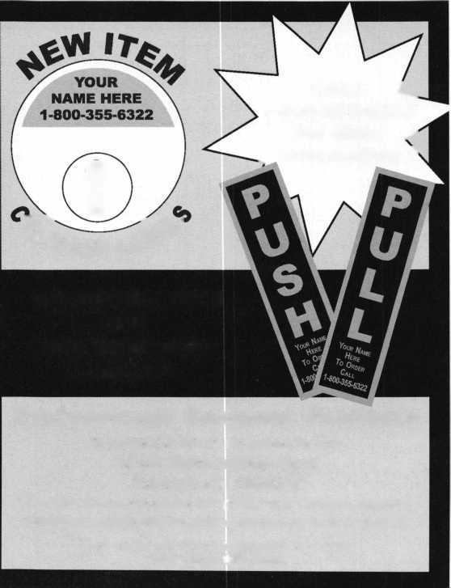

**Lactcnft**

**Sum is Ahead**

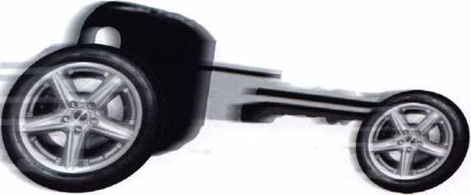

Get used to our market momentum! Lockcraft keeps your sales moving with our ever- expanding lineup of automotive locks, keys and service tools. Ask for all the OEM quality replacements you need -- for Ford, Daimler- Chrysler, Nissan, Honda, Toyota, and more. Yes, Lockcraft is still priced tight and right. Yes, Lockcraft still boasts 5-day/90%order fill. Yes, Lockcraft still offers the best profit opportunities in the business for you.

Surge ahead with Lockcraft!

7A LOCKCRAFT

2345 N. Central Avenue Brownsville, TX 78521 Phone:965-838-2480 FAX 956-838-1796

Know when to browse. Take the tempo of the trade show. When exhibit traffic is light, make your high-priority, business-oriented vis­its. You'll be able to spend more time with exhibitors this way. When traffic is heavier, you can browse through the lower-priority booths more casually.

Set goals. Decide what you want out of each exhibit even before you start making the rounds. Do you want help with a thorny service problem? Want to learn about a new line of products? Want to save money? Keep these goals in mind as you visit each booth. You might even want to develop a list of stock questions to ask each exhibitor you visit.

Understand the goals of exhibitors. They vary. Some exhibitors want to foster an image or impart positioning statements. Others may want to build prospect lists. Others may want to gather qualified leads. And the list could go on and on. You can often discern an exhibitor's pur­pose with a quick glance or a brief conversation. Ask yourself: is the exhibitor's goal compatible with yours? If not, don't spend excessive time there.

Stick to your agenda. Approach each booth with your agenda in mind. Stop, look around, introduce yourself, and then move directly to the business at hand.

Look for the quick message. When you approach a booth, look and listen for the "quick message" -the exhibitor's key points. The signs, posters or demonstrations around the booth often display this mes­sage at a glance.

Overlook the clutter and hype. Trade show exhibits are designed to whet your appetite for what's being offered there -and that's good. But don't spend so much time around the signs, the giveaways and the show-and-tell demonstrations that you neglect what you're really after.

Bring your specs. Bring along specifications for products you'll need in the months and years ahead. Refer to them when talking with exhibitors, and don't hesitate to pass copies along to exhibitors who may help fill your product needs later on.

Ask for help. Pose questions and problems -perhaps from a ready­made list -to exhibitors. Specifically, ask for help with problems you're having on the job. They frequently know what's happening in your industry, and can offer you valuable solutions, insights and rec­ommendations.

Ask for high-value materials. What relevant brochures, magazine reprints and case studies can exhibitors give you? If an exhibitor doesn't have what you're looking for, ask him to place your name on a followup list.

Ask about free seminars. Many exhibitors offer seminars or demon­strations during the convention, or throughout the year. Ask for a schedule of events, and note topics, dates and times that are right for you.

Learn about the competition. Chat with the exhibitors about the com­petition. You might discover clues about their recent successes and problems.

Let them sell you. When you visit a busy trade show booth, you often have the opportunity to see the representatives of various firms in action -giving information, answering questions, attempting sales, managing the booth -in short, juggling a myriad of duties. It's a great time to test the capabilities of exhibitors, the quality of their products, and their ability to serve you.

Kick the tires. Participate in demonstrations. Try your hand at surveys, exercises or evaluations offered by exhibitors. Do you have a product or service suggestion for an exhibitor? Don't hesitate to throw in your two cents before you leave. “Offer advice. Have you used an exhibitor's products in the past? If so, can you offer examples of effective and inef­fective performance? Offer your insights. Exhibitors take these sugges­tions very seriously, and often forward them to their home offices.

* Become a customer. If you're pretty sure you're going to be doing business with an exhibitor, give her whatever information she needs to begin a successful sales relationship -right then and there. This information might include company background, credit references, products used now, quantity information and purchasing resources available.
* Evaluate. Make a brief handwritten note after you leave each exhibit. Jot down the key points you've learned, product problems you've encountered, or issues you'd like to raise in a return conversation with the exhibitor.
* Develop company contacts. Exhibitors often know the companies they represent inside and out. They may be able and willing to furnish you with the names and telephone extensions of key training, accounting and technical people in the company. If you're conscientious in gather­ing this information, you can often leave the convention hall with a treasure trove of new contacts.
* Organize information. Carry a portfolio or bag with pockets so that you can sort and file printed material as you receive it. If you indis­criminately dump everything handed to you in an oversized bag, chances are that most of the material will eventually land in a junk pile.
* Talk to other visitors. You can often learn about their needs and prob­lems, and pick up valuable tips from them. Better yet, you can build new professional acquaintances that can make your job easier over time.
* Boost your energy. To revitalize yourself after walking around a busy exhibit hall, stand in a corner, and tense and rotate your foot and leg muscles, one limb at a time. Then, standing erect and relaxed, take five to ten deep breaths before going along your way.
* Look for benefits. Yes, you can get free promotional items and refreshments in the convention hall. But look, too, for benefits of last­ing value: technical literature, case studies, product samples. Unlike the giveaways that bring momentary pleasure, items that influence your profitability offer lasting value -long after you return home.

MAKE YOURSELF KNOWN:

A GUIDE TO CONVENTION NETWORKING

Conventions are one of the best ways to make yourself known within your profession or industry. Equally impor­tant, conventions are one of the best places to meet people who may help you become more successful. How? New contacts can help you obtain exciting new products... acquire new customers... learn about new innovations... forge new partnerships.

So this year at ALOA 2005, don’t be a passive observer. Instead, use a few of these twenty-five tips to start you on the road to new acquaintances and new adventures:

1. Organize pre- and post-convention events, such as post-convention wrap-up seminars or pre-convention travelogues.
2. Circulate position papers. These need not be elaborate. Jot a few pages of your thoughts on the current state of your industry, legisla­tive matters, or other issues of pressing concern.
3. Let colleagues know you'll be there. Make telephone calls or send e-mails to people you want to meet beforehand.

**18**

Keynotes • July/August 2005

1. Join a committee. This might be the convention marketing commit­tee, the budget committee, or the program committee. Committee service is a great way to meet the movers and shakers in your industry, as well as the people they know.
2. Volunteer. If committee work is not up your alley, offer to host a reception for speakers, introduce a speaker before a seminar audi­ence, or moderate a panel discussion. Or propose a volunteer opportunity of your own.
3. Look sharp. Don't underestimate the importance of dressing well in places where you'll be noticed.
4. Wear your business identification. This might be a convention but­ton or badge, giving others the opportunity to address you by name. Better yet, wear a button displaying your business name and logo.
5. Publish an article for the convention newspaper. Describe the steps you took toward a major accomplishment. Share information about a new selling technique. Be sure to mention your telephone number and e-mail address.
6. Organize a lunch or dinner. Invite peers you meet to join. If you're interested in hosting a roundtable lunch on a specific topic, place a public notice in the convention hall with response instructions.
7. Set up your own reception. A small seminar room might be a per­fect place for your own informal gathering. If you're trying to make your business better known, you might request that your reception be part of the formal convention program.
8. Circulate your business cards. Give them to everyone you meet.

1 2. Leave business cards and brochures everywhere. Leave a few

cards at popular booths or gathering places. Ambitious folks even leave them in restrooms.

1 3. Meet and greet the speakers. They may gather in a convention  
lounge, and the lounge may be open to convention-goers.

1. Offer to speak. Remember this doesn't have to be an in-depth talk.

It might be nothing more than participating in a panel discussion. This is a great way to build exposure.

1. Use booths as meeting places. Don't assume that the only reason to stop at a booth is to examine products. It's a great way to meet your peers and talk about items of mutual interest. And if you notice a booth that attracts innovators, stay close.
2. Sit strategically. If you arrive early at a seminar, sit squarely in the front of the room; some attendees might assume you're associated with the speaker, and will visit with you. You'll also be able to chat briefly with the speaker. Alternatively, sit near the door and greet participants as they come in. You'll be amazed how strongly people will be attracted to you when you assume this stance.

Stalk the leaders. Here's another way to meet convention organizers or seminar leaders: Arrive early at events where they'll be speaking. Stand near key entrances or registration tables and be ready to introduce yourself.

Use the bulletin boards. Want to gather convention participants for a special discussion? Tack a note on the board.

the **honest** most **happening**

place to be...is our booth

#3109

FREE SEMINARS EVERY DAY - JULY 22-24

**AUTO OPENING UPDATE * TRANSPONDER UPDATE  
KEY GENERATION TIPS AND TRICKS  
LOCKMASTERS’ ORIGINAL RYPASS AND OPENING SEMINAR**

Each seminar held daily, Friday thru Sunday.

For seminar start times and to register -  
Stop by LOCKMASTER’S® Booth #3109.

EXPERT FORUM FRIDAY, JULY 22

**HYATT REGENCY HOTEL ' LONDON ROOM-from 7-10 pm**

This forum includes representatives from the safe lock and automotive industries; plus LOCKMASTERS®’ PUREAuto Pit Crew. For your convenience the forum will be conducted in two parts. The Safe Lock Forum will run from 7:00 until 8:20 PM and the Automotive Forum will run from 8:40 -10:00 PM. Join us for one or both portions - there is no charge for admission.



800.654.0637 • 859-885-6041  
lockmasters.com • pureauto.com

1 9. Announce yourself. When you introduce

yourself in person, or during a meeting, offer your name, your business name and, if appropriate, a key product line. Ditto when you ask a question.

1. Distribute samples. Do you have a small product or distinctive item that will help people remem­ber you or your business? Something easy to carry, yet tasteful and inexpensive? Give them away liberally.
2. Listen to the competition. As you network, listen carefully for hints on what your competitors are saying about the industry, about their products, and about their strategies. Don't hesitate to join in the infor­mal "chat" or "gossip" sessions; they'll help you become a better competitor.
3. Meet the press. Do you have a story to tell? If so, make it a point to to contact the ALOA 2005 media team. The ALOA Creative Services Department can be contacted via the registration desk or seen photo­graphic the event. An even bolder move: suggest to your local or regional press a story that might feature you or your business and tie it in to the convention you're planning to attend.
4. Become technologically savvy. Your laptop computer and cell phone can put you in touch with your office if you're confronted with questions about your product, or if someone wants information you don't have with you.
5. Offer your notes. If you're a good note- taker, offer to share your jottings with other convention participants. This is a great way to build your network.
6. Organize your own events. Conventions are often filled with social outings -golf, tours, and visits to historic sites. But there's no reason why you can't to take the lead in developing your own personal tour or visit to an out-of-the-way place that convention organiz­ers might not have thought about. A few of your peers may want to join you.

Keynotes • July/August 2005

Always remember that one of the hidden benefits of ALOA 2005 is the opportunity to build new acquaintances.

Before your convention, build a personal networking plan for yourself and resolve to carry it out. The result: the people you meet may remain active in your circle of part­ners long after the convention is over.

ONE DOZEN SECRET BENEFITS OF YOUR NEXT CONVENTION

You already know why ALOA 2005 is important: it's a chance to view new products, discuss emerging trends, and visit with people who make a difference in the industry. All true. But if you look and listen very carefully at this impor­tant event, you can glean benefits you probably haven't thought about.

Your convention offers you a rich variety of secret benefits. Here are a dozen of them:

* Communication Secrets. Sure, you'll meet and greet people at the convention. But here's a chance to carefully observe how people you know and admire communicate with each other. Things to watch for: How your peers meet people they don't know... How they probe for information... how they affirm others, and prepare for upcoming deals. Just imagine what you can learn from these folks.
* Technology Secrets. There's a possibility that software vendors will be displaying their systems at the event. If you've always wondered how new information systems might help you, bring along some sam­ple data and ask one or two vendors to allow you to input your infor­mation and give their software a test drive. Even if you don't end up buying, you'll end up with new insights about information system capabilities -and ideas to make your existing software more produc­tive.
* Vendor Secrets. So you think that vendors are experts only in what they sell? Think again. Vendors who sell to your industry try to learn everything they can about it! They get to know your peers, perhaps much better than you. And they get to see firsthand how your peers practice their craft and solve problems. So make it a point to hang around with one or two vendor reps. Ask whatever industry-related questions you're curious abouFsales trends in another part of the country, hot marketing ideas, product launch costs, whatever -and you might discover that your newfound friends are full of insights.
* Advertising Secrets. Did you ever wish you could see a collection of world-class advertising and marketing materials? Guess what? This may be exactly what you encounter at your convention-if you look for it. Check the best booths. Browse the literature swaps. Pick up the brochures you see scattered around the convention hall. Look at the signage and the posters. Firms that advertise at conventions and trade shows try to put the industry's best foot forward. Watch that foot, and follow it around.
* Organizational Secrets. Staying organized in this frantic day and age keeps you ahead of the pack. True, you may get away from your usual organizational routine while you're at the convention. But take this opportunity to watch how conventioneers -the committee, the vendors, even your friends in the industry -organize themselves. Do they carry schedules? Use electronic organizers? Make notes for their secretaries or assistants? Do they seem to have specific goals when they talk with seminar participants or favorite vendors? Watch closely and you can pick up tips that can save and make time for you in the future.

Logistics Secrets. Once you learn new organizing secrets, try to fig­ure out how your convention is staged. What kind of team effort was required to put it together? How are seminars planned, outlined and presented? How does your association market to vendors and partici­pants? What happens when someone walks onto the convention floor for the first time? How do organizers keep people feeling safe and secure? Connect the answers to these questions to your own business, and you might figure out how to make things at home more enticing to your customers.

Your 3:30 a.m. Wake-Up Call Canceled. You know what wakes you up with worry and fear at 3:30 a.m. Maybe it's rising wholesale costs. Or inadequate employee training. Or a weak balance sheet. Whatever your 3:30 a.m. worries happen to be, seek out someone at your convention who's been through your problem and addressed it with creativity and vigor. Don't know who? Find out! Ask a conven­tion organizer or seminar leader. Or bring your problem up with friends at the first luncheon you attend. Don't go home without hear­ing how at least one peer canceled those pesky 3:30 a.m. wakeups.

Travel Secrets. Unless your convention happens to be close to home, you're going to be visiting a new -and possibly strange -destination. So you have... a learning experience. What can you learn about the most efficient travel methods? Fitness tips while on the road? Great food and lodging? Unique gifts you can bring home to family and friends? Nearby attractions that can call you back in the years ahead?

Hospitality Secrets. "Hospitality" -that constellation of customer care skills -is more important than ever in the 21 st century. You can learn secrets from some of the masters at your convention. Watch how the organizers arrange for your comfort. Listen and learn from confer­ence chairs as they direct you to and from events. Pick up tidbits from the hotel and floor staff, hosts, and wait staff. Just a single idea or two -maybe a heartwarming hospitality habit, an example of a cre­ative directional sign, or a chance comment in the hotel lobby -can add spark to your own customer care efforts back home.

Secret War Stories. OK, so you're going to attend four seminars! Yes, you'll pick up a new skill or two here, and you'll learn about industry trends. But the best education may well be the war stories -replete with tales of victory and defeat -at lunch or dinner, or at the bar. Listen to your colleagues explain how they corralled an important, but lost, customer. Or picked their way through a regulatory mine­field. Or lost critical market share because of a bad strategic deci­sion. This is the school of hard knocks. Your convention helps you work toward your diploma.

Secrets from Home. Do you wonder how the folks back at the office or shop get along without you? Convention time is when you finally learn the answer to this question. If you find yourself on the tele­phone or e-mail connection every half-hour, you have a problem; when you return, it's time to parcel out more responsibility or simplify tasks through new work processes. If your people get along well without you, you've learned a great lesson as well: your people are quite capable and, left to their own devices, they might do great things in the future. Let them.

People Secrets. Maybe you know a lot of the folks in your industry. But chances are you'll have the opportunity to meet people who are new to your line of work. When you meet them, make the most of the opportunity. They entered your business for a specific reason: Why? What are their goals, personal and financial? Did they have any unique coaching or preparation along the way? And, entering the field with new and unbiased eyes, what success secrets have they learned? Listen carefully. You might pick up some nuggets of wis­dom. At the very least, you'll catch the enthusiasm of these newcom­ers and carry it home with you.

**20**

Keynotes • July/Auugust 2005

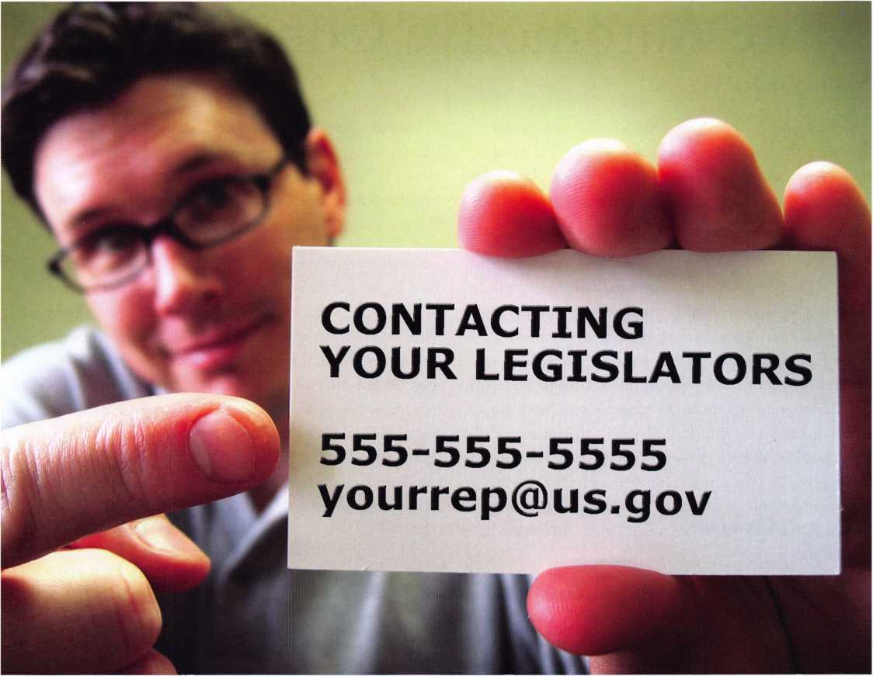

Your ALOA Board of Directors has concluded that the most important activity of the association is legislation. The policy states, "A membership that is informed and consulted about legislative activity that may affect it".

To keep you informed and make it easier for you to be involved in legislative activities, we have sent you a special legislative card. This card has the telephone numbers of your elected representatives at the state and federal level. The card was created using your business address. In some cases, your "voting" address may be in a different district making the information on the card incorrect. In the event that it may be necessary for the membership to contact lawmakers, this card will help. You may, of course, find this contact information useful for other purposes not related to the ALOA legislative work.

NOTE: Some of the PRP designations were printed incorrectly on the special legislative cards due to text conversion issues experienced by the print vendor. While we consider ALOA designations to be extremely important, we also realize that the purpose of the card is to provide legislative contact information. We trust that this information is correct. However; if you have received a card with incorrect legislative contact information or inadvertently received another member's card, please contact Mary May, Member Services Manager at 214-819-9733 x220.

ALOA Legislative Affairs - Working for You!

More Automotive Complications

By Eric Costley, CPL

Just when you thought I was kidding about auto work being a nightmare, I got more...much more. I stopped looking into the sky for crossed stars long ago. Automotive work always goes haywire and the older the vehicle, the more the work tends to stretch your patience.

Early in my career, my brother, Brian, and I entertained a biker from sixty miles out in the desert who brought in an old 50's Chevy. He had an ignition key, but nothing else. "Tonapah Joe" went next door to the grocery store and bought a gallon of cheap wine, which he immediately set out to drink in the back room of the shop while we fought with his antique nightmare. As it turned out, there was a different key for every lock. Both doors, the trunk, and the glove box had all been changed from the original locks. Joe was bigger and (I assumed) meaner than both Brian and I. put together Still, he left happy with 5 keys even though he was drunk and chunk-of-change lighter than when he walked in.

Newer cars are rarely such a mystery. As the vehicle gets older, the chances of something being changed out increase. When vehicles change owners, the new owner may not even realize that when the car left the showroom floor that it required only one key for all the locks. They sometimes assume that it is normal to have a different key for the ignition or perhaps the trunk.

When the customer loses the keys to the vehicle, it is important to get as much information as you can before you arrive on the scene. More than once, I've been work­ing on a Ford or Chrysler product, scratching my head and double-checking my progressions only to have the cus­tomer finally mutter, "Oh yeah, the ignition key is differ­ent, I think." Thanks. That information would've been useful an hour ago.

An automotive dealer called us to make keys to a 1995 Ford Escort. I was surprised since this dealership deals pri­marily with new vehicles. Apparently, the Escort was taken

in on trade and somehow the keys "disappeared". I was actually amused that they would bother to spend the money on keys, since I was sure the car was headed straight to the auction yard once I was finished. As I soon found out, the fun was just beginning.

Before I tear into this Ford, I should mention that the Ford Escort has always been a thorn in my side. I remem­ber that back in the late 80's and early 90's, I never knew what to expect when I got a call for this model. Until the dust settled, I found it difficult to determine whether it used the five-pin two-key system, the 10-cut system, (with or without the separate pin tumbler trunk key), the 7-cut system, (primarily used only on the Escort) or the Canadian-made Mazda set up. Every time I hear someone say "Ford had a better idea", I wish that they would stop having quite so many ideas!

This particular vehicle was a rust-bucket. It also turned out to be the 7-cut variety with five wafers in the doors and a 7-cut sidebar lock in the ignition. As soon as I opened the door, I knew something was very wrong. The "keys are in the ignition" bell started sounding although there were no keys there. In addition, the ignition lock seemed loosely mounted to the column.

I impressioned the door lock to get my first five cuts, then decoded the key. I punched the cuts into the code program on my laptop, and only one possibility popped up. I cut the key by code and headed back to the vehicle. Of course, the key didn't work. At this point, I pulled the column shroud off and inspected the ignition lock. The roll pins which hold the cylinder in the housing protruded a bit and had been ground down. This was obviously not the original lock!

Since the incessant chiming of the bell indicated a problem,

I returned to the shop to retrieve a replacement ignition.

There are two different locks used for this particular model: one for the standard transmission and another for the auto­matic. I grabbed both, and headed back to the dealership.

**22**

Keynotes • July/August 2005

The Ford Escort 7 cut, before I started.

The shroud was removed and a small hole was drilled near the roll pins which  
secure the lock cylinder.

Since this model had the manual transmission, the correct lock was the ASP C-42-191. I drilled two small holes next to the roll pins and gently pried them out, using an old impressioning file with a broken tip. (A file tends to grip the roll pins better than a simple pointed probe, so I never throw out broken files.) Once these are extracted, the igni­tion slides easily out of the housing. I found out immedi­ately why the bell was continuously ringing. It seems that when this ignition was installed, the spring which holds the buzzer activator in place was missing. After the key had been inserted the first time, the buzzer activator was raised and never moved back down into the lock. I retreated to the van to key the new cylinder to the correct key.

When I opened the poly bag that contained the new cylin­der, I got a surprise. ASP, in an effort to make things easier for "non-locksmith" keying, had loaded the lock with "uncoded service wafers" and left the sidebar out. Instructions called for using a dremel tool to cut the appropriate slots in the wafers, and then install the sidebar.

I opted to remove these and to use the standard wafers that we all know and love. (All Lock A-6100 Ford side bar lock service kit).

Once the lock was properly coded, I slid it into the hous­ing, installing the buzzer activator and the spring which was previously missing. A few screws were needed to reat­tach the shroud, and the job was completed.

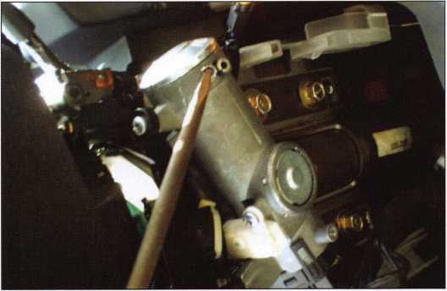

...prying out those pesky roll pins!

Before I move on, I probably should say that the 7-cut Ford system is primarily identical to the 10-cut system, except that only cuts 4-10 are used. The spacing, depths and wafer kits are virtually identical in every other fashion.

Now, moving on from the ridiculous to the sublime, lets shift to the upscale world of the Porsche. It was about an hour before quitting time when the call came in. A gentle­man with a 1987 Porsche 924 called, inquiring if we could make a key for the locks which cover the lug nuts.

Hmmm. "I don't know," I said. I told him I'd have to do some research, but suggested he bring it over so I could take a look at it. Of course, this was on a Friday, just before closing.

Keynotes • July/August 2005

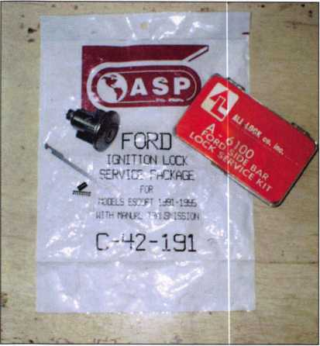

The old ignition, the ASP poly bag, the buzzer activator, spring  
and roll pin, and the handy All-Lock 10-cut keying kit.

I was in the parking lot getting something out of the van  
when the boss said "I think your Porsche is here." "How  
could you tell?" I retorted as the shiny thing roared into the  
parking lot.

Each of the wheels had one lock, which was protected  
against dust and weather by a nice plastic cover. I was sur-  
prised to find that the Fast Facts book by Robert G.  
Sieveking listed "Wheel nut locks". This gave me a wealth  
of information, including the blank number, number of  
cuts, and the knowledge that there were only 3 depths. The  
keyblank that these locks use is the Ilco DM31. We had  
two. They were also "red tagged", which meant that the  
blanks were expensive. I looked them up, and we had them  
listed at $5.00 each. I quoted the guy a price, and told him  
that he would probably have to leave one with me. Since it  
was Friday, he asked if I could remove them all so he could  
drive worry-free through the weekend.

**New!** Keedex Stainless Steel Armored Door Loops

ALL

STAINLESS STEEL  
DESIGN

STAINLESS

STEEL CONDUIT

STAINLESS STEEL  
END PIECES

STAINLESS STEEL

NTING SCREWS

FROM YOUR

KEEDEX DISTRIBUTOR

MADE IN U.S.A.

COSTS NO MORE  
THAN MOST DOOR  
LOOPS THAT HAVE

PLASTIC END PIECES

Call or write today  
for your free catalog!

Keedex, Inc.

12931 Shackelford Lane

Garden Grove, CA 92841 714-636-5657 • Fax: 714-636-5680

"Ideas That Work”

e-mail: [info@keedex.com](mailto:info@keedex.com)

[www.keedex.com](http://www.keedex.com)

They picked surprisingly easily: a quarter turn to the left and then unscrew to reveal the lugs. It took less than 5 minutes to remove them all.

Now, before you go out and stock up on DM31 blanks, let me clue you in on a little secret. The blank profile and length is virtually identical to your bread- and-butter Y12 blank. The only difference is the height of the key blade. If you thin a Y12 down from its original .250 width to .215, you have an inexpen­sive version of the exact same blank to work with. This insures that you have plenty of cheap blanks to work with. Of course, the final key will be on the DM31 since the quote was based on that, but now I knew that I wasn't going to run out of blanks if I ran into trouble.

Trying to "decode" the wafers from the rear, (as Sieveking recommended,) turned into a nightmare. Since the plug and the housing were both made of a plastic-like material, I decided to try to impression these, using the Framon machine to move each mark down to the next specified depth. That didn't work out too well. The next step was to look at the actual code series. Since the code series only goes from



Keynotes • July/August 2005

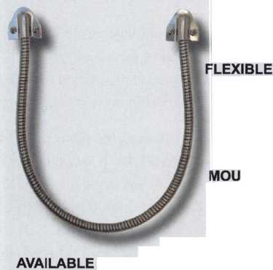

**CENTRAL INTELLIGENCE AGENCY**



**YOUR TECHNICAL KNOWLEDGE IS**

**OUR SECURITY**

Technical Security Officers

CIA Technical Security Officers configure, deploy and maintain

a variety of security systems, regularly working with US- and  
overseas-based Security Officers to coordinate programs.

They also perform administrative duties, as well as working

with and lifting heavy equipment. After a few years’  
experience, you may be asked to serve in an overseas  
assignment.

Minimum requirements include a bachelor’s degree  
in engineering or an associate’s degree in electronics  
technology. In lieu of a degree, a certificate of  
completion for equivalent military, commercial or  
industry-recognized electronics school or training  
programs, or comprehensive work experience, may

be accepted. Candidates must be proficient in the field of electronics,  
or in an electromechanical environment. Knowledge of electronic  
and/or mechanical safe/lock servicing, alarms, CCTV, and experience  
working as a locksmith are ideal. Several years of service in

the corporate security field are also preferred. Overseas

experience is desired but not required.

For additional information and to apply online, please visit: [www.cia.gov](http://www.cia.gov) and view under “CIA Careers’’ —“Engineers and Technology”— “Technical Security Officers.”

All applicants must successfully complete a thorough medical and psychological exam, a polygraph interview and an extensive background investigation. US citizenship is required. EOE

THE WORK OF A NATION. THE CENTER OF INTELLIGENCE.



ID601-ID654, I knew there were only 55  
keys that were involved. Since I could see  
that the last cut was the deepest, that nar-  
rowed it down to a mere 14 possibilities.

Now, I can admit that at this time, I still  
don't have a working key for this cus-  
tomer. The other side of this is that the  
customer knew that the job wouldn’t be  
cheap. He knows that he's asking for a  
lot and he knows that it will take me  
“however long” it takes me to accomplish  
this feat. He doesn't care because no one  
else has been able to do the work. I also  
know for a fact that he will come back  
when the job is through, since this is a  
"show car". Despite removing all of the  
wheel locks initially he wanted to keep  
everything in original condition. (If I  
could afford a car like this, I would too!)

No, I will still not admit that automotive  
is in my "field of expertise". Who would?  
Yes, I do a great deal of automotive work,  
and most of it is like pulling teeth.  
(There's only 32 there.. Take what you  
want. This will only hurt for a little bit.)  
The other side of the story is that auto  
work can pay well, and if you get your  
greasy little paws into it, a regular pay-  
check can be expected.

Is it for everyone? Definitely not. Even  
so, if you've got a little grease in your  
blood... go on, dive in.

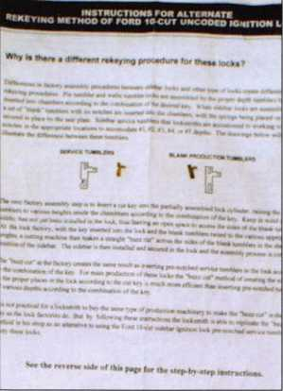

Page 1 of the “non-locksmith” keying instruc-  
tions, with an uncoded service wafer and a  
normal wafer from the All-lock keying kit in  
their appropriate places.

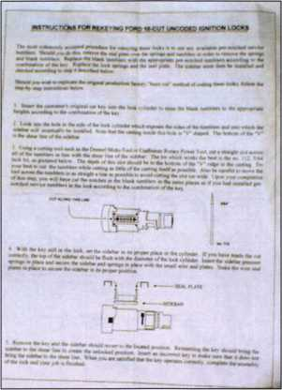

The 2nd page of instructions...! wouldn’t use  
a Dremel tool to cut my own notch in these  
small wafers. Would you?

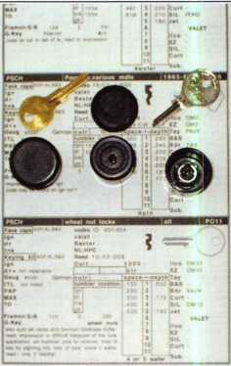

i

The Porsche wheel lug locks, the prescribed  
blank and our old-favorite Y12 all perched  
upon the Fast Facts appropriate page.

God bless us grease monkeys, every one.



Keynotes • July/August 2005

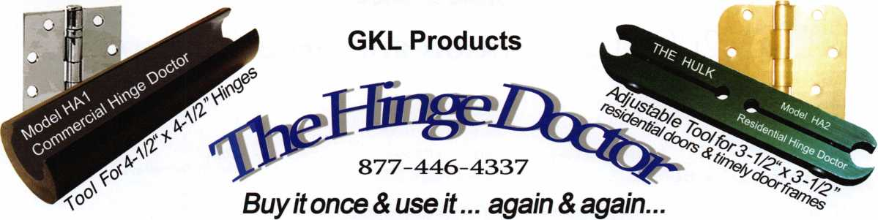

*Repair Sagging Doors in Seconds!*

Fixes Bent & Worn Hinges Instantly!

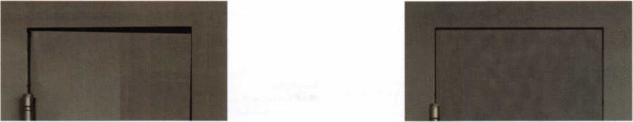

Note Door  
Hitting Frame

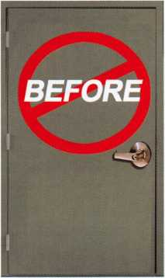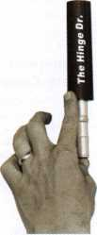

From this to this

Door is Fixed!!

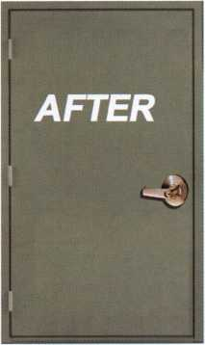

/nseconds.

[www.hingedoctor.com](http://www.hingedoctor.com)

*No more backaches*

*from pulling & rehanging doors!*

*TheffimeDnisHeneH!*

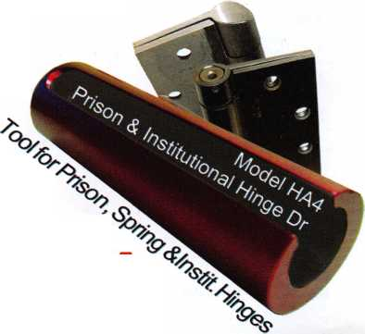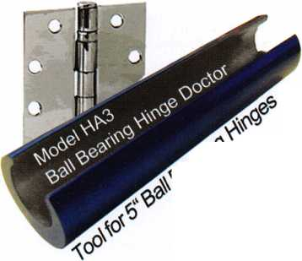

ALOA 2005 Convention and Security Expo

Exhibitors

(Associate Members)

1 -800-LOCKSMITH # 1724

6400 Bay Parkway Brooklyn, NY 11204 800-562-5764; 718-236-4504 fax Contact(s): Jacob Goldberg

1-800 UNLOCKS, Inc #1011

2110 Spencer Road Richmond, VA 23230 804-377-9396; 804-421-0079 fax Contact)s): Barry Wilson

**1st in Hardware #424**

2901 Whittington Ave, Suites F&G

Baltimore, MD 21230

866-397-9900; 866-646-0045 fax

www. 1 stinhardware.com;

e-mail: [info@lstinhardware.com](mailto:info@lstinhardware.com)

Contact (s): Ed Korenge, John Edwards, Mike Wooten

Wholesale-Alarms; Builders Hardware;

Business/Technical & Educational; Electric/Electronic

Security; Lock Devices; Tools & Supplies; Safes/Vaults;

Storefront Door Hardware

A-l Security Mfg. Corp. ..#617

3001 West Moore St.

Richmond, VA 23230 804-359-9003; 804-359-9415 fax [www.demandal](http://www.demandal) .com; e-mail: service@demandal .com Contact(s): Frank McCarthy, Julien McCarthy Manufacturer—Tools & Supplies

**A&B Safe**

**Corporation #1400**

114 S. Delsea Dr. Suite 3 Glassboro, NJ 08028 856-863-1186; 856-863-1208 fax [www.a-bsafecorp.com](http://www.a-bsafecorp.com); e-mail: [info@a-bsafecorp.com](mailto:info@a-bsafecorp.com) Contact)s): Edward C. Dornisch,

S. Mildred A. Dornisch

Manufacturer, Wholesale-Bank Security Equipment; Safes/Vaults

ADI, Inc #517

263 Old Country Rd • Melville, NY 11747

631-692-1000

[www.adilink.com](http://www.adilink.com);

e-mail: [info@adi-dist.com](mailto:info@adi-dist.com)

Contact: Cliff O'Shea

Distributor-Alarms; Bank Security; Builders Hardware; CCTV/Photo imaging; Electric/Electronic Security; Lock Devices

**ASSA ABLOY Americas ....#605**

110 Sargent Drive New Haven, CT 06450 203-624-5225; 203-785-8108 fax [www.assaabloy.com](http://www.assaabloy.com) Contact: Yvonne I. Vizcaino Manufacturer-Alarms; Builders Hardware; Electric/Electronic Security; Lock Devices

ASSA Inc #813

110 Sargent Drive New Haven, CT 06534 724-969-2595; 724-969-2594 fax Contact: Tom Demont

Abloy Door Security #818

9630 Transcanada Hwy Montreal, Quebec, Canada H45 1V9 800-465-5761; 800-730-3570 fax [www.abloy.ca](http://www.abloy.ca); e-mail: [info@abloy.ca](mailto:info@abloy.ca) Contact: Martin Day Electric/Electronic Security Lock Devices

**ABUS Lock Company #505**

23910 N. 19th Ave. Ste. 56 Phoenix, AZ 85027 623-516-9933; 623-516-9934 fax [www.abuslock.com](http://www.abuslock.com); e-mail: [abuslock@abuslock.com](mailto:abuslock@abuslock.com) Contact: Grant Laitala Manufacturer—Lock Devices

**Accredited Lock**

**Supply Co #718**

1161 Paterson Plank Road Secaucus, NJ 07094 800-652-2835; 201-865-5031 fax [www.acclock.com](http://www.acclock.com) email: [mail@acclock.com](mailto:mail@acclock.com) Contact: Norman Koller

Distributor-Alarms; Bank Security equipment; Automotive; Builders Hardware; Business/Technical & Educational; CCTV/Photo Imaging; Electric/Electronic Security; Lock Devices; Tools & Supplies; Safes/Vaults

**Adams Rite**

**Manufacturing # 1224**

260 Santa Fe Street

Pomona, CA 91767

909-632-2300; 909-632-2369 fax

[www.adamsrite.com](http://www.adamsrite.com); e-mail: [dhopkins@adamsrite.com](mailto:dhopkins@adamsrite.com)

Contact(s): Donna Hopkins

Manufacturer—Alarms; Builders Hardware;

Electric/Electronic Security; Lock Devices

**ADESCO Safe #1520**

16720 S. Garfield Ave.

Paramount, CA 90723 562-630-1503; 562-408-6427 fax [www.adesco.com](http://www.adesco.com); e-mail: [earl@adesco.com](mailto:earl@adesco.com) Contacts): Earl Halls Manufacturer—Safes/Vaults

**Adrian Steel Company ..#1318**

906 James Street Adrian, Ml 49221 517-265-6194; 517-265-5834 fax Contact(s): Todd Goldmeyer

Manufacturer—Tools & Supplies

**Advanced Diagnostics**

**USA #305**

180-C South Spruce Ave., So.

San Francisco, CA 94080 650-876-2020; 650-876-5193 fax [www.autokeys.com](http://www.autokeys.com); e-mail: [brookfrancisco@yahoo.com](mailto:brookfrancisco@yahoo.com) Contacts): John Steiner Automotive; Tools & Supplies

Akron Hardware #1234

1100 Killian Road Akron, OH 44312 800-321-9602; 800-328-6070 fax [www.akronhardware.com](http://www.akronhardware.com); e-mail: [sales@akronhardware.com](mailto:sales@akronhardware.com) Contacts): Glenn Siegman, Bill Jubara Wholesale-Builders Hardware; CCTV/Photo Imaging; Electric/Electronic Security

Alarm Lock

Systems, Inc #1312

345 Bayview Ave.

Amityville, NY 11701 631-789-4871; 631-789-3383 fax [www.alarmlock.com](http://www.alarmlock.com); e-mail: [salesinfo@alarmlock.com](mailto:salesinfo@alarmlock.com) Contact)s): Brian Strom, Brian Gold, Bob Swoope Manufacturer— Alarms; Lock Devices

**All 5 Lock #1232**

70 Enterprise Drive Bristol, CT 06010 860-583-1691; 860-583-4516 fax Contact(s): Joseph Nemec

Manufacturer- Lock Devices

Allied Finishing, Inc #513

4100 Broadmoor S.E..

Grand Rapids, Ml 49501 616-698-7550; 616-698-0312 fax [www.alliedfinishinginc.com](http://www.alliedfinishinginc.com); e-mail: [scott.barnard@alliedfinishinginc.com](mailto:scott.barnard@alliedfinishinginc.com) Contact(s): Scott Barnand, Ed Ruzic, John Gray Manufacturer—Decorative Chrome/Brass/

Bronze Plating

**Allstate Insurance Company #1516**

2775 Sanders Road, Suite D7 Northbrook, IL 60067 847-402-8196; 847-326-7509 fax [www.allstate.com](http://www.allstate.com); e-mail: [abisO@allstate.com](mailto:abisO@allstate.com) Contact(s): Anita Bishop Commercial Insurance

**American**

**Auto Lock.Com #630**

1039 North Christian Street Lancaster, PA 17602 800-860-5625; 717-581-8353 fax Contact(s): William Neff

American Eagle

Lock Co #829

144 Newport Rd Leola, PA 17540

717-656-4281; 717-656-6892 fax Contact(s): Lisa Rohrer

Manufacturer—Builders Hardware

American

Lock Company #728

3400 West Exchange Road Crete, IL 60417-2099 708-534-2000 or 800-323-4568;

708-534-0531 fax [www.americanlock.com](http://www.americanlock.com) e-mail: contact(s)[us@americanlock.net](mailto:us@americanlock.net) Contact)s): Dave Kraninger, Mike Quillin Manufacturer-Lock Devices

American

Safe Technologies #1723

1925 Enterprise Ct.

Libertyville, IL 60048 847-362-9800 Contact(s): Ed McGunn

**American**

**Security Products #923**

11925 Pacific Ave. • Fontana, CA 92337 800-421-6142; 909-685-9685 fax [www.amsecusa.com](http://www.amsecusa.com) Contacts): Bob Sallee

Manufacturer—Safes/Vaults

AO BA

Security Technology #1635

19 Senoko Ave.

Singapore 758308 Contacts): Julie Gan

Arrow Lock & Door Hardware # 713

325 Duffy Ave.

Hicksville, NY 11801 516-704-2700 or 800-221-6529 877-288-6480 fax [www.arrowlock.com](http://www.arrowlock.com)

Contact(s): George Hansen, Charlie Armstrong, Fernando Nunez

Manufacturer—Builders Hardware; Lock Devices; Tools & Supplies; 1C Cores

Associated Locksmiths of America, Inc. (ALOA)

3500 Easy Street.

Dallas, Texas 75247 1-800-532-2562; 214-819-9736 fax [www.aloa.org](http://www.aloa.org); email: [aloa@aloa.org](mailto:aloa@aloa.org)

International Locksmiths Trade Association William Young, President

ALOA Legislative—Up-to-the-minute news and information on legislation affecting your business.

Key Personnel: Tim McMullen, Legislative Affairs Consultant

ALOA Scholarship Foundation—Provides funding for promising locksmiths.

Key Personnel: Don Rule, Dennis Watanabe

Auto Security Products ....#417

POBox 10 Redmond, WA 98073 425-556-1900; 425-558-1205 fax [www.carlocks.com](http://www.carlocks.com) Contacts): Steve Shain

Manufacturer—Automotive; Business/Technical & Educational; Lock Devices

Barnes Distribution #633

1301 E. 9th St. Ste. 700 Cleveland, OH 44114 216-430-5742; 216-592-1621 fax Contact(s): Ladd-E Urbas

**Bianchi USA, Inc # 831**

31336 Industrial Parkway, Suite 3.

North Olmsted, OH 44070

440-716-8006; 216-803-0202 fax

[www.bianchil770usa.com](http://www.bianchil770usa.com)

e-mail: [info@bianchil770usa.com](mailto:info@bianchil770usa.com)

Contacts): Erin Kocab or Joy Skowron

Manufacturer-Key Machines, Keys, Transponder Servicing

Tools

Blackhawk Products # 1230

25913 County Road T.5

Dolores, CO 81323

970-882-7191; 970-882-7228 fax

[www.blackhawk7.com](http://www.blackhawk7.com);

e-mail: [staff@blackhawk7.com](mailto:staff@blackhawk7.com)

Contact(s): Roger Weitzenkamp, CML

Manufacturer—Computer software

**Buddy Products/**

**Locksmiths Division #600**

1350 South Leavitt Chicago, IL 60608 312-733-6400; 312-733-8356 fax Contact(s): Megan Varney



Keynotes • July/August 2005

Cam/AM

Door Hardware #1713

746 Halpern

Montreal Canada H9P 1G6 514-296-8888 Contacts): Vincent DeRose

**CCL Security Products #928**

301 W. Hintz Road

Wheeling, IL 60090

800-733-8588; 847-537-1881 fax

[www.cclsecurity.com](http://www.cclsecurity.com)

e-mail: [info@cclsecurity.com](mailto:info@cclsecurity.com)

Contacts): Bill Walsh, Lyle Elliott

Manufacturer—Builders Hardware; Lock Devices;

Combination Padlocks

California Locksmith Association #1822

1240 N. Jefferson St. Ste. G Anaheim, CA 92807 Contact(s): Suzanne Harmony

Camden Door Controls ....#506

5151 Everest Drive Unit #6 Mississauga, Ontario L4W-2Z3 Canada 1-877-226-3369; 905-366-3378 fax [www.camdencontrols.com](http://www.camdencontrols.com) e-mail: [info@camdencontrols.com](mailto:info@camdencontrols.com) Contact(s): Heidi Goldberg

Manufacturer—Electric/ Electronic Security; Lock Devices; Handicap Activation Devices

**Clark Security Products ....#924**

7520 Mission Valley Road San Diego, CA 92108 619-718-7301; 619-718-7333 fax Contact(s): Ron Cooling

Distributor—Automotive; Business/Technical & Educational; CCTV/Photo imaging; Electric/Electronic Security; Lock Devices; Tools & Supplies; Safes/Vaults

Clear Star

Security Network # 1726

1140 University Ave.

Berkeley, CA 94702

510-841 -4807; 510-841 -7915 fax

[www.clearstar.com](http://www.clearstar.com);

e-mail: [security@clearstar.com](mailto:security@clearstar.com)

Contact(s): Jay Long, Richard Reichert

Restricted-Access Website for Locksmiths & Safe Techs.

CODELOCKS, LLC #1600

2930 B College Ave.

Costa Mesa, CA 92626 714-979-2900 Contactf s): Todd Shaw

Commercial

Van Interiors #324

8840 St. Charles Rock Road St. Louis, MO 63114 314-423-7477; 314-427-1525 fax Contact(s): Brian Peck

Distributor—Van & Truck Equipment

**COMPX**

**Security Products # 1323**

P.O. Box 200 Mauldin, SC 29662 864-286-1693; 864-286-1698 fax [www.compxnet.com](http://www.compxnet.com) Contact(s): Lou Galvao Manufacturer—Lock Devices

Corbin Russwin Architectural Hardware #605

(An ASSA Abloy Group Co.)

225 Episcopal Road Berlin, CT 06037

800-543-3658; 800-447-6714 fax [www.corbin-russwin.com](http://www.corbin-russwin.com) Contact(s): Yvonne I. Vizcaino

Manufacturer-Alarms; Builders Hardware; Electric/Electronic Security; Lock Devices

Corporate Safe

Specialists #1531

14800 McKinley Ave.

Posen, IL 60469

708-371-4200; 708-371-3326 fax e-mail: [selvigm@corporatesafe.com](mailto:selvigm@corporatesafe.com) Contact(s): Mandy Selvig, Michael McGunn

Electric/Electronic Security; Safes/Vaults

**Cross Country**

**Automotive Services #729**

4040 Mystic Valley Pkwy Medford, MA 02155 800-541-2262; 781-393-0256 fax Contact(s): Nancy D'Ambrosio

DCI-Brillcast #1511

3400 Wentworth Grand Rapids, Ml 49519

616-534-4977; 616-534-0880 fax

[www.dcicomponents.com](http://www.dcicomponents.com)

e-mail: [sales@dcicomponents.com](mailto:sales@dcicomponents.com)

Contact(s): Jeff Doornbos, Brad Doornbos, Rich Pytka

Manufacturer-Builders Hardware

**D&D Technologies**

**USA, Inc #1707**

7731 Woodwind Dr.

Huntington Beach, CA 92647 800-716-0888; 800-464-6400 fax Contact(s): Maureen Williams

Manufacturer

Defiant Safe Co #1133

3140 Towerwood Drive Dallas, TX 75234

972-243-3711; 972-241-7669 fax Contact(s): Scott Wilson

Wholesale Manufacturer—Safes/Vaults; Defiant Safe Moving System (safe chariot)

**DETEX Corporation # 1517**

302 Detex Drive New Braunfels, TX 78130 800-729-3839; 836-620-6711 fax [www.detex.com](http://www.detex.com); e-mail: [grb@detexcorp.com](mailto:grb@detexcorp.com) Contact(s): Trice Kastein, Greg Drake Manufacturer-Alarms; Builders Hardware; Electric/Electronic Security; Lock Devices

Diplomat Safe #1332

1583-4 Song Jung-Dong Gangseo-Gu Busan Korea

8251-831-4400

Contact(s): Man-Young Chang

**Discount Key Machines.Com/ Busch #1627**

P.O. Box 691796 Orlando, FL 32869 800-332-8724; 407-363-4666 fax Contacts): Jeff Busch

**Don-Jo Mfg # 623**

P O Box 929 Sterling, MA 01564 978-422-3377; 978-422-3467 fax [www.don-jo.com](http://www.don-jo.com); e-mail: [info@don-jo.com](mailto:info@don-jo.com) Contacts): Peter Vaillant Manufacturer—Builders Hardware

DoorKing, Inc #1328

120 Glasgow Avenue

Inglewood, CA 90301

310-645-0023; 310-642-1314 fax

[www.doorking.com](http://www.doorking.com); e-mail: [info@doorking.com](mailto:info@doorking.com)

Contact(s)s: Larry Wanat

Manufacturer—Electric/ Electronic Security

DORMA Architectural Hardware # 1717

Dorma Drive, Drawer AC

Reamstown, PA 17567

717-336-3881; 717-336-2106 fax

[www.dorma-usa.com](http://www.dorma-usa.com)

e-mail: [archdw@dorma-usa.com](mailto:archdw@dorma-usa.com)

Contacts): Bill Espinola, Gary Phillips, Lloyd Seliber

Manufacturer—Builders Hardware; Electric/Electronic

Security; Lock Devices.

Dor-O-Matic, see IR Security &

Safety #907

**Doyle**

**Security Products #1134**

2211 West River Road North Minneapolis, MN 55411

612-521-6226; 612-521-0166 fax [www.doylesecurity.com](http://www.doylesecurity.com); e-mail: [sale@doylesecurity.com](mailto:sale@doylesecurity.com) Contact(s): Eric Edquist, Paul Justen

Distributor-Automotive; Builders Hardware; Electric/Electronic Security; Lock Devices; Tools/Supplies; Safes/Vaults

Dugmore &

Duncan, Inc #601

30 Pond Park Rd.

Hingham, MA 02043

781 -927-2127; 781 -749-2869 fax

[www.dugmore.com](http://www.dugmore.com);

e-mail: [ed@dugmore.com](mailto:ed@dugmore.com)

Contact(s): Bob Cullum, Michelle Lawn,

Ed Minishak, Skip Reid

Distributor—Builders Hardware; CCTV/Photo Imaging; Electric/Electronic Security; Lock Devices; Tools & Supplies

ECONZ Wireless #416

3107 Carte Caleta Newport Beach, CA 92660 866-408-3475 [www.econz.com](http://www.econz.com) e-mail: [salessupport@econz.com](mailto:salessupport@econz.com) Contact(s): Harry Lane Wireless Job Dispatch Software

ekey USA

Systems, LLC #409

6150 53rd Avenue East

Bradenton, FL 34203

941 -782-1227; 941 -256-3555 fax

[www.ekeyusa.com](http://www.ekeyusa.com); e-mail: [info@ekeyusa.com](mailto:info@ekeyusa.com)

Contact(s): Hassan Hares, Donna Hares

Distributor-Biometric Access Control

ESP Lock

Products, Inc #823

81 Apsley Street Hudson, MA 01453 800-434-8960; 978-562-9859 fax Contact(s): Andrew Gontarz

Builders Hardware; Lock Devices; Tools & Supplies; Locking Systems for Furniture

ETL #626

2351 Tenaya Drive Modesto, CA 95354 800-344-3242; 209-529-3554 fax [www.etlproducts.com](http://www.etlproducts.com); e-mail: [info@etlproducts.com](mailto:info@etlproducts.com) Manufacturer—Safes/Vaults

Executive Safe and Security Corp #1631

1480 S. Carlos Ave Ontario, CA 91761 800-520-2677; 909-947-7677 fax Contact(s): Mark Malone

FAC Seguridad, S.A #423

Avd Constitucion,

108-112, 45950 Casarrubios, Toledo Spain 34918183144 Contact(s): Antonio Estepa

**FKI Security Group # 1106**

101 Security Parkway

New Albany, IN 47150

800-457-2424

[www.fkisecuritygroup.com](http://www.fkisecuritygroup.com);

e-mail: [fkisecuritygroup@fkisecuritygroup.com](mailto:fkisecuritygroup@fkisecuritygroup.com)

Contact(s): Fred Wyatt, Brent Miller

Manufacturer—CCTV/Photo Imaging; Safes/Vaults

Falcon, see IR Security & Safety #907

**\Framon Manufacturing Company #733**

909 Washington Ave.

Alpena, Ml 49707 989-354-5623; 989-354-4238 fax Contact(s): Phil Agius

Manufacturer—Tools & Supplies

GE Security #1411

4001 Fairview Ind. Drive SE

Salem, OR 97302

503-581-9101; 503-375-6421 fax

[www.geaccesspoint.com](http://www.geaccesspoint.com)

e-mail: [felechia-burleigh@ge.com](mailto:felechia-burleigh@ge.com)

Contact(s): Rick Boes, Debby Bradish

Manufacturer—Automotive; Lock Devices

GMS Industries, Inc # 1614

25-11151 Horseshoe Way

Richmond BC V7A 4S5

888-774-5625; 604-448-1249 fax

[www.gmslock.com](http://www.gmslock.com)

e-mail: [info@gmslock.com](mailto:info@gmslock.com)

Contact(s) Mike Tong, Lynn Lee

Manufacturer-Lock Devices; Tools & Supplies

Gardall Safe Corp #1433

P.O. Box 240 Syracuse, NY 13206 315-432-9115; 315-434-9422 fax [www.gardall.com](http://www.gardall.com); e-mail: [info@gardall.com](mailto:info@gardall.com) Contact(s): Mark Koesterer Manufacturer—Safes/Vaults

Global Door Controls #627

5808 Long Creek Park DR. Ste A Charlotte, NC 28269 800-256-7377; 704-596-5659 fax Contact(s): Geoff Meyer

Glynn-Johnson, see IR Security

& Safety #907

Guardian Safe Co #1514

38 Grace Cress.

Barrie Ontario Canada L4N 9S5  
705-722-8894; 705-722-9156 fax  
[www.guardiansafes.com](http://www.guardiansafes.com);  
e-mail: [sales@guardiansafes.com](mailto:sales@guardiansafes.com)  
Contact(s): Paul O'Hara  
Distributor- Safes/Vaults

HES #817

22630 N. 17th Avenue

Phoenix, AZ 85027

623-582-4626; 623-582-4641 fax

[www.hesinnovations.com](http://www.hesinnovations.com)

e-mail: [sales@hesinnovations.com](mailto:sales@hesinnovations.com)

Contact(s): Matt Thomas, Chuck Christiansen

Manufacturer-Electric/Electronic Security; Lock Devices

H.L. Flake #931

5031 Gulf Freeway  
Houston, TX 77023  
713-926-3200  
Contact(s): Dan Floeck

HPC, Inc #1023

3999 N. 25th Ave  
Schiller Park, IL 60176  
847-671-6280; 847-671-6343 fax  
Contact(s): Francine Hoffman  
[hpc@hpcworld.com](mailto:hpc@hpcworld.com)

Manufacturer-Automotive; Business/Technical &  
Educational; Tools & Supplies; Safes/Vaults; Key  
Cabinets & Security Storage

**HRH Insurance #1035**

5520 LBJ Frwy #600  
Dallas, TX 75240

972-385-9922; 972-764-1759 fax  
[www.hrh.com](http://www.hrh.com)

Contact(s): Becky Ashwood,

Trevor Pierce, Wendy Erskine

Insurance/Risk Management Services



Keynotes • July/August 2005

**Hammerhead**

**Industries #1215**

1501 Goodyear Ave Ventura, CA 93003 805-658-9922; 805-658-8833 fax Contact(s): John Salentine

Hardware

Merchandisers, Inc #1618

4555 NW 103rd Avenue, #102 Ft. Lauderdale, FL 33351 800-423-4712; 954-741-1599 fax Contact(s): Steve Meltzer

Manufacturer-Tools & Supplies

High Tech Tools #1611

1628 NW 28* Street Miami, FL 33142

305-649-7014; 305-541-0074 fax Contact(s): Tony Vigil

Howard Keys #1223

1610 Industrial Center Circle Charlotte, NC 28262 704-509-4944; 704-509-6248 fax Contact!s): Howard J. Goldberg

Hurd Corporation #420

503 Bohannon Avenue Greenville, TN 37745 800-877-2581 Contact(s): Teresa McKinney

**IDN, Inc #1110**

2401 Mustang Dr. Ste. 100 Grapevine, TX 76051 817-421 -5470; 817-421 -5470 fax Contact(s): Mike Groover

Distributor—Alarms; Bank security equipment; Automotive; Builders Hardware; Business/Technical & Educational; CCTV/Photo imaging; Electric/Electronic Security ; Lock Devices ; Tools & Supplies; Safes/Vaults

Inkas Safe Mfg #1513

830 Flint Road

Toronto, On M3J 2J5 Canada 877-913-7233; 877-913-7232 FAX Contact(s): Jim Martin

Innovative Concepts Engineering #1125

3219 Bagley Avenue, Ste 2 Los Angeles, CA 90034 888-396-5334; 213-388-7150 fax Contact(s): Nick Gentry

Institutional Locksmiths Association #1824

P.O. Box 4188 Trenton, NJ 08610 866-745-LOCK; 312-732-8729 fax [www.ilanational.org](http://www.ilanational.org); keysl [50@juno.com](mailto:50@juno.com) Contact(s): Thomas Negron, CIL;

Kurt Kloeckner, CIL, TCPL Association-In House Locksmiths

Internet-Locksmith.com..# 1826

8542 33 Ave NW

Calgary, Alberta T3B 5K2 Canada

[www.internet-locksmith.com](http://www.internet-locksmith.com); e-mail:

[membership@internet-locksmith.com](mailto:membership@internet-locksmith.com)

Contacts): John Truempy

Free Internet Forums for locksmiths

**IR Security & Safety # 907**

111 Congressional Blvd. # 200 Carmel, IN 46032 317-805-5700; 317-805-5777 fax www. i rsecu rityandsafety.com; e-mail: [pat_olmstead@irco.com](mailto:pat_olmstead@irco.com) Contact(s): Pat Olmstead

Alarms; Builders Hardware; Electric/Electronic Security; Lock Devices

Ives, see IR Security & Safety #907

Jackson Corporation #411

3447 Union Pacific Ave.

Los Angeles, CA 90023 323-269-8111,800-888-6855 fax [www.jacksonexit.com](http://www.jacksonexit.com); e-mail: [hilda@jacksonexit.com](mailto:hilda@jacksonexit.com) Contacts): Terry Bunker

Manufacturer-Builders Hardware; Electric/Electronic Security; Lock Devices

JLM Wholesale #500

3095 Mullins Court Oxford, Ml 48371 800-522-2940; 800-782-1160 fax Contacts): Dennis Ingamells

JMA USA #1701

2409 Avenue J, Suite A Arlington, TX 76006 817-385-0515; 817-385-4850 fax Contact(s): Mike Conti

**Jet Hardware**

**Mfg. Corp #606**

800 Hinsdale St.

Brooklyn, NY 11207

718-257-9600; 718-257-0973 fax

[www.jetkeys.com](http://www.jetkeys.com);

e-mail: [keys@jetkeys.com](mailto:keys@jetkeys.com)

Contacts): George Buchinger, Art Koines

Manufacturer—Lock Devices-Utilily locks; Tools& Supplies;

Key Displays; Key Cutting Machines, Transponder

Duplicator & Decoder

**KABA ILCO Corp.-Access Controls #1105**

2941 Indiana Ave.

Winston Salem, NC 27105 336-725-1331; 336-725-8814 fax [www.kaba-ilco.com](http://www.kaba-ilco.com) e-mail: [cself@kaa.kaba.com](mailto:cself@kaa.kaba.com) Contact(s): Richard Stone

Manufacturer—Electric/Electronic Security; Lock Devices; Push Button Locks

**KABA ILCO Corp.-**

**Key Systems # 1105**

400 Jeffreys Rd.

Rocky Mount, NC 27804 252-446-3321; 252-446-4702 [www.kaba-ilco.com](http://www.kaba-ilco.com) e-mail: [info@irm.kaba.com](mailto:info@irm.kaba.com) Contacts): Lynn Best Manufacturer-Tools & Supplies

KABA MAS Corp #1105

749 W. Short Street

Lexington, KY 40508

859-253-4744; 859-255-2655 fax

[www.kaba-mas.com](http://www.kaba-mas.com);

e-mail: [customerservice@kml.kaba.com](mailto:customerservice@kml.kaba.com)

Contacts): Bill Rice

Manufacturer-Bank Security Equipment; Safe Locks

Keedex

Manufacturing # 1508

12931 Shackelford Lane

Garden Grove, CA 92641

714-636-5657; 714-636-5680 fax

[www.keedex.com](http://www.keedex.com)

e-mail: [info@keedex.com](mailto:info@keedex.com)

Contacts): Cormac "Mac" Dorsey

Manufactuer- Automotive; Builders Hardware;

Electric/Electronic Security; Lock Devices; Tools &

Supplies; Gate Boxes

**Keri Systems, Inc #523**

1530 Old Oakland Rd. Ste 100 San Jose, CA 95112 408-451-2520; 408-441-0309 fax [www.kerisys.com](http://www.kerisys.com); e-mail: [sales@kerisys.com](mailto:sales@kerisys.com) Contact(s): Mike Bevan Manufacturer-Electric/Electronic Security

Kevin's Key ID #511

2900 Livorno Cove Cedar Park, TX 78613 512-459-1422; 512-258-1325 fax Contact(s): Roger Lawhon

**KEY-BAK #1714**

4245 Pacific Privado

Ontario, CA 91761

800-685-2403

[www.keybak.com](http://www.keybak.com)

e-mail: [sales@keybak.com](mailto:sales@keybak.com)

Contact(s): Michael Winegar

Manufacturer-Automotive; Tools & Supplies; Retractable

Key Chains

Keyless Ride #1434

800 Paloma Dr. Ste 110

Round Rock, TX 78664

512-310-5757 or 877-619-3136

208-475-6230 fax

[www.keylessride.com](http://www.keylessride.com)

Contacts): Michael Laranang, Noel Lopez

Manufacturer-Automotive (Keyless Entry)

Klassy Keys, Inc #1331

63 Carrs Tavern Road Clarksburg, NJ 08510 888-844-5397; 800-610-6670 fax Contacts): Bob or Albert

KSP #1227

33 Hermon St.

Worcester, MA 01610 800/577-5397; 508/753-2183 fax Contacts): Doug Maston

Kwikset/

Weiser Lock # 1532

19701 DaVinci Lake Forest, CA 92610 949-672-4508; 949-672-4825 fax www.kwikset.com,[www.weiserlock.com](http://www.weiserlock.com) e-mail: [anna.vanpatten@bdhhi.com](mailto:anna.vanpatten@bdhhi.com) Contact(s): Anna Van Patten Manufacturer-Lock Devices

**LAB Security # 1407**

700 Emmett St. Bristol, CT 06010 800-243-8242; 860-583-7838 fax [www.labpins.com](http://www.labpins.com) Contact(s): Thomas Martucci

Manufacturer-Lock Devices (including Pins & Pin Kits); Tools & Supplies

**LAGARD, Inc # 1005**

3330 Kashiwa St.

Torrance, CA 90505 310-325-5670; 310-325-5615 fax [www.lagard.com](http://www.lagard.com) e-mail: [theone@lagard.com](mailto:theone@lagard.com) Contact(s): Josh Brisbane, Dan Sparks Manufacturer— Safes/Vaults

Lasershield Systems #1602

5631 Palmer Way, Ste C Carlsbad, CA 92008 760-930-1908; 700-930-8056 fax Contacts): Eileen Johansson

LCN, see IR Security &

Safety #907

Lectro Truck/I.M.S. Inc #501

310 South 10th Street; P.O. Box 700167 Oostburg, Wl 53070-0169 920-564-6272; 920-564-2322 fax [www.lectrotruck.com](http://www.lectrotruck.com) e-mail: [information@lectrotruck.com](mailto:information@lectrotruck.com) Contact!s): Jason Tagel Manufacturer—Tools & Supplies

Lockcraft #732

1612 Union Valley Road W. Milford, NJ 07480 973-728-3707; 973-728-3731 fax Contacts): John Wiltshire

**\Lockmasters, Inc # 1309**

5085 Danville Rd.

Nicholasville, KY 40356

1. 885-6041; 859-885-7093 fax www. lockmasters .com

e-mail: [maryfosters@lockmasters.com](mailto:maryfosters@lockmasters.com) Contacts): Mary Foster Distributor—Automotive; Builders Hardware; Electric/Electronic Security; Lock Devices; Tools & Supplies; Safes/Vaults

Locknetics, see IR Security & Safety #907

Locksmithing, Uni. LLC #512

828 S. Broom St.

Wilmington, DE 19805-4245 302-575-0993; 302-571-1677 fax [www.locksmithingunl.com](http://www.locksmithingunl.com) e-mail:[ted@locksmithingunl.com](mailto:ted@locksmithingunl.com) Contact!s): Ted Gula, John Baker Manufacturer-Tools & Supplies

**Locksmith Ledger International/Cygnus Security Group #825**

102 Wilmut Suite 470 Deerfield, IL 60015 847-405-0254; 847-405-0359 fax Contacts): Nancy Brokamp

Locksmith industry publication-has provides up-to-the-minute valuable information for nearly 6 decades. Ledger bridges the gap between Locksmith, Distributor & Manufacturer with the ultimate goal of providing an environment of coopera­tion & profitability for all parties.

Login Lock #1618

53 Railroad Ave.

Southington, CT 06489

1. 378-0302; 860-378-0340 fax [www.loginlock.com](http://www.loginlock.com)

e-mail: [tom@loginlock.com](mailto:tom@loginlock.com) Contact(s): Tom Divito Manufacturer-Lock Devices

**Lucky Line Products, Inc.# 1217**

7890 Dunbrook Rd.

San Diego, CA 92126 800-654-6409; 800-334-9709 fax [www.luckyline.com](http://www.luckyline.com); e-mail: [info@luckyline.com](mailto:info@luckyline.com) Contacts): Julie Penaskovic, Jim Layher Manufacturer-Key Chains & Key Accessories

**MAG Mfg #1123**

15381 Assembly Ln.

Huntington Beach, CA 92649 714-891-5100; 714-892-6845 fax Contacts): Vera Collins

Manufacturer—Builders Hardware

MBA USA, Inc # 1623

101 Edgewood Plaza Drive Nicholasville, KY 40356 888-622-5495; 859-887-9491 fax [www.mbausa.com](http://www.mbausa.com); e-mail: [mbatools@aol.com](mailto:mbatools@aol.com) Contact(s): Mark Bates

Distributor—Business/Technical & Educational;

Tools & Supplies; Training

MDS Incorporated #1401

317 Bracken Lane

Brandon, FL 33511

813-653-1180; 813-684-5953 lax

Contacts): Bob Battle

Manufacturer, Distributor—CCTV/Photo Imaging; Borescopes/Magnascopes

Main's Lock Supply #1633

13630 2nd Street, Yucaipa, CA 92399 909-795-2320; 909-795-3123 fax [www.iccores.com](http://www.iccores.com); e-mail: [randy@iccores.com](mailto:randy@iccores.com) Contact(s): Randy Main, Judy Main

Distributor: I.C. Cores

Keynotes • July/August 2005

Prevents Surreptitious Entry at Airports.

Know when your bag has been searched by a TSA agent or violated by an unknown person.

***ako avcutabk:***

Black Fire Engine Red

Pewter Purple Grape

Bright Nickel Construction Orange  
Brass Plated Cobalt Blue  
Hot Pink

ffiijisSfii

**SearchAlert**

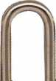

|  |  |
| --- | --- |
| :E  to C*> V v | ! g   * O * fe |
| 1 : :•  ‘ ro. CO '  J *  ^ ‘ '' | ' m - m * l fiu  iJ |

**TRAVEL SENTRY**

CERTIFIED

Recognized by the TSA

Security Window

I lock has been opened

lock not opened

CCL

301 West Hintz Road • Wheeling, IL 60090

Security Products 8OO.733.8588 • Fax: 847.537.l88l • [www.cclsecurity.com](http://www.cclsecurity.com)

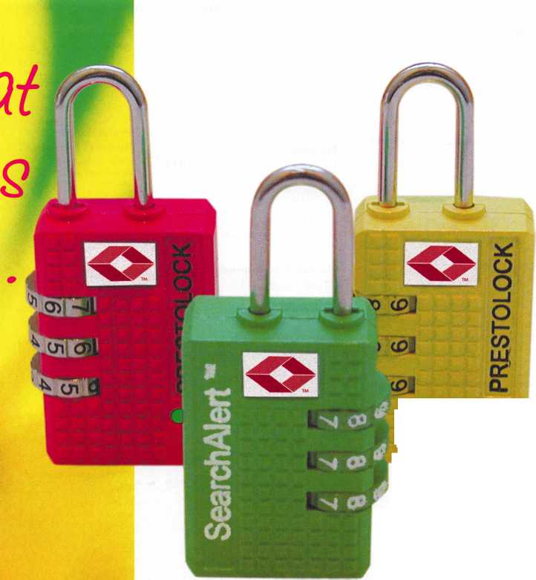

Major

Manufacturing, Inc #1718

1825 Via Burton Anaheim, CA 92806 714-772-5202; 714-772-2302 fax [www.majormfg.com](http://www.majormfg.com) e-mail: [mail@majormfg.com](mailto:mail@majormfg.com) Contact(s): Bill DeForrest

Markar Products Inc #1231

68 Ward Road Lancaster, NY 14086 716-685-4104 OR 800-866-1688,

716-685-3919 fax [www.markar.com](http://www.markar.com) e-mail: [information@markar.com](mailto:information@markar.com) Contact(s): Kathie Miller

Manufacturer—Continuous Hinges, Door Assemblies, Lite Kits, Louvers, Pivots

MARKS USA #1431

5300 New Horizons Blvd.

Amityville, NY 11701

631-225-5400; 631-225-6136 fax

[www.marksusa.com](http://www.marksusa.com)

e-mail: [wjs@marksusa.com](mailto:wjs@marksusa.com)

Contact(s): William Sporre

Manufacturer-Builders Hardware; Electric/Electronic

Security; Lock Devices

Master Lock Company #724

137 W. Forest Hill Avenue Oak Creek, Wl 53154 414-571 -5625 or 800-308-9244 800-308-9245 fax [www.masterlock.com](http://www.masterlock.com) e-mail: [masterlock@mlock.com](mailto:masterlock@mlock.com) Contact(s): Dave Kraninger, Mike Quillin Manufacturer—Lock Devices

Maxcess

Card Systems, Ltd #1017

Flat B, Floo 7, 38 Cha, Wan Kok St.

Tsuen Wan, Hong Kong 800-713-4823 (USA)

852-2419-0116-(Hong Kong) fax [www.maxcess-card.com](http://www.maxcess-card.com) e-mail: [maxcess@netvigator.com](mailto:maxcess@netvigator.com) Contact(s): Bruce Sedley, Dennis Davies Manufacturer-Lock Devices, Electric/Electronic Security

**Medeco**

**High Security Locks # 705**

3685 Allegheny Drive Salem, VA 24153 540-380-5000 or 800-675-7558 540-380-5010 fax [www.medeco.com](http://www.medeco.com) Contact(s): Mignon Smith Manufacturer—Lock Devices

Midwest Wholesale Hardware #612

1000 North Century Ave.

Kansas City, MO 64120 800-821-8527; 888-829-2399 fax [www.midwestwholesale.com](http://www.midwestwholesale.com) Contacts): Leo Czyz Wholesale—Builders Hardware

Mil-Comm

Products, Co, Inc #405

2 Carlton Ave.

East Rutherford, NJ 07073 201 -935-8561; 201 -935-6059 fax Contacts): Gordon Furlong

Monarch, see IR Security & Safety #907

**MUL-T-LOCK USA, Inc #717**

300-1 Route 17 South Lodi, NJ 07644

800-562-3511; 973-778-4007 fax [www.mul-t-lockusa.com](http://www.mul-t-lockusa.com) e-mail: [info@mul-t-lockusa.com](mailto:info@mul-t-lockusa.com) Contacts): Oren Avigdor, Ron Rachlin

Manufacturer—Lock Devices;

High Security Locks & Cylinders

National Auto

Lock Service #412

180-B South Spruce Ave.

South San Francisco, CA 94080 800-954-5454; 650-875-0123 fax [www.laserkey.com](http://www.laserkey.com)

Contact(s): Michael Hyde-Transponder Experts

Manufacturer, Distributor- Automotive; Tools & Supplies; Transponder Experts

Norton Door Controls #605

(An ASSA Abloy Group Co.)

3000 Highway 74 East Monroe, NC 28112 877-974-2255; 800-338-0965 [www.nortondoorcontrols.com](http://www.nortondoorcontrols.com) Contact(s): Yvonne I. Vizcaino Manufacturer-Builders Hardware

Olympus Lock, Inc #524

18424 Highway 99 Lynnwood, WA 98037 206-362-3290; 206-362-3569 fax [www.olympus-lock.com](http://www.olympus-lock.com) e-mail: [info@olympus-lock.com](mailto:info@olympus-lock.com) Contact(s): Mike Donohue Manufacturer—Lock Devices

OSI Security Devices # 929

1580 Jayken Way

Chula Vista, CA 91911

619-628-1000; 619-628-1001 fax

[www.omnilock.com](http://www.omnilock.com)

e-mail: [sales@omnilock.com](mailto:sales@omnilock.com)

Contacts): Rick Rasmussen, John Choi

Electric/Electronic Security

PDQ Manufacturing #830

2754 Creek Hill Rd.

Leola, PA 17540

800-441-9692; 717-656-6892 fax [www.pdqlocks.com](http://www.pdqlocks.com); e-mail: [edpoole@pdqlocks.com](mailto:edpoole@pdqlocks.com) Contact(s): Lisa Rohrer

Builders Hardware

Perma-Vault Safe Co #1708

72 Ash Circle Warminster, PA 18974 800-662-3360 or 215-292-9951 215-293-9952 fax [www.perma-vault.com](http://www.perma-vault.com) e-mail: [sales@perma-vault.com](mailto:sales@perma-vault.com) Contact(s): Norman Bartwink Manufacturer-Safes/Vaults

Peterson

Manufacturing #935

P. O. Box 744 East Rochester, NY 14445 585-385-3896; 585-586-0425 fax Contacts): Ken Persson

Phoenix Safe Int'l #508

P. O. Box 608.

Lebanon, IN 46052

765-483-0954; 765-483-0962 fax

www. phoen ixsafeusa .com

e-mail: [pgolden@phoenixsafeusa.com](mailto:pgolden@phoenixsafeusa.com)

Contacts): Penny Golden, Jeff McQueen, Janet Pape

Distributor— Safes/Vaults

Pop-A-Lock #1700

1018 Harding St. Ste 101 Lafayette, LA 70503 337-233-6211; 337-233-6655 fax Contact(s): Scott Clause

PowerMate/

LP International, Inc #1436

P.O. Box 696, 151 Savannah Oaks Drive  
Brantford, ON N3T 5P9 Canada  
800-697-6283; 519-759-3298 fax  
[www.powermate.info](http://www.powermate.info); email: info@powermate.info

Manufacturer-Material Handling

Professional

Business Products #1617

620 W. Commerce Rd  
Commerce, Ml 48382  
248-360-3979 or 800-355-6322  
248-360-3982 fax  
[www.pbp2000.com](http://www.pbp2000.com)  
e-mail: [sales@pbp2000.com](mailto:sales@pbp2000.com)  
Contact(s): Kristy Emerick  
Distributor—Business Forms, Labels &

Promotional Products

PRO-LOK # 518

655 North Hariton Street

Orange, CA 92868

714-633-0681; 714-633-0470 fax

[www.pro-lok.com](http://www.pro-lok.com)

e-mail: [marshall@pro-lok.com](mailto:marshall@pro-lok.com)

Contact(s): Adam Weinraub, Marshall Daugherty

Manufacturer—Tools & Supplies

**RA-Lock Company #1114**

3570 N. Hwy 67  
Midlothian, TX 76065  
800-777-6310; 972-775-6316 fax  
Contact(s): David Price, Sandi Price

Distributor—Lock Devices; Vending Locks, Truck & Trailer  
Security Devices

**ROFU International**

**Corp #1620**

7107 28th Street East  
Tacoma, WA 98424  
800-ALL-ROFU; 253-922-1728 fax  
[www.rofu.com](http://www.rofu.com); e-mail: [info@rofu.ws](mailto:info@rofu.ws)  
Contact(s): Julie Collins, Ken Erickson  
Manufacturer—Electric/Electronic Security

Recognition Systems, see IR

Security & Safety #907

**Rutherford Controls**

**Int'l Corp-RCI #1136**

2697 International Parkway, Parkway 5

Virginia Beach, VA 23452

519-621-7651; 519-621-7939 fax

[www.rutherfordcontrols.com](http://www.rutherfordcontrols.com)

e-mail: [Kelly.romph@rutherfordcontrols.com](mailto:Kelly.romph@rutherfordcontrols.com)

Contact(s): Kelly McManus

Manufacturer, Distributor- Electric/Electronic Security

SDC #502

3580 Willow Lane Westlake Village, CA 91361 805-494-0622; 805-494-8680 fax [www.sdcsecurity.com](http://www.sdcsecurity.com); e-mail: [service@sdcsecurity.com](mailto:service@sdcsecurity.com) Contact(s): Dwayne Johnson, Kelly Boyce Manufacturer-Electric/Electronic Security SDC's new products include the Selectric Series, electrifi­cation of major brand locksets, the PTH Electric Hinge, UL listed for fire rated doors. SDCs new Website also pro­vides complimentary system drawings, System Design Wizard, your personal Project Folders and online RFQ capability.

Safe & Vault Technicians Association (SAVTA) #1728

3500 Easy Street

Dallas, TX 75247

214-819-9771

214-819-9736 fax

[www.savta.org](http://www.savta.org);

e-mail: [dialcenter@aol.com](mailto:dialcenter@aol.com)

Contacts): Mike Oehlert

Safe Technicians Trade Association

**Sargent &**

**Greenleaf, Inc #1415**

One Security Drive  
Nicholasville, KY 40356  
859-885-9411, 859-885-3063 fox  
[www.sglocks.com](http://www.sglocks.com)  
e-mail: [sales@sglocks.com](mailto:sales@sglocks.com)  
Contacts): Phil Pitt, Ned Urschel  
Manufacturer—Lock Devices

**SARGENT Manufacturing  
Company #807**

100 Sargent Dr.

New Haven, CT 06511

203-562-2151

www. sargentlock. com

Contact(s): Tom Mayer, Heidi Pascale

Manufacturer—Builders Hardware; Electric/Electronic

Security; Lock Devices

Schlage Lock, see IR Security &

Safety #907

**SCHWAB Corp #1211**

110 Professional Ct.

Lafayette, IN 47905

765-447-9470; 765-447-8206 fax  
[www.schwabcorp.com](http://www.schwabcorp.com)  
e-mail: [rlashbrook@schwabcorp.com](mailto:rlashbrook@schwabcorp.com)  
Contact(s): Ron Lashbrook

Manufacturer-Safes/Vaults, Fire-resistant files,  
media & record cabinets

**Securifort, Inc #1333**

45 Cayouette

Tingwick, Quebec, Canada JOA 1LO  
819-359-2226; 819-359-2218 fax  
Contact(s): Carol Evans

Securitech Group, Inc #624

54-45 44th Street  
Maspeth, NY 11378  
718-392-9000; 718-392-8944 fax  
Contacts): Mark Berger

Electric/Electronic Security

**Securitron #611**

550 Vista Blvd.

Sparks, NV 89434  
800-624-5625; 775-355-5636 fax  
www. securitron .com  
Contact(s): Mark McBroom  
Manufacturer—Electric/Electronic Security

**Security**

**Distributors Inc #1130**

8901 Chancellor Row  
Dallas, TX 75247-5363  
214-879-1555; 214-879-1525 fax  
Contact(s): Howard Johnsen, Paul Justen

Distributor-Automotive; Builders Hardware;  
Electric/Electronic Security; Lock Devices; Tools &  
Supplies; Safes/Vaults

**Security**

**Lock Distributors #1030**

40 A Street/PO Box 815  
Needham Heights, MA 02194  
800-847-5625, 800-878-6400 fax  
Contact(s): David Schwartz



Keynotes • July/August 2005

Select Hinges/

Select Products Limited ....#401

9770 Shaver Road  
Portage, Ml 49024  
269-323-4433; 269-323-3815 fax  
[www.select-hinges.com](http://www.select-hinges.com)  
e-mail:[kenl@select-hinges.com](mailto:kenl@select-hinges.com)  
Contacts): Ken Loffredi, Bob Cronk  
Manufacturer—Continuous hinges

Southwest

Specialty Products # 1131

2710 W. Cheery Lynn Road  
Scottsdale, AZ 85260  
602-307-0901; 602-307-0909 fax  
[www.cansafe.net](http://www.cansafe.net); e-mail: [sspecialty@qwest.net](mailto:sspecialty@qwest.net)  
Contact(s): Sandy Patchefsky  
Manufacturer—Can Safes

Steelcraft, see IR Security &

Safety #907

**STRATTEC**

**Security Corp #723**

3333 W. Good Hope Road  
Milwaukee, Wl 53209  
414-247-3333; 414-247-3564 fax  
[www.aftermarket.strattec.com](http://www.aftermarket.strattec.com)  
e-mail: [jbaker@strattec.com](mailto:jbaker@strattec.com)  
Contact(s): Jeff Baker  
Manufacturer-Automotive

Strong Arm

Security Inc #1619

2228 Kenry Way

So. San Francisco, CA 94080

650-952-7710; 650-794-0541 fax

[www.strongarmdrills.com](http://www.strongarmdrills.com); e-mail: [jvdrills@aol.com](mailto:jvdrills@aol.com)

Contact(s): Jeff Volosing

Manufacturer, Distributor-Tools & Supplies; Safecracker drill  
bits and Drill Rigs

Supra Products, Inc #1411

4001 Fairview Industrial Drive SE,

Salem, OR 97302  
800-547-0252  
Contact(s): Rick Boes

Taymor Insdustries #306

14809 N. 73rd Street Ste 102  
Scottsdale, AZ 85260  
480-607-9040  
[wmessing@taymor.com](mailto:wmessing@taymor.com)  
Contact!s): Wayne Messing

Telexper, Inc #1518

33235 Transit Avenue  
Union City, CA 94587  
510-477-9150; 510-477-9655 fax  
Contact(s): Keither Delorio

The Determinator #400

P.O. Box 895  
Ocoee, FL 34761

800-561-0443; 407-884-6730 fax  
email: [determinatortom@aol.com](mailto:determinatortom@aol.com)  
Contact)s): Tom Tusing

Manufacturer-Automotive

**The Locksmith Store # 1228**

1229 E. Algonquin Rd Unit E.

Arlington Heights, IL 60005  
847-364-5111  
Contact(s): Josh Swiderek

The National

Locksmith #1127

1533 Burgundy Parkway  
Stream wood, IL 60107  
630-837-2044; 630-837-1210 fax  
Contact(s): Marc Goldberg

**Timemaster, Inc #1501**

157 Venture Court Suite 9  
Lexington, KY 40511  
888-798-8464; 800-798-8463 fax  
[www.time-master.com](http://www.time-master.com)  
Contacts): Tim Abner  
Distributor

**Townsteel, Inc #1510**

1611 W. San Bernardino Rd #D Covina, CA 91722 626-858-5080; 626-858-3393 fax [www.townsteel.com](http://www.townsteel.com); e-mail: [sales@townsteel.com](mailto:sales@townsteel.com) Contacts): Dennis Ma, Jessie Chu Manufacturer-Electric/Electronic Security; Lock Devices; Safes/Vaults

Triplett #514

One Triplett Drive.

Blufton, OH 45817

419-359-5015; 419-358-7956 fax

Contact(s): Ted Suever

**Turn 10 Wholesale #1029**

P.O. Box 746, Marietta, OH 45750 800-848-9790; 800-391-4553 fax [www.turnten.com](http://www.turnten.com); e-mail: [sales@turnten.com](mailto:sales@turnten.com) Contact(s): Andy Miller

Wholesale-Safes/Vaults

**U.S. Lock #1116**

77 Rodeo Drive Brentwood, NY 11717 631-243-3000; 631-243-0275 Fax [www.uslock.com](http://www.uslock.com); e-mail: [keuler@uslock.com](mailto:keuler@uslock.com) Contact(s): Kathy Euler, Alex Puccio Distributor—Alarms; Bank security equipment; Automotive; Builders Hardware; Business/Technical & Educational; CCTV/Photo imaging; Electric/Electronic Security; Lock Devices; Tools & Supplies; Safes/Vaults

Ultra Lift Corporation ....#1607

475 Stockton Avenue Unit E San Jose, CA 95126 800-346-3057; 408-297-1199 fax Contact(s): George W. Dabb

Victor E-Lok, Inc #1316

15520H-1 Rockfield Blvd.

Irvine, CA 92618

949-916-1200; 949-916-1300 fax

Contacts): Jimmy Yu

Manufacturer

**Videx, Inc #1324**

1105 NE Circle Blvd.

Corvallis, OR 97330 541-758-0521; 541-752-5285 fax [www.videx.com](http://www.videx.com); e-mail: [sales@videx.com](mailto:sales@videx.com) Contact(s): Tish Phillips-Marketing Mgr.

Manufacturer—Electric/Electronic Security

Von Duprin, see IR Security &

Safety #907

**Wilson**

**Safe Company #1334**

3031 Island Ave, P.O. Box 5310 Philadelphia, PA 19142-0310 800-345-8053; 215-492-7104 fax [www.wilsonsafe.com](http://www.wilsonsafe.com); e-mail: [info@wilsonsafe.com](mailto:info@wilsonsafe.com) Contact(s): Ray Wilson Manufacturer-Safes/Vaults

**Yale Commercial Locks and Hardware #605**

(An ASSA Abloy Group Co.)

100 Yale Avenue Lenoir City, TN 37771 800-438-1951; 800-338-0965 fax [www.yalecommercial.com](http://www.yalecommercial.com) Contacts): Yvonne I. Vizcaino Manufacturer—Alarms; Builders Hardware; Electric/Electronic Security; Lock Devices

ZIPF Lock Co #1432

830 Harmon Ave Columbus, OH 43223 800-848-1577; 800-228-6320 fax [www.zipflockco.com](http://www.zipflockco.com); e-mail: [zipflockco@aol.com](mailto:zipflockco@aol.com) Contacts): Rick Zipf, Don Chandler, Don Burson Wholesale, Distributor—Automotive; Builders Hardware; Business/Technical & Educational; Electric/Electronic Security; Lock Devices; Tools & Supplies.

Get What's  
Coming To You

AIOA continues to provide you with this

Need information in a hurry?

Use AlOA’s Fax On Demand se

Just call 310-575-5074 and receive

1. ALOA Index of Documents
2. Becoming a Locksmith (1 pg)
3. Locksmith Career Summary (3pg)
4. Locksmith School List (2pg)
5. ACE Class Schedule (8pg)
6. Certification lnformation(3pg)
7. PRP Category List (Ipg)
8. ALOA Membership Application(2pg)
9. ALOA List of Benefits (1 pg)
10. Scholarship Application Form (Ipg)
11. ALOA Video Library Order
12. ALOA Membership Items  
    Order Form (Ipg)
13. Safe & Vault Technicians Association  
    Member Application/Subscription  
    Form (2pg)
14. ALOA Chapter Roster (3pg)
15. Legislative Action Network (2pg)
16. Legislative Action Network  
    Newsletters (Ipg)
17. Various State Laws (lOpg)
18. Industry Position Pager (Ipg)
19. Current Legislative Action Network  
    Newsletters (Ipg)

120. Board of Directors Nomination

Form (2pg)

ALOA Convention Registration

ALOA Board Expense Reimbursement &

Request Form

■

**pit®**

ifliip

¥ ft

H

ms

310-575-5074

Keynotes • July/August 2005

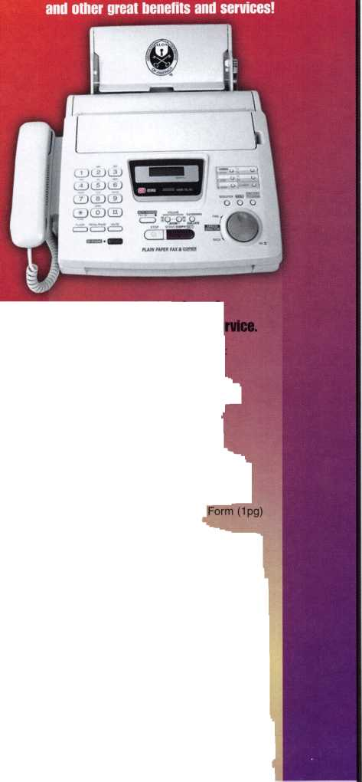

Rochester Institute of Technology Key System Graduates to New Level

in progress will replace a 20-year old second-generation key  
system with a Schlage Everest high-security key system.

RIT, founded in 1829, is an internationally recognized  
leader in professional and career-oriented education. It  
enrolls more than 15,000 students in eight colleges and  
awards degrees at all undergraduate and advanced levels.

Gordon Field House and Activity Center is one of the buildings at Rochester Institute of Technology with locks that are being upgraded to Schlage Everest high security keyways.

Another view of the Gordon Field House and Activity Center that now incorporates Schlage Everest interchangeable core lock cylinders for patent-protected security.

A new high-security key system is bringing improved secu­rity and consistent key control to more than 190 buildings on the 1,300 acre main campus of the Rochester Institute of Technology (RIT). An extensive re-keying program now

The campus encompasses more than 190 buildings, includ-

ing academic, athletic and residence units. It requires the  
customary safety and security needs for personnel, student,  
payroll, and health records. In addition, the campus col-  
leges house various sponsored research programs that  
require specialized secure access for proprietary processes  
and equipment. RIT has in excess of 14,000 doors, includ-  
ing keyed and non-keyed, in its academic buildings and res-  
idence halls, excluding apartments.

Originally, the campus had a combination of two different  
key systems, which had become compromised over the  
years. Approximately 20 years ago, a single system was  
introduced for the residence halls and was subsequently  
rolled out across the campus. This allowed RIT to regain  
better control of the two compromised systems and provid-  
ed the added flexibility of a removable core system.

Recently, RIT began implementing a new-generation  
patent-protected keyway that will ensure future security by  
preventing unauthorized key duplication. The Schlage  
Everest key system is a high-security system, with factory-  
controlled distribution of key blanks. Combined with the  
protection of patent law, this prevents unauthorized indi-

viduals from obtaining key blanks at mall key shops or

hardware stores and keeps key control within RIT.

Jan Reich, Associate Director, Facilities Management  
Services at RIT explains, “Schlage offered high security key-  
ing with the addition of a patented key/core system. While  
price was one determining factor, system versatility was the  
biggest selling point.” He notes that the Schlage core sys-  
tem is compatible with the majority of the existing locksets  
on campus, which makes it possible to re-core instead of  
replace them at most locations. He states, “This compati-  
bility saves us the material cost as well as the labor cost for

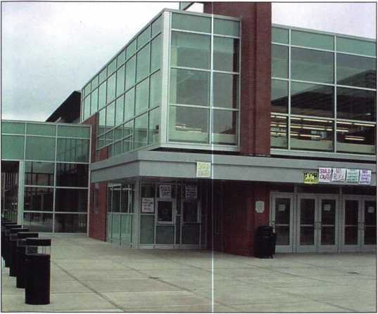

Keynotes • July/August 2005

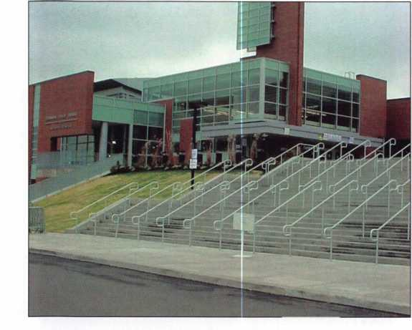

each installation. The system also afforded us the ability to design a long-term solution that antici­pates future campus growth.”

The key system is managed by RIT’s Facilities Management Services and its Lock Shop. The Lock Shop has formulated a campus-wide keying matrix that accommodates both security and access control needs. It allows a group of Area Key Control Coordinators to manage area authorization while retaining centralized control of all key and core work. The keying matrix is a detailed hierarchy that provides single universal key access to meet the Life/Safety requirements of the Campus Safety Department, as well as a descending master key system that is distributed across campus housing and academic units.

Reich says that a significant benefit of the new system is its potential for eliminating compro­mised key systems, some of which are more than 30 years old. He notes that Schlage has provided RIT with a Systems Design Consultant to assist in planning the changeover. He adds, “Mechanically, the Schlage system also has a smoother keyway operation, and the key itself has a larger head, which makes it easier for our users to operate.”

The Schlage Everest key system will be applied exclusively in all new construction, according to Reich, as well as in areas of major retrofit. In addition, RIT uses other IR products extensively, including LCN door closers and Von Duprin exit devices. For ADA-compliant entrance accessibili­ty, LCN Senior Swing power door operators are also being tested.

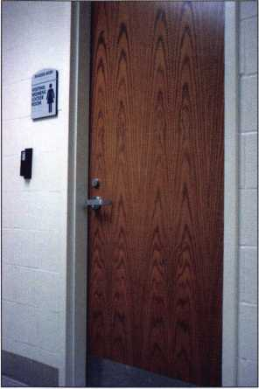

Typical interior door has an interchangeable core cylinder that has been upgraded with a minimum of expense and labor.

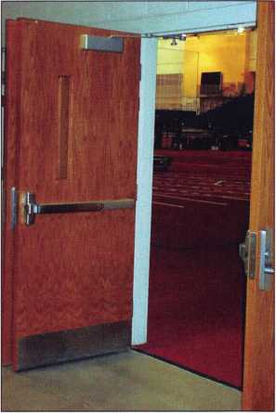

Pairs of doors incorporate the new keyway in the outside trim, while Von Duprin 98 Series exit devices inside provide safe egress and LCN door closers control the door’s operation.

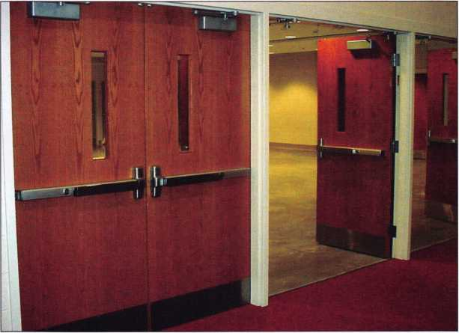

Pairs of cross-corridor doors include Von Duprin exit devices with keyed cylinders for dogging.

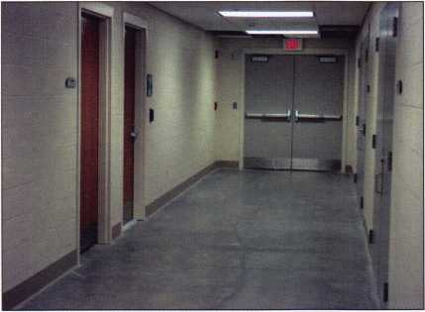

Fire exit doors with Von Duprin exit devices and LCN closers are located in the egress path at the end of this hallway.

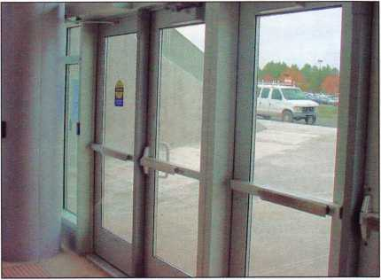

LCN Senior Swing door operator provides access for people with disabilities on the door at the rear of photo, while LCN door closers are used on the other entrances.

Meet the NEW ALOA Board of Directors

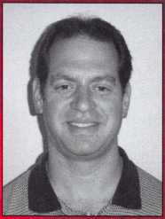

**PRESIDENT**

Robert Mock

SECRETARY

John Soderland

SOUTH

CENTRAL

REGION

DIRECTOR

NORTH CENTRAL SOUTH REGION EAST

DIRECTORS

Bill Smith, RL

NORTH

WEST

REGION

DIRECTOR

CD Lipscomb, CML, CPS

REGION

DIRECTORS

SOUTHWEST REGION DIRECTORS

r

Ken Kupferman, CRL

Julie McCluneyj CRL

i

Tom Gillingham

ASSOCIATE DIRECTOR

Gordon Racine

NORTH EAST REGION DIRECTORS !

Jim Jeffries

Paul Justen

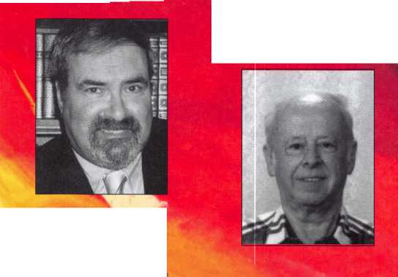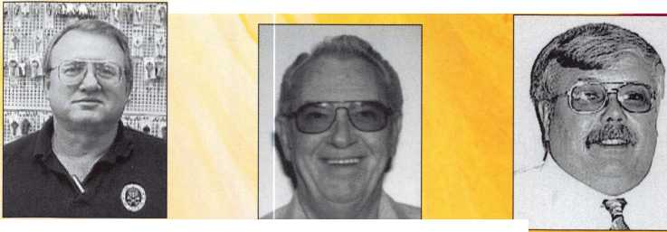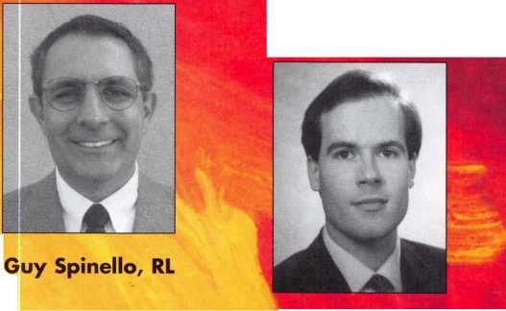

KABA

Attention Locksmith Field Agents!

Your Mission:

Uncover new time saving, profit making  
products and services at the ALOA Show.

Field research coordinates:

Booth 1105, Hall F, Donald E Stephens  
Convention Center, Rosemont, II

Mission support coordinates:  
[www.kaba-ilco.com/](http://www.kaba-ilco.com/) mission

User Name:  
locksmith

Password:

profit

For your eyes only:

Kaba Access Control, Kaba Mas and ILCO have set up a field-agent training center at ALOA. Uncover the latest Kaba security products, technology enhancements and specialized, hi-tech gizmos specifically designed for the security professional. Training classes for mission specialists are available through ALOA.

Can't break cover to visit ALOA? Then log on to

[www.kaba-ilco.com/mission](http://www.kaba-ilco.com/mission) and enter the user name and password given above. Your mission support site will provide need to know detail on all mission critical products and services.

**Look in your ALOA registration bag for mission instructions.**

**KARA**

**Kaba Americas**

[www.kaba-ilco.com](http://www.kaba-ilco.com)



New Lower Prices  
on Select Floor,  
Fire, CBF and  
Depository Safes!

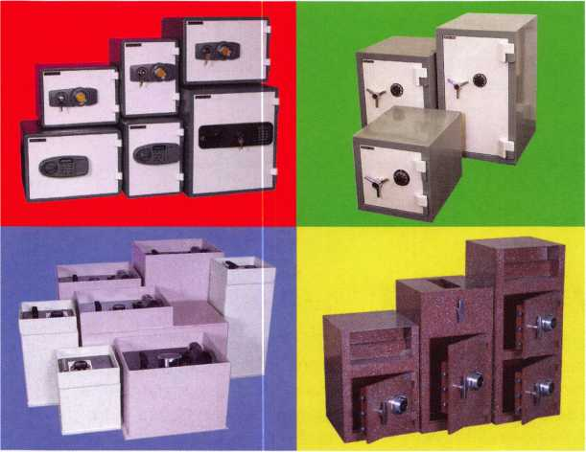

Beginning May 1st, you can find substantial savings on our most popular models. Adesco continues to lead the way in offering superior quality at a better price. I invite you to call your local distributor and visit our website for your new lower price.

manufacturing co.

Call your Adesco distributor today.

(800) 694-9340 • [www.adesco.com](http://www.adesco.com) • [safes@adesco.com](mailto:safes@adesco.com)

Q Keynotes • July/August 2005

**NORTH**

**EAST**

**REGION**

**DIRECTORS (cont.)**

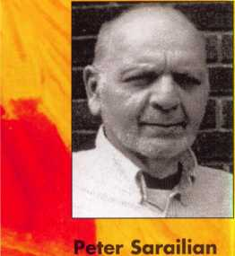

**TRUSTEES**

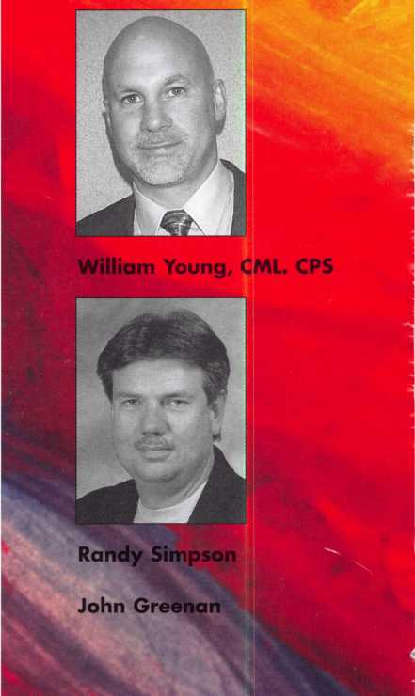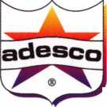

***OPERATOR SAFETY***

Injuries can be virtually eliminated. Ultra Lift does the lift­ing so that operator effort required to complete a move is minimized. Heavy loads are broken back with ease. The operator stays in control by using a combination of motor power, balance and leverage in every phase of a move.

***REDUCE LABOR COSTS***

Fewer people are required for any move with Ultra Lift. Manpower can be scheduled more productively. Labor savings often pay for the Ultra Lift in one month.

***ELIMINATE DAMAGE***

Loads are broken back, set down and moved under power with maximum leverage and operator control. Gentle handling eliminates bumps, bounces and damage to the load and premises.

***INCREASE PROFITS***

Increased operator safety, reduced labor cost and elimina­tion of damage to the load and premises all contribute to significant increases in profits.

FOR LITERATURE, VIDEO OR ON-SITE DEMONSTRATION, WRITE OR CALL:

ULTRA LIFT CORPORATION

475 STOCKTON AVENUE, UNIT E SAN JOSE, CA 95126 800-346-3057 408-287-9400 FAX 408-297-1199 E-mail: [info@ultralift.com](mailto:info@ultralift.com) [www.ultralift.com](http://www.ultralift.com)

ULTRA LIFT supplies the power — so you don't have to. One person can safely and easily handle loads that usually require 2 or 3 people, even up or down stairs. Two people can handle most safes to 1500 pounds. If safety is your concern, ULTRA LIFT is the best move you'll ever make!

U.S. PATENT 4.570.953

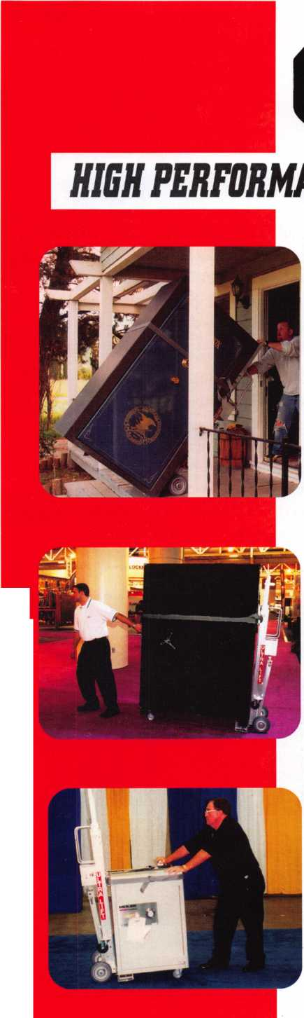

A Couple More Group 2M Locks

By: Greg Perry, CML, CPS

Last month, we looked at a new Group 2M lock from LaGard. This month, let s look at its predecessor, a Group 2M lock from Sargent and Greenleaf. First, what is a Group 2M lock? Let us look quickly at what each classifica­tion means. There are four classifications of mechanical combination locks from Underwriters Laboratories Standard 768.

The basic principle of a radiological attack that and x-ray is taken of the lock after all wheels have been turned to the left and the dials has been set at (0). The gates of metal wheels will then show up on the x-ray. Knowing the location of the dial in relation to the three wheel gates enables one to deter­mine the combination.

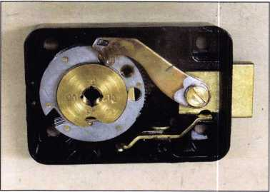

First, is the Group 2 classification. This is the most com-  
mon lock used in quality safes. The standard requires each  
lock to have, theoretically, a million possible combinations.  
In reality, they offer combinations in the range of 200,000.  
Next, the lock must not open when the combination is  
dialed more than 1 1/4 numbers or dial graduations. It  
must also offer a moderate degree of resistance to manipu-  
lation. Group 2M adds a requirement of 2-hour resistance

to expert manipulation. Group 1 locks  
must resist expert manipulation of 20  
hours. Finally, Group 1R locks, in addi-  
tion to the 20 hours of expert manipula-  
tion, must also resist radiological attack.

Not listed by UL, but commonly found are the non-rated locks. These are typically found in less-expensive safes like Sentry, Center Manufacturing and many imported fire safes. They can also be found in much older safes with locks manufactured by Yale, Herring Hall Marvin, or Eagle, Moving a screw, changing a driver location or using some other method to change the combination, if possible, typi­cally changes the combinations of these locks.

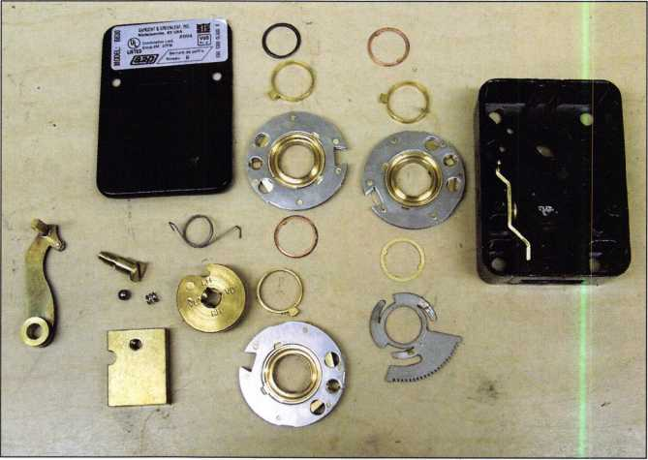

Photo 1 shows an S&G 6630 with the  
back cover removed.

Photo 2 shows the S&G lock disassembled.

Keynotes • July/Augusst 2005

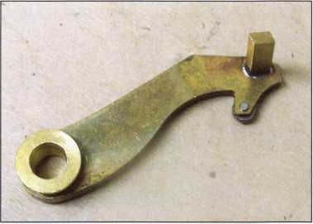

Photo 3 shows a close-up view of the roller  
on the end of the lever nose.

At first glance, the Sargent & Greenleaf 6630 Group 2M looks very similar to the 6730 Group 2 lock. The dial, dial ring, case, bolt, relock, torque adjuster, drive cam and flies are all the same. The difference appears in the wheels and nose of the lever. The wheels have two false gates and the lever nose has a roller that prevents consistent readings during manipulation. Service on this lock should be done anytime the combination is changed, or at least once a year. Service should include a complete disassembly and cleaning. Then, a fresh application of AeroShell 22 should be applied on bearing surfaces to lubricate the lock.

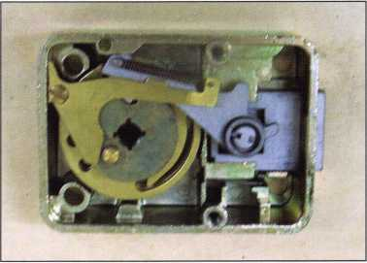

Photo 4 shows the LaGard 3332 lock  
with the back cover removed.

Dow Corning Gn Metal Paste and Novagard G322L (for­merly a GE product) have been used in the past by S&G to lubricate their locks. The general rule is “If you see the lubricant then you’ve put too much on”.

LaGard’s 3332 is also a Group 2M lock. It looks very simi­lar to the model #1985 Group 1 lock. This lock uses a simi­lar design to the 3370 lock profiled last month. The drive cam has a bearing on the backside that interacts with lever actuator to pull the fence lever assembly into the wheel pack when the correct combination is dialed. The lever is

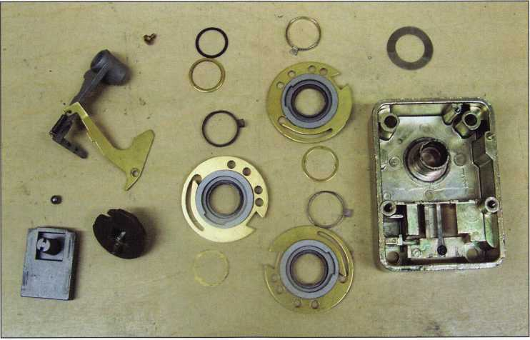

Photo 5 shows the LaGard lock disassembled.



Keynotes • July/August 2005

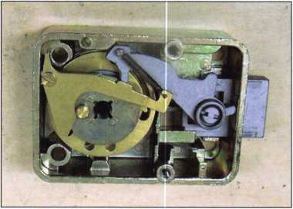

Photo 6 shows the LaGard lock with the drive cam bear-  
ing against the lever actuator, attempting to pull the lever  
assembly into the wheel pack.

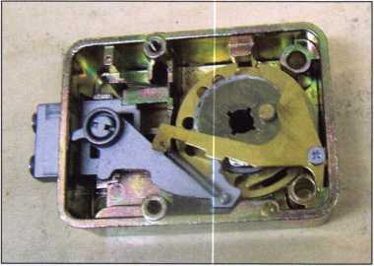

Photo 7 shows the wear on the drive cam of a lock from  
an ATM. This wear makes the dial feel  
very gritty as it is turned.

\

You need it When?

**How about now!? :-)**



also missing the lever spring. The balance of the lock is the same as their 3330 Group 2 lock. IVe seen a few problems with this lock. The original bearing was plastic. Over time, a flat spot is worn on the bearing and it no longer turns smoothly. It feels very gritty, as the drive cam engages the lever actuator. The solution is either to replace the actua­tor and drive cam or replace the complete lock. IVe also seen the edge of the drive cam wear off.

LaGard has never recommended a lubricant for their locks. This means the service will include dis­assembly and cleaning but no lubricant.

Dialing the combination on these locks is the same process as most Group 2 locks, dial left 4 turns to the first number, dial right 3 turns to the second number, dial two turns left to the third number, then finally back to the right to the stop. Drilling them open is also the same process; 7/8” out from center of dial at 97 for a RH mounted lock. The relock triggers are also in the same location as their Group 2 cousins. S&G is located 1 1/8” out from center of dial at 62, LaGard is located 1 3/8” out from center of dial at 58.

Group 2M locks and higher will be used primarily on TL-15, TL30 and higher-rated safes, although many gun safe manufacturers are installing the locks on their “B” rate gun safes. If you haven’t seen them on a container yet, you will.

Another Special  
Value-added Benefit to your

ALOA Membership! Click here...

iL

[www.clearstar.com/ALOA](http://www.clearstar.com/ALOA)

Keynotes • July/August 2005

IN THE WAR ON CRIME, YOU DON'T NEED A PADLO YOU NEED AN ARSENAL

You’re constantly fighting crime on many fronts. That’s why we manufacture a complete line of commercial padlocks, each one tough enough to be called a Master Lock. It’s the name trusted the world over for quality padlock security. Whether you’re battling theft, unauthorized entry or the elements, we can arm you with a solid solution for any industrial application, even safety lockout. So make our commercial line your Wttt

first line of defense. For more information, contact your local

distributor, or call 1-800-308-9244.

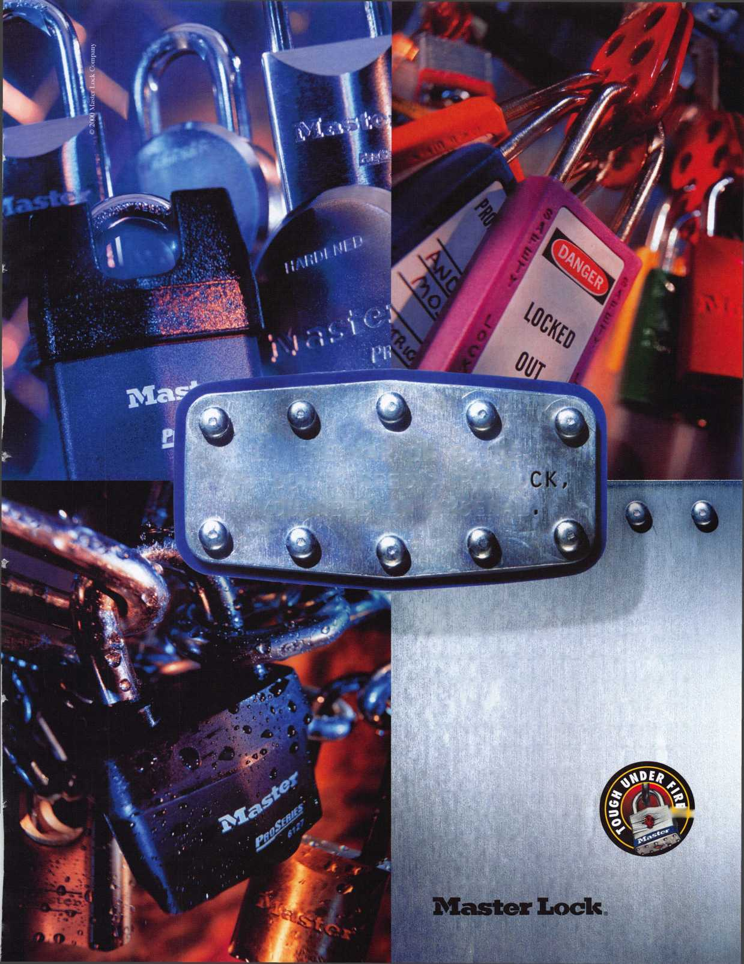

Restricted keyway offers flexible option for hardware upgrades

Taking the security capability of electric key  
switches one step further, Dortronics Systems,

Inc., offers an optional high security cylinder for  
its 5240 Series Electric Key Switches. The new  
device, model 5241-K65-HS High Security Key  
Switch, is keyed per order and may only be  
duplicated with authorized customer approval. It  
is ideal for use by customers who need an extra  
measure of security without implementing an

entirely new system. The concept for the 5241-K65-HS High Security Key Switch resulted from one of the cus-  
tom orders frequently fulfilled by Dortronics.

"Our new high security key switch option offers an additional level of protection in maintaining the integrity of a restricted area because they keys cannot be readily duplicated," said John FitzPatrick, Vice President, Dortronics Systems, Inc. "It's a versatile and cost-effective solution for both the installer and the customer."

The 5241-K65-HS High Security Key Switch is available in a variety of models, including two gang and one gang plates for flush wall or surface box mounting and narrow plate for hollow metal or aluminum door frames.

Key operation comes standard as one position, key removable, with SPDT K65 contact output.

t

Available options include a push button with SPDT P-15 or DPDT P-25 contact outputs, and an LED option with choice of bicolor and pushbutton features.

The switch contacts are rated for 3 amps at 115VAC or 28VDC and the LED is rated at .02 amps at 24VDC. Installed 5240 Series Electric Key Switches, designed to restrict the use of electrically operated entrance con­trol systems, alarms, electric locks and other devices to key carrying personnel, can be retrofitted with the new restricted keyway.

Dortronics1 flexible and state of the art manufacturing capabilities make it possible for the company to offer the high security key switch in the variety of options, as well as with custom engraved graphics on the brushed stainless steel plates.

For more information on Dortronics extensive line of access control products, call toll free 1-800-906-0137, e-mail [sales@dortronics.com](mailto:sales@dortronics.com) or visit their web site [www.dortronics.com](http://www.dortronics.com).

Dortronics Systems, Inc. is the industry's "quick-ship" supplier of standard and custom finish access control products including electromagnetic locks; power supplies; key switch controls; pushbutton controls; digital key­pad controls; delayed egress controls; annunciators and controllers; high security locks; motion sensing door releases; and emergency pull stations.

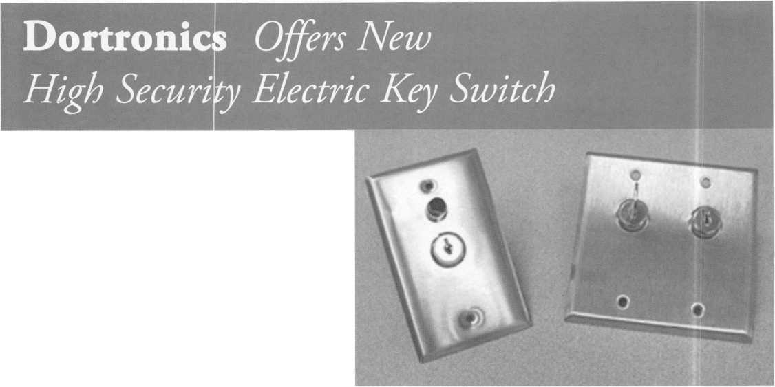

**GflTE$ = DOOR$ TO  
GREATER PROFITS**

Innovative Child Safety Gate Latch

* # 1 child safety gate latch in the world!
* Award-winning, patented magnetic technology
* Unprecedented safety, reliability & child resistance
* Self latching and key-lockable

The Ultimate Security Gate Latch

Just one of the security products in our range, the innovative Lokk»Latch PRO® is the most sophisticated privacy and security gate latch ever devised. It is **the** privacy latch that locksmiths and security businesses have been raving about!

* Locks and operates from either side of the gate
* Durable polymer and stainless steel = no rust
* Effective for residential and commercial gates
* Rekeyable 6-pin lock can be master-keyed or maison-keyed
* Lock can be replaced with a high-security cylinder
* No mechanical interference to closure
* Horizontal and vertical adjustability
* Tested to 400,000 cycles

***When you do a s***afel***y audit  
rememb***er that gat***es are  
additional doors*** to ***greater p***rofits!



**10)**

D&DTechnologies

7731 Woodwind Drive, Huntington Beach, CA 92647

Tel: (800) 716-0888 Fax: (800) 464-6400 E-mail: [info@ddtechusa.com](mailto:info@ddtechusa.com) Web: [www.ddtechglobal.com](http://www.ddtechglobal.com)

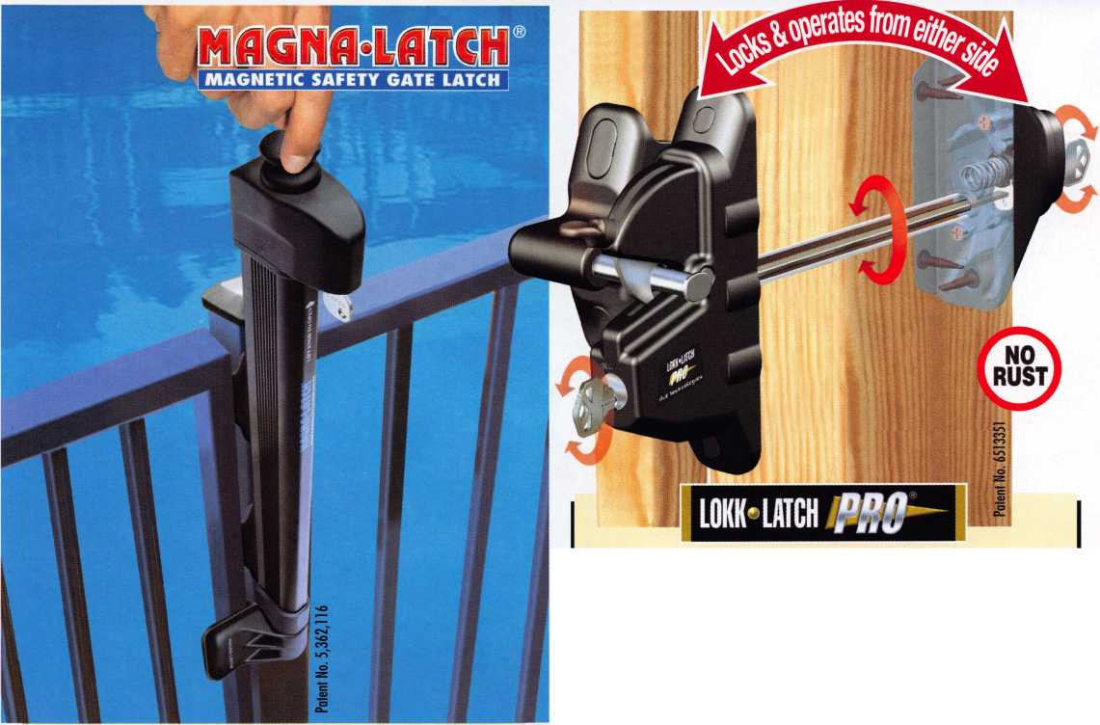

**IBS tf EGAS**

|  |  |
| --- | --- |
| 1 1 | m r Jm\ |
| 1 1 | 1 |

£ver V

b0dV **Wa«fs it- You MIGHT TAKE**

IT HOME!

One Lucky Member Attendee at ALOA  
2006 is going home with this gorgeous  
mint-condition 1956 Ford Thunderbird.

A ticket will be given to each ALOA

Member who registers and attends the  
show. Someone has to win it, and it  
might as well be YOU!

(Must be present to win. Exhibitors,  
Employees. Family Members of Employees, and  
nonmembers are not eligible for this door prize.)

*

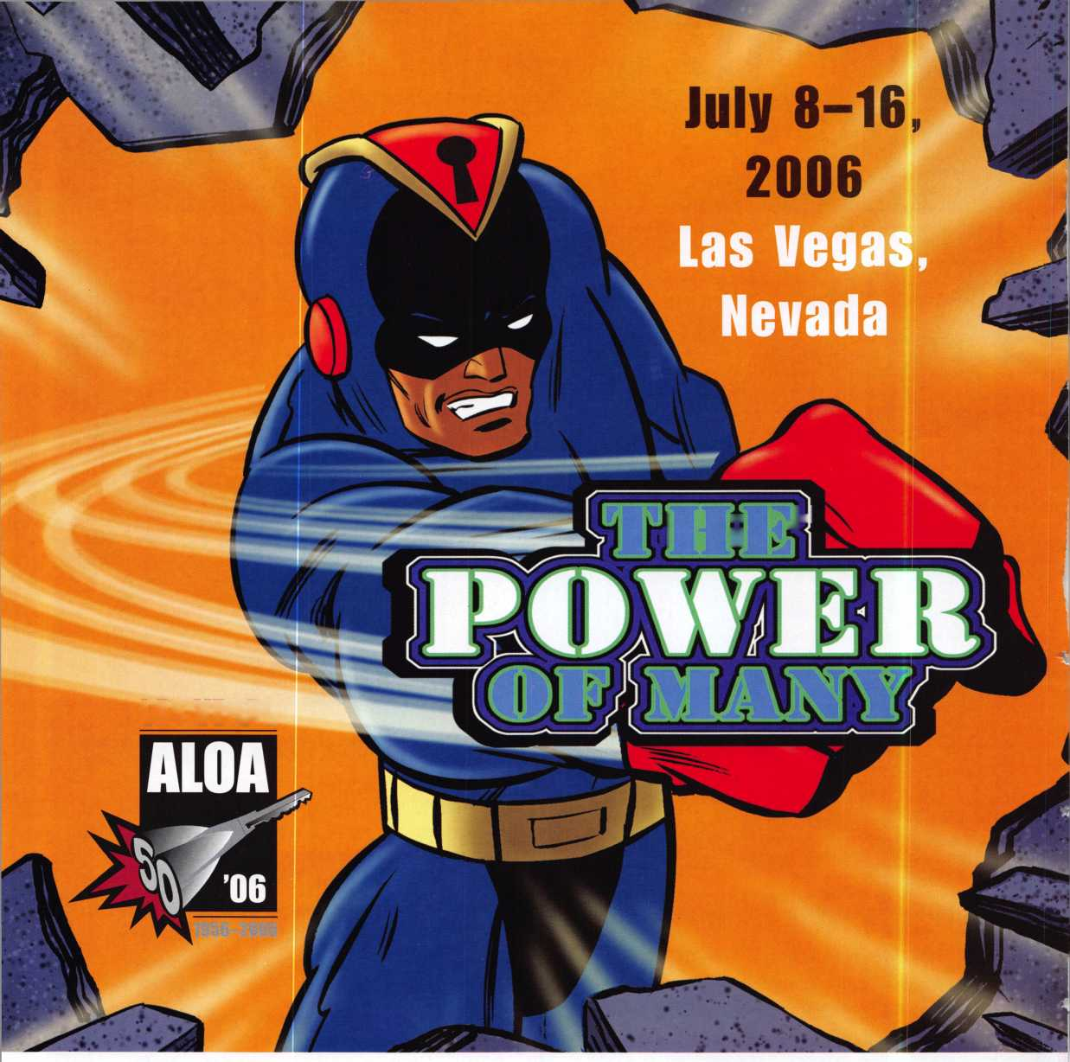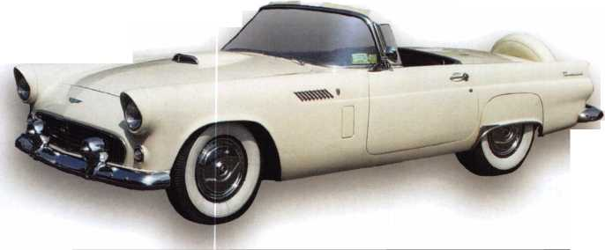

ROTORS

OlSfRl

w'e Know

ssr'sSS-

ss£ias3?

SSfe!3”

NOTCH-aLB

sag

JJS

•.//stagrq^

SeTndustrvtor

3»**

needs

**,nctse«mt>«ty'**

■I

Hi

inwmet

servingV^

2005

Customer

wwsSSft

842 page

TND Product Catalog now availabe online!

Top Notch Distributors, Inc.

At Top Notch Distributors, We Know Service is our commitment to providing everything you expect in architectural hardware — plus an ever-increasing array of value-added benefits.

Click on our new Web site — [www.topnotch.bz](http://www.topnotch.bz) — and you’ll see what we mean. Our home page is your gateway to a lineup of totally interactive features:

* Product catalog — listed by manufacturer and viewable as an Adobe Acrobat PDF.
* Credit application, order form, resale form and other customer support documents.

There’s more ... a lot more. As a customer, a password will connect you with promotions geared specifically for your business and will enable you to view our current inventory. To receive a customer password, contact New Accounts at 800-233-4210. It’s all at [www.topnotch.bz](http://www.topnotch.bz) - a site for your eyes.

Serving North America

East

Pennsylvania

1-800-233-4210

Midwest

Missouri

1-800-211-4607

West

Nevada

1-800-722-4210

[www.topnotch.bz](http://www.topnotch.bz)

[sales@topnotch.bz](mailto:sales@topnotch.bz)

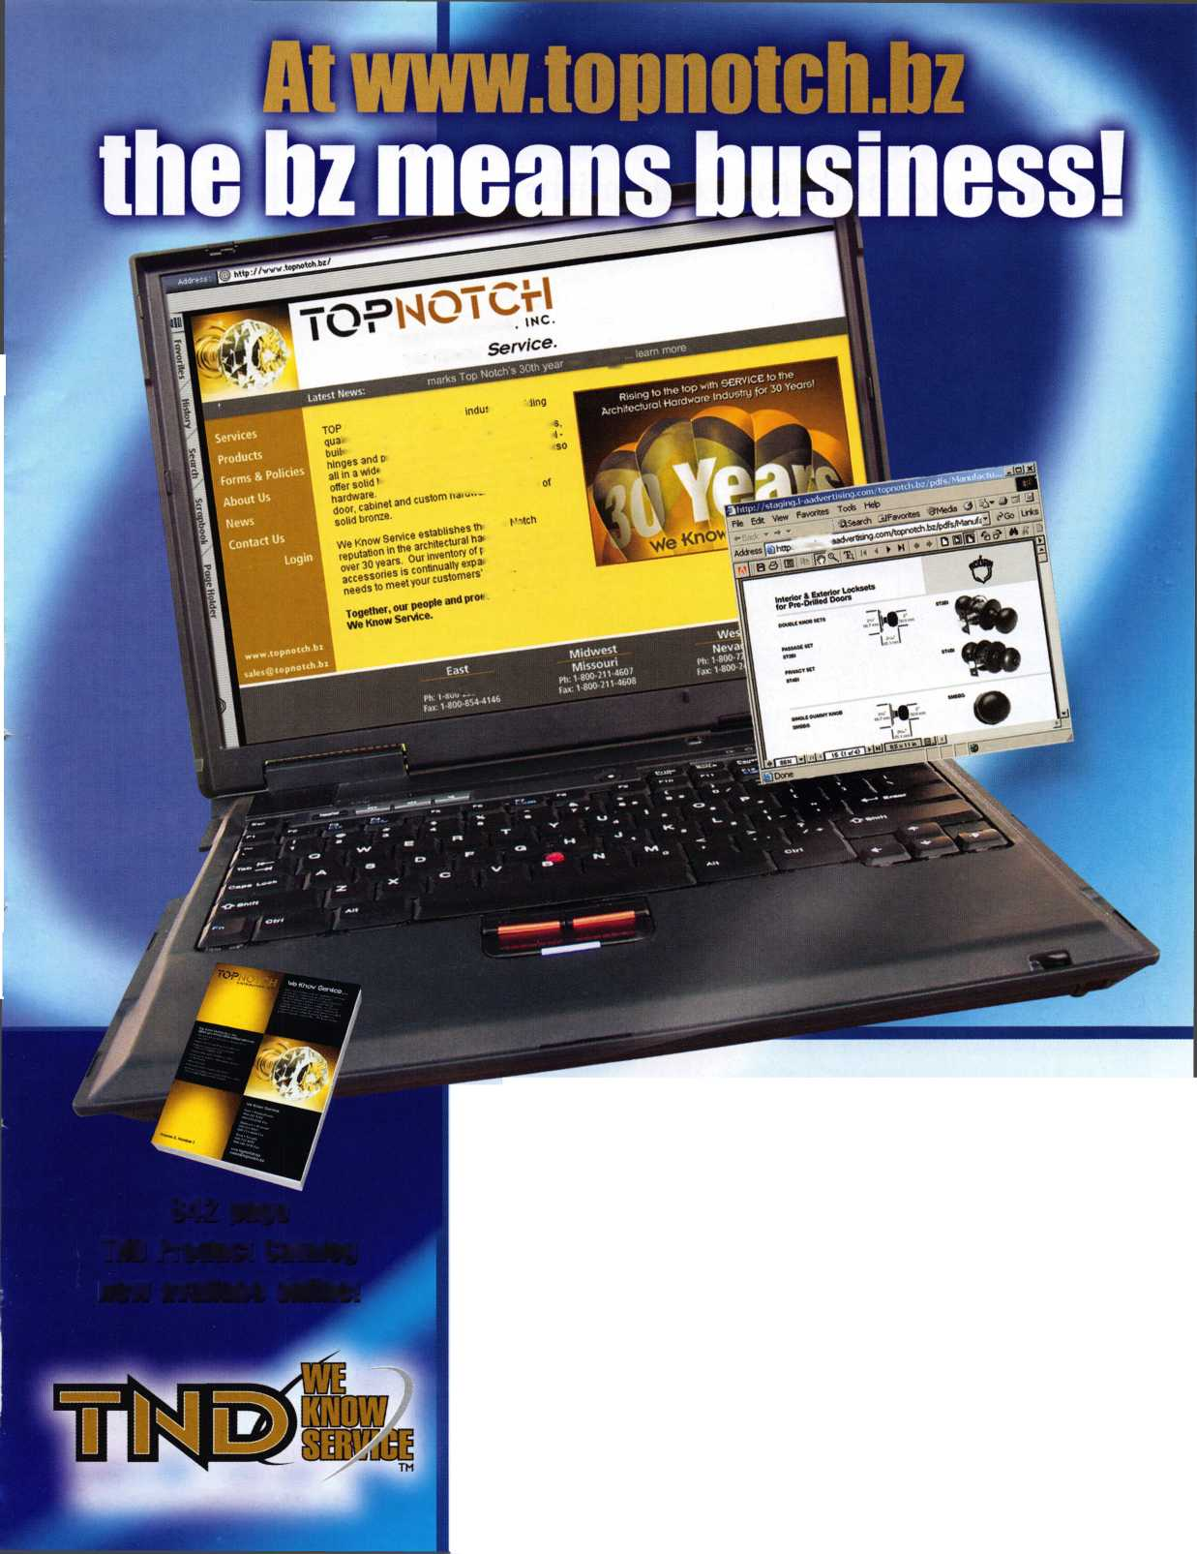

HPC’s Blue Shark

Designed and Built for Locksmiths



Keynotes • July/August 2005

RF

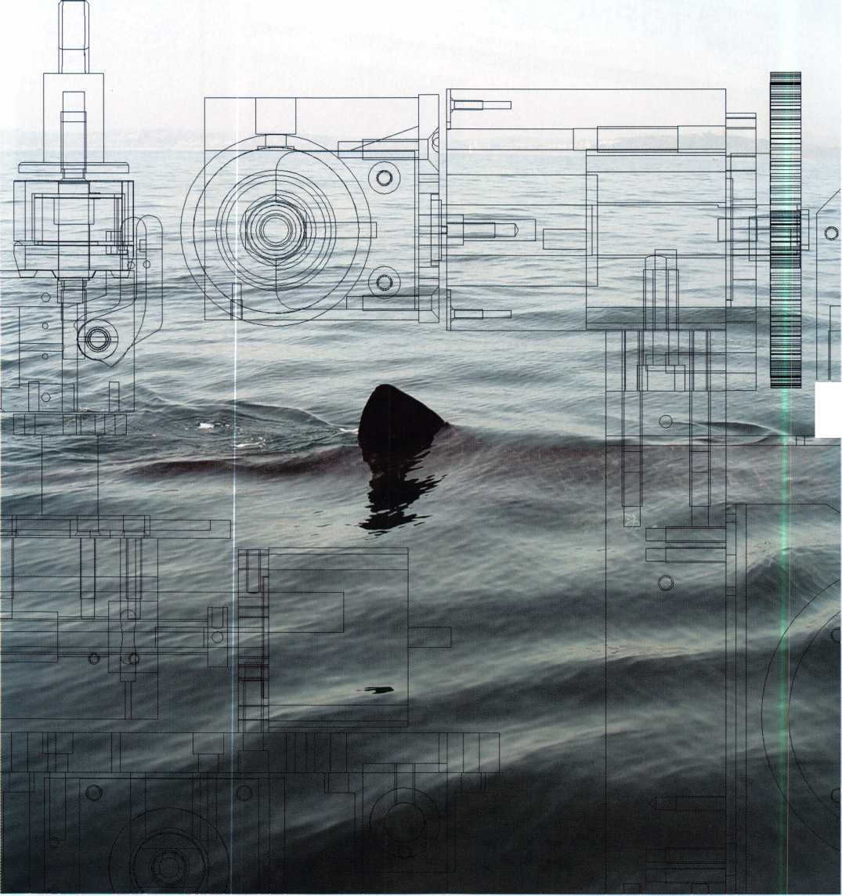

Since the introduction of the HPC  
1200CMB Blitz™ locksmiths world-  
wide have learned to depend on  
HPC for providing the best code  
machines in the industry. HPC  
then introduced the CodeMax®,  
the original computerized key  
machine strengthening their  
position as the clear leader in  
code cutting machines.

When HPC decided to take the  
next step they asked the locksmith

community what they were looking for in the ulti-

mate code machine. From this information, the Blue  
SHARK™ was born.

SHARK stands for Stand-alone Hand Activated Robotic Keymachine.

The number one necessity for all the locksmiths was accu­racy. Everyone agreed that the machine had to be accurate, but it was taken a step further. The user needed to be able to calibrate and fine-tune their machine to .0005”. The Blue SHARK™ has a self-calibration system that electroni­cally determines the distance between the jaw and the cut­ter and confirms and/or corrects depths, shoulder spacing, tip spacing, and even tip-to-bow measurements. The Blue SHARK™ also gives the user the ability to override the self­calibration results and make DSD specific or overall machine adjustments. These features allow the operator to

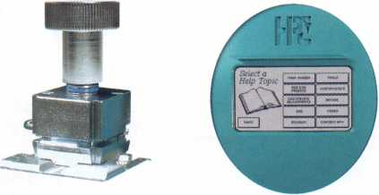

easily set an individual machine  
to his/her exact requirements.

After accuracy, it was unanimous  
that the Blue SHARK™ had to be  
easy to use. Too many times com-  
plex machines have confusing  
controls, multiple buttons that  
have to be pressed in the right  
sequence, and long lists on alpha-  
numeric codes that need to be

entered in order to do the simplest of

tasks. What good would a multi-func-

tioned machine be, if you had to continu-

ously refer back to the manual? The Blue  
SHARK™ had to be the easiest code machine to operate.  
Adding a touch screen with a graphical user interface solved  
this problem. For the first time ever, true advanced com-  
puter controls were added to a key machine. A graphic-  
intensive touch screen allows users to clearly, quickly, and  
easily jump from one screen to another and find everything  
they need.

The Blue SHARK™ is loaded with depth and space infor­mation for over 900 manufacturer lock specifications that you can easily search through by name or HPC DSD (Depth & Space Data) number. On the opening screen there are shortcut buttons that allow the user to get cutting information on specific keys fast. These are called “presets”, where the user presets their top-three most popular keys, so

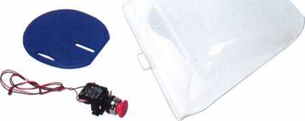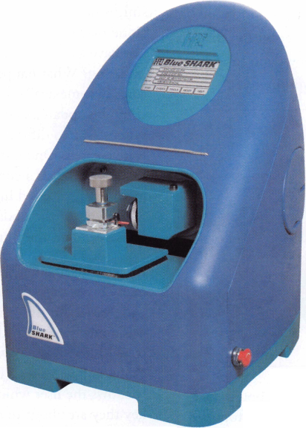

with a simple click of the button they are ready to start entering a bitting. This feature was at the top of many locksmiths’ wish list. There is also another button that dis­plays the last key that was cut. This allows you to jump right back into the last job you were working on.

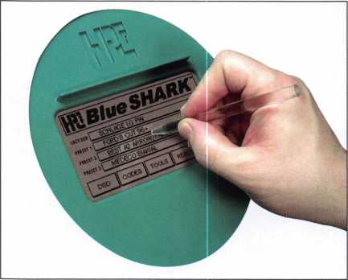

“The ultimate computerized code machine should have codes inside,” was another recurring statement from the locksmith industry. But not just automotive codes, all codes needed to be readily accessible. So the entire HPC CodeSource® database of cuttable keys was added, broken down into four sections; Vehicle, Padlock, Lockshop, and Lockshop Direct Digit codes. A bitting can be found when searching by code, manufacturer, or key blank. Again, the idea was taken a little further and a key blank cross-refer­ence was added to help the user do their job even faster.

By adding all of these features into the machine the lock­smiths next concern was answered. They wanted a stand­alone machine - a computerized code machine that did not have to be hooked up to a computer. But what about updating? What happens when more codes and new fea­tures become available? Everyone wanted a machine that could be updated easily with or without the use of a com­puter. So, two different ways to update the Blue SHARK™ were created. One way is via CD with a Windows® based PC. The other is a computer-free method using a multi- media card inserted into the back of the Blue SHARK™. Simply insert the update card; press the update button on the screen and the Blue SHARK™ takes care of the rest.

Along with making the Blue SHARK™ easy and fun to use, many other great features were added that allow it to cut a wide variety of different keys. The first of these features was a newly developed 4-way jaw that mimics HPC’s time- tested Blitz® 2-way jaw with the addition of two more spe­cially designed sides. The Blue SHARK™ Cut Screen clear­ly shows the user which side of the jaw to use based on the key they are about to cut. With this new jaw and the elec­tronic touch-off feature cutting double-sided keys accurate­ly becomes extremely easy to do. The electronic touch-off system momentarily determines the position of the key before it starts cutting so you get

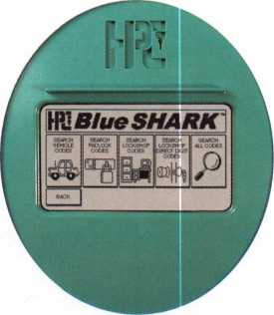

Keynotes • July/August 2005

**Ruv HPC Products!**

**and**

GET FREE STUFF!

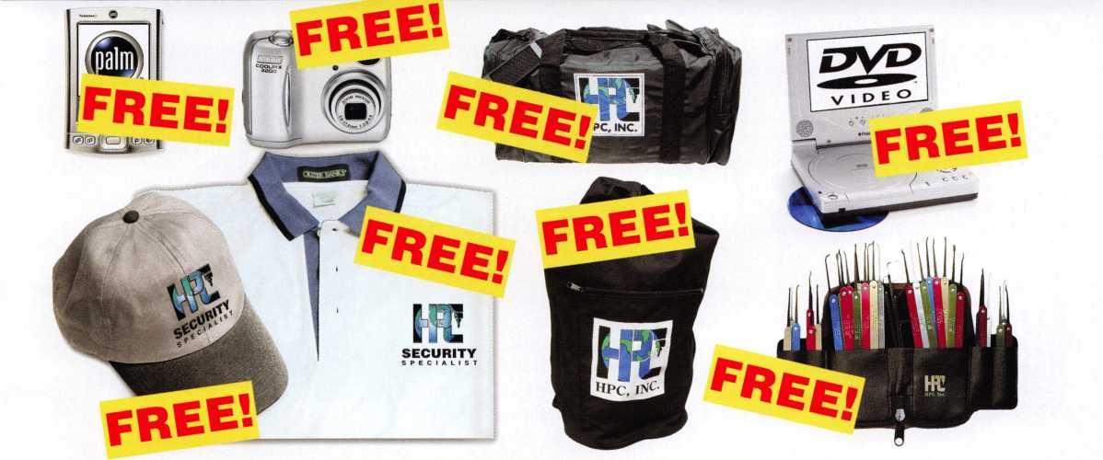

During the months of May through December 2005 all HPC purchases will  
earn you points to redeem for free merchandise. See **[www.hpcworld.com/freestuff](http://www.hpcworld.com/freestuff)**

for complete details of this promotion, and a list of  
the FREE apparel, electronics, and HPC tools.

Every HPC purchase earns points.

SO HOLD ONTO YOUR RECEIPTS!



**HPC, Inc.**

**3999 N. 25th Avenue Schiller Park, IL 60176 USA Tel: 847.671.6280 Fax: 847.671.6343 [www.hpcworld.com](http://www.hpcworld.com)**

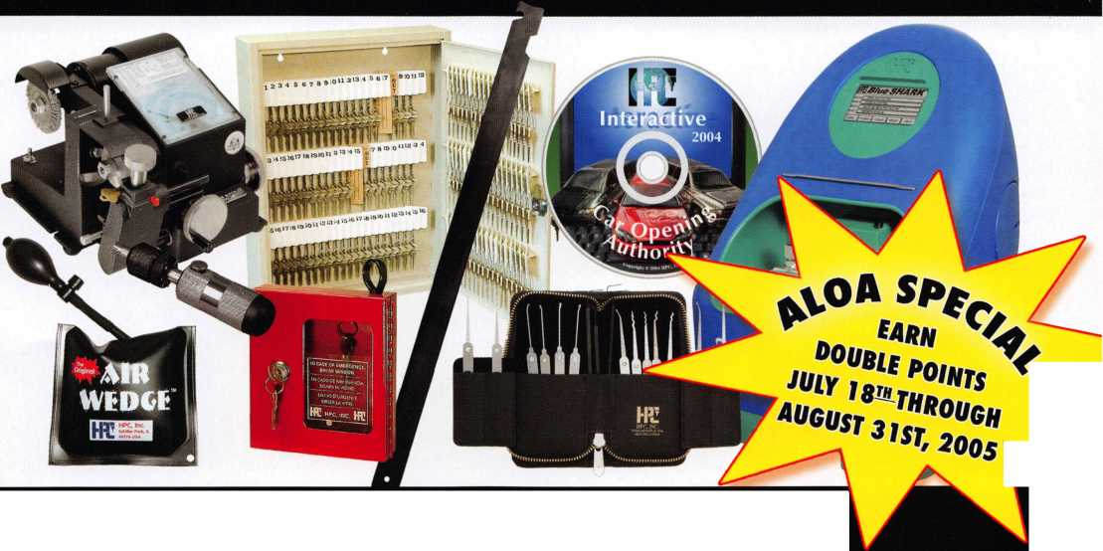

Member Milestones

1956

! Maty, Philip A.

Mclnerney, William D., RL \ v McGinnis, Arthur E. Walters, George E.

Taylor, James L.>, RL.

Brust, Herman B., Jr., RL v Gort, Harold

Kenton, William C. Paradise, Roger J., RL Stein, Herbert Dietzel, Edwin Maffey, Constant &., RL Nelson, Jay, RL L Moncur, Roman G.

Sussina, SJ, RL Britt, James L., RL Stapel, Carl A, RL Ricciuto, Ernest J.

1957

Hafiey, Stanley C,, CPL

Smith, Joseph J., Sr.

oil, HatryJ.

1958

Lockman, Richard M., RL Greenberg, William J., RL Weberman, Louis, RL McCown, Robert C., RL Jones, Edgar L, Jr., RL Leimbach, Fredrick P., RL Cooper, Charles M., RL Pfeil, Edward A., CML Buchanan, Lawrence R, RL Annuith, Joseph S., RL Dobs, Donald G., RL Troy, Kenneth J., RL, Veniero, Joseph A.

Stiering, Walter H., RL Fish, Aaron Max

I960

Dube, Joseph A., CML Malinowski, John R., CML Drake, John E., RL Mangione, Gerard E.

^Beggs, Raymond E., CM L Thomas, Charles W., CML Freed, Robert W„ RL Heaton, Warren G.*, RL McManus, John Son tag,-Robert Fu, RL Shaffer, Jerry C.*

Merlin, Ramon fir, RL

1962

Griffing, Timodiy G., Jr, RL Ellis, Dan C., CPL

1963

Miller, Arthur C., Rl. Wentz, Karl C, RL Hatfield, Maurice W, RL Meilan, Jerry, RL Sass, Harvey W.

Trouland, George J., Rl.

McAfee, Alfred G; CMC

Ambrosi, Nick D„ CPL Winne, Gene S., RL Wolferseder, Milton F., RL Miller, Walter L.

Henke, Robert G., CRL Stetzer, Afan P.

Angelroth, Charles M., RL Hersh, Yehuda M.

Mullins, Virl Pinson, George Condil, James C.

Del phi a, Edward J., RL Berg, John H., RL Frey, George F.

Phillips, EdwinJL, RL Jones, Ernest L _

1965

Anderson, Lugene R., RL -Schultz, William G,

Keefe, John N., RL Lascar, Walter W., RL Rosehprotnpi, Sandy D. Iffrig, George A.

Grossman, Edward R., CRL

UK

1966

Fowler, Carl A., RL Skobrak,^Charles E., Sr.,

Rucps;.

Walters, Marion J., CRL Leeper, David E,, RL Kotler, Edward, RL Crider, Garvis E. DeCosta, John, Jr., CML Gunkel, Patsy, RL * Walter, John W., CPP Mozisek, James, CML Johnson, Stuart W.

Taormina, Paul C., RL Shandy, John L., CML Jackson, John E., RL Knecht, Raymond P.

Barrett, Lawrence I., Sr, RL Fullmer, Richard E., Jr, CPL Cook, B. W . "

Alessandrini, Lewis A., RL Wasilenko, Walter R., RL Cutler, Michael E, CML Watkins, Arby R.

Kline, Roger D., RL Weaver, Ronald W. Hutchison, Ronald E.

Wills, Harold J.

Killip, David J., CML Ralston, Larry B., RL

1968

Lewis, Keith R., CML Dedge, Arthur L., CRL Buck, Arlin E., RL Eigenbrod, Alan K., RL Moxley, Reginald W., CPL Perkins, Merritt L., RL Tellerico, Frank W. DeSalvo, Nicholas, RL Wright, Leo F., RL Texidor, Gabriel, Jr. Townsend, Albert S., CML Ward, Norman F.

1969

Harmon, Clarence Gunkel, William E, RL f fibbitts, Harold L, CML Adams, Thomas A., CPL Greenwood, Richard H., RL Anthony, Cheryl R., RL Sanders, Elizabeth M., RL Bares, Herbert R., RL Karch, Michael S., CPL, CPP Byer, Robert J.

Ellman, Kenneth Detzel, Robert A., RL Mester, George A., CPL Clifford, Starlin M., Jr, CML Golden, Paul S., RL Vos, James J., CML Anderson, Barry L.

1970

Huth, Robert W., RL Henley, Homer D., CPL Hardy, Jack M., Sr., CPL Camp, Breck H;, CML Kovener, Jesse J., RL Allen, George L , Jr, ILL Lamb, Richard G., RL Arnold, Martin, Sr., CML Gilsdorf, Gary L.

Newton, Thomas J., Jr, CML, CPS Bruso, William L.

Capreri, Edward J., RL Demont, Thomas J., CML Elliott, John C., Sr., RL Dougherty, Richard E., RL Merrell, t)avid O., RL Stroud, Herman, CML Field, Peter H., RL Williams, Donnie L.

West, Samuel A. ,^v.r



**NOW EDGE™ KEY CONTROL KEEPS YOUR CUSTOMERS COMING BACK.**

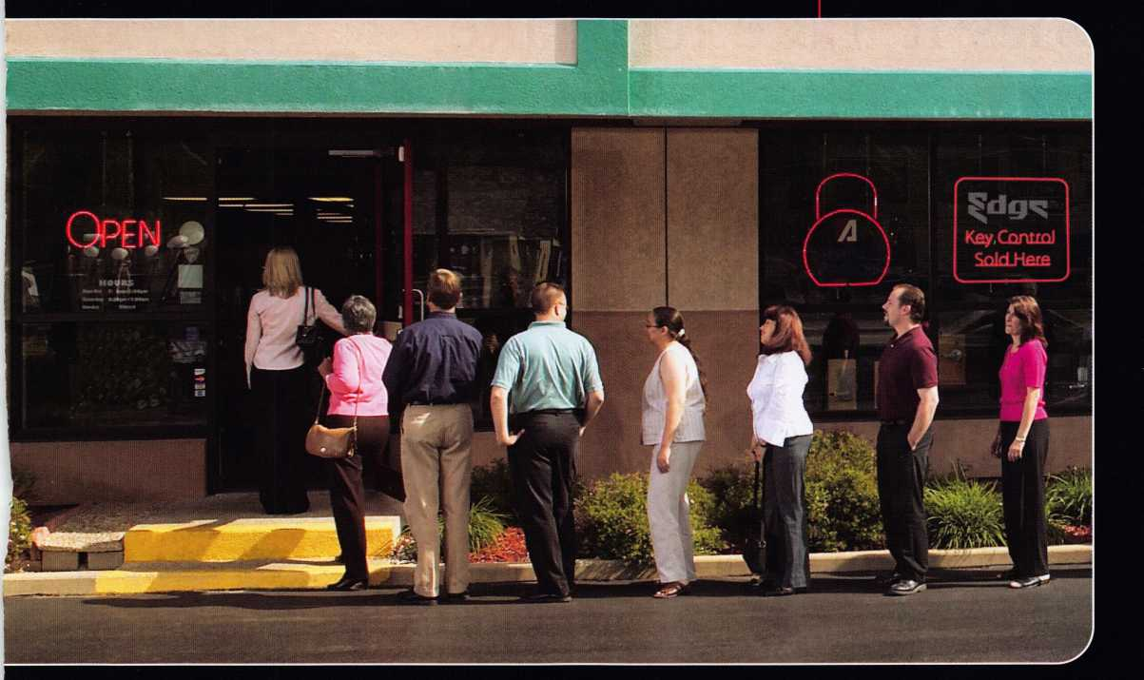

™ *Introducing Edge™ key control:  
the patent-pending system that*

*brings customers back to you* — *only you —  
again and again.*

What a great way to gain new customers and lock-in business for years to come!

Unlike costly "high security" systems, Edge lets you offer the kind of security a multitude of businesses need for door locks, padlocks — the works.

No one can duplicate keys without their consent. And no one can duplicate keys for them but you!

**Repeat business you can “own.”**

Edge key control prospects are everywhere — local

restaurants, strip malls, utilities,  
hospitals, municipalities, neigh-  
borhood stores, franchisees ...  
the list goes on.

Edge lets you deliver the

key-control security

they want — and  
can pay for. Year

after year after year.

Ask your distributor about  
Edge key control today.

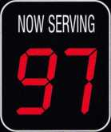

*Edge fits American Lock® and Master Lock® commercial security products, as well as other makes.*

***The Locksmith's Lock***©

© 2005 American Lock Company, a Division of Master Lock Company

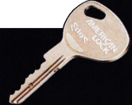

How Many People  
Does it Take to Make  
a Key to a 1934

GMC Truck?

By Ed Woods, CML, CPS

Would you believe

that it took five people

and one thousand forty-two

miles to furnish the customer with a key

to this truck?! The journey began with a Mr.

Brooks Cole in Fort Collins, Colorado, who removed the passenger side door handle of his 1934 GMC pickup truck and brought it to it to Ray D’Adamo at Tri-City Security. Ray looked at his key board and determined that he didn’t have a key blank for the lock. Then I came into the picture.

Keynotes • July/August 2005



■MMi

||\k\>

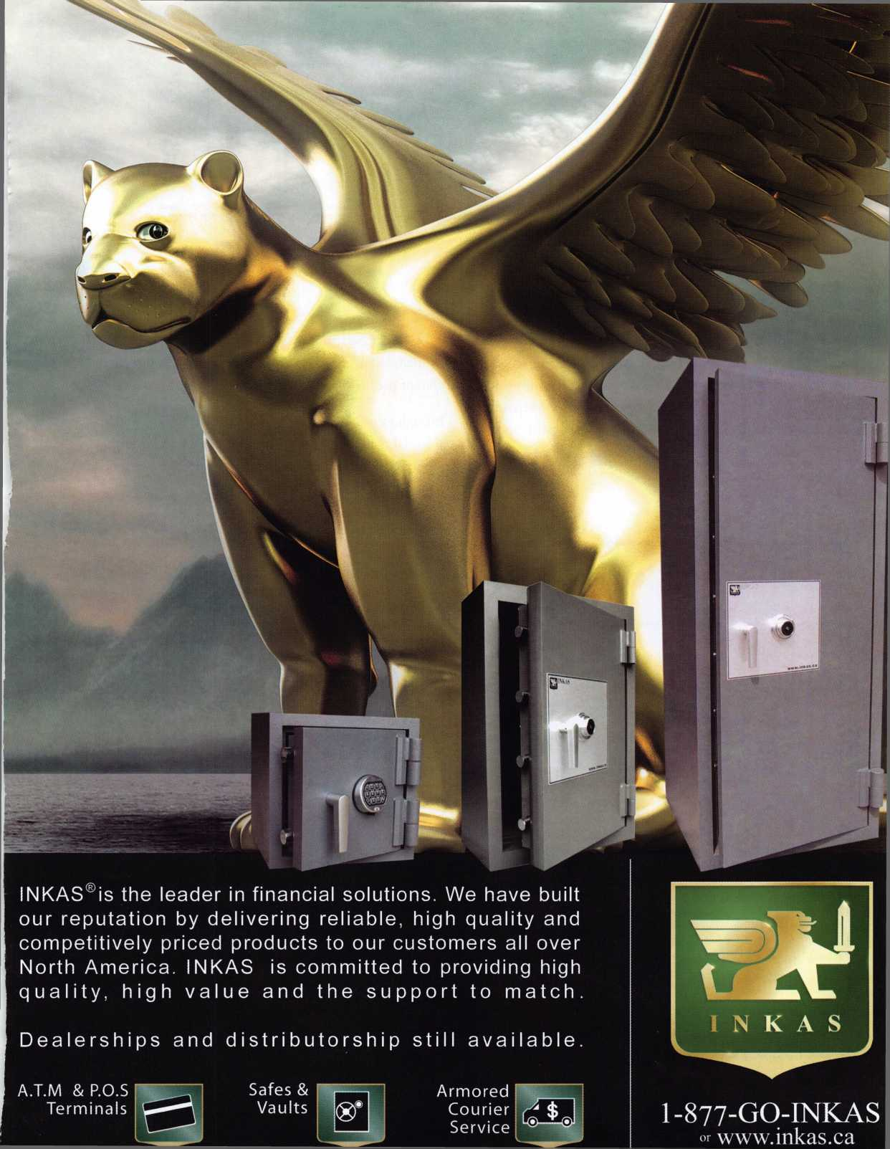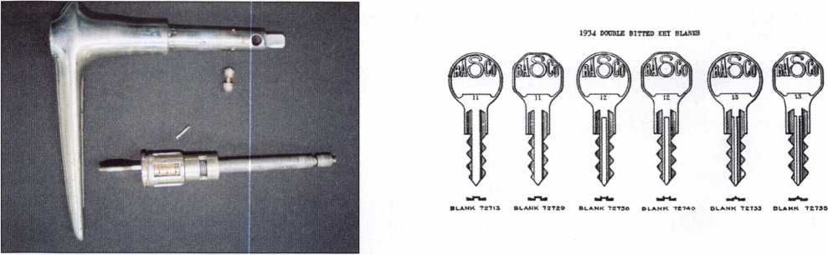

Ray questioned me about double sided pre-1935 BASCO blanks, and I told him I had a few at my shop. I had acquired the blanks when I purchased the remaining stock from a retiring locksmith ten years ago. The handle and lock was sent to me, and I was surprised to find the code stamped on the handle (photo)! I got right to work and discovered that one blank would enter the lock and anoth­er wouldn’t. I contacted Vera Latus of Stattec in

Milwaukee, Wisconsin. She sent me pictures of all key pro­files, cylinder part numbers, and prices from 1941. She also included a key chart that showed not one, but three different profiles of keys used in 1934 (photo).

Through examination of the documents sent and the ini­tial initial troubleshooting I did, I determined I had the proper key blank for the cylinder. All I needed was a code

2005 ALOA Show Booth 1507

[www.ibuttonlock.com](http://www.ibuttonlock.com)

866-241-9874

hotel lock, office lock, home lock solution

**programmable  
electronic lock  
by UCA, Inc.**

**CODE**

**BOOK**

for Automobile **Keys**

Using

BRIGGS & STRATTON  
BRIGGS & STRATTON DOUBLE

YALE - YALE JUNIOR  
OMEGA OFFSET and  
HURD KEY SERIES

**vv**

PUBLISHED BY

CORKS KWifi

MS* rROSftCT AVENUE

Third Edition

CUTICIER

1 CLEVELAND, OHIO

■ August **1936**



Keynotes • July/August 2005

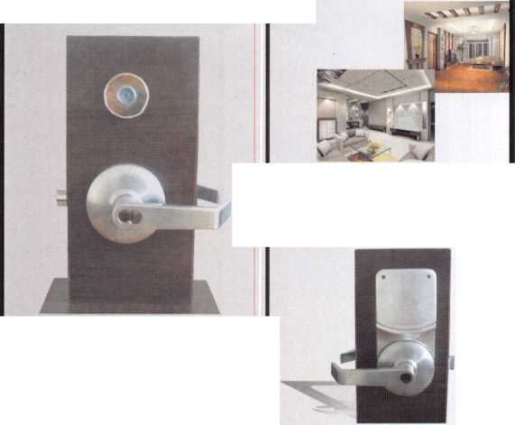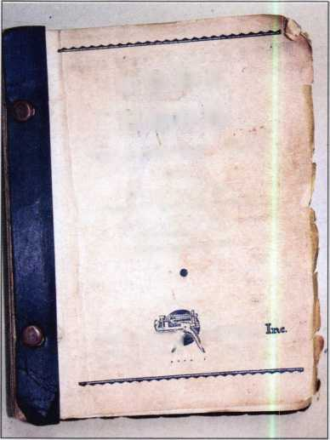

**THE U.S. MILITARY’S EFERRED MECHANICAL (VRl ACCESS SYSTEM* AVAILABLE TO YOU NOW!**

**NEW “MAXCESS” REPLACEMENT CARD-OPERATED  
CYLINDERS ADAPT TO MOST LOCKSETS AND PROVIDE  
INSTANT CODE CHANGES WHEN CARDS ARE LOST.**

CYLINDRICAL

LOCKSET

MORTISE LOCK

ELECTRIC SWITCH

TUBULAR DEADBOLT

PADLOCK

DOUBLE CYLINDER DEADBOLT

THIS “MAXCESS” CODE MODULE IS USED ON ALL LOCKSETS PICTURED

RIM LOCK

LEVER HANDLE LOCK

EURO CYLINDER

CABINET LOCK

***+* - \*** TUBULAR LATCH

■■■■■■■

ATTEND A **FREE** TRAINING CLASS AT OUR ALOA BOOTH #1017.

ONE CLASS EACH HALF HOUR.

YOU CREATE BOTH CARD AND LOCK CODING WITH SIMPLE TOOLS  
AND LEARN MASTERKEYING, ALL IN 20 MINUTES.

TAKE HOME THE “MAXCESS” LOCK AND CARD  
THAT YOU CODE AS A GIFT... A $100.00 VALUE!

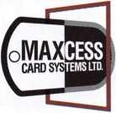

WHEN YOUR CUSTOMERS NEED A SINGLE MASTER­CARD TO MANY DIFFERENT TYPES OF LOCKS, REPLACE THEIR CYLINDERS WITH “MAXCESS”.

— YOU CODE THEM — YOU CONTROL THEM. —

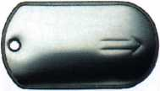

THE MAXCESS CARD

**TO LEARN MORE ABOUT “MAXCESS” AND BECOME AN AUTHORIZED DEALER:**

VISIT: [WWW.MAXCESS-CARD.COM](http://WWW.MAXCESS-CARD.COM) USA OFFICE: 800-713-4823

* MAXCESS type cylinders are on all doors in 70 Military Base Schools in Japan, Korea, Guam, Europe, USA. 75 Dormitories on Bases in Japan, Korea, Europe, USA. 5000 Dependent Family Blousing apartments in Japan and USA, plus Hotels, Offices and Recreational Facilities. Military specifications on request.

MAXCESS CARD SYSTEMS LTD

Licensee of CorKey Control Systems Inc.

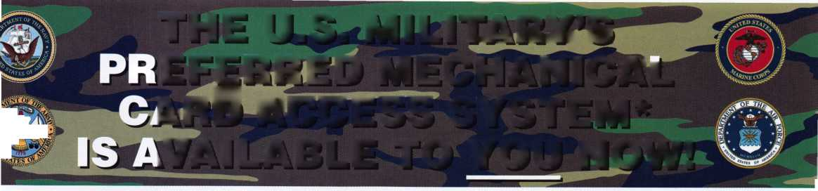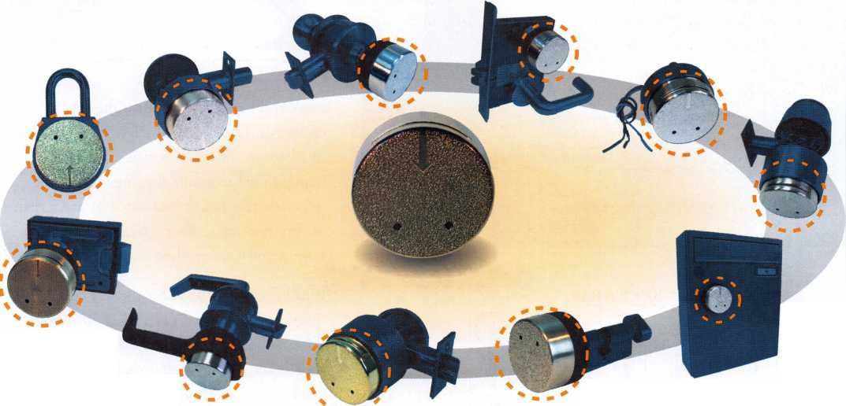

book and key cutter to finish the job. I  
called Mr. Gary Perry of Perrys Lock & Key  
in Mattoon, Illinois. He was more than  
happy to help, despite digging around for  
materials that hadn’t been used in more than  
twenty-five years. After a two day search,  
both items were on their way to my shop.

INSTRUCTIONS FOR OPERATING

AND

DESCRIPTION **OF CURTI**S KEY CUTTER

bne side of the machine is marked “L” for left and the other “R” for ^ (N OCTAGON POST is provided, each side bearing numbered holes' nitinl letters for the type of key to be cut.

“ get the desired rib of the POST into the proper position, loosen THU ?FT SCREW on the back of the machine, push the lever arm towards] •ntste the POST until the screw in the lover arm fits into a hole in **ir^er rib, and** then tighten THUMB SET SCREW. **.**

**A Jht** carriages are provided to take care of the various types of k tvne 0f key fits in its particular type of carriage, rhfspadn^ is accomplished by turning the THUMB BUTTON which m<

f a carriage does not come out easily, pull the le\er down.

IN ALL KEYS THE FIRST CUT IS MADE AT THE SHOULDER **gffwng THE KEY, AND THE LAST CUT IS MADE AT THE TIP.]**

KEY BLANKS

**AUTOMOTIVE KEY BLANKS**

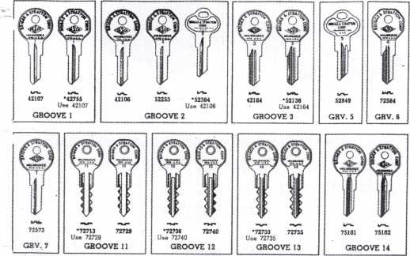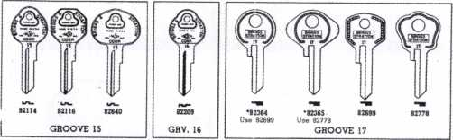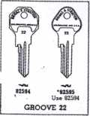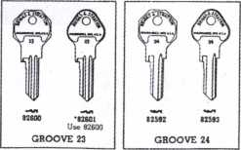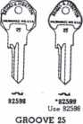

USE ORIGINAL KEY BLANKS



I read the instructions for the key cutter first (photo). I have never seen a key cutter like this one before (photo)! In addition to the code book and key cutter that I requested, Gary also sent me an Independent Lock Company 1198C blank and a Curtis key blank. I found it interesting that the Curtis key blank lacked the precuts displayed in the

Use Blank **K’U**

Order Key Blanks from CURTIS KEY CUTTER, Inc,  
1836 Prospect Ave.. Cleveland, Ohio

BRIGGS & STRATTON

im CHEVROLET Post BSD

From 4100 to in

4126*1. 443345 4160-L 452535 4I75-L 324*

R 384432 R 325243 - ™

4126-L 822555 4151-L 325485

Carriage BSD. Double Cut

1. L 542555 R 235222
2. L 532245

R 2

R 452322

KEY BLANKS

**CURTIS KEY i’’ CUTTER**

C. W. Richardson

oiiTmeuTOR

R 4534  
4178-L 5232  
* R 2545  
77-L 2543  
R 5234  
#8-L 5423  
R 2354  
hf9-L 2352  
R 5425  
SO-L, 4332

R 3445

80! BUSH STREET

4111-L 853345  
R 424432  
4122-L 525455  
R 252322

1. L 333345 R 444432
2. L 252555 R 525222
3. L 422245

n. aa.Tgort

1. L 524335 R 253442
2. L 253235 R 524542

4188-L 548435 R 234842

1. L 234535 R 543242
2. L 434335

a Ontario

1. L  
   R
2. L

R

1. L  
   R
2. L 435435 R 342312
3. L 342535

Keynotes • July/August 2005

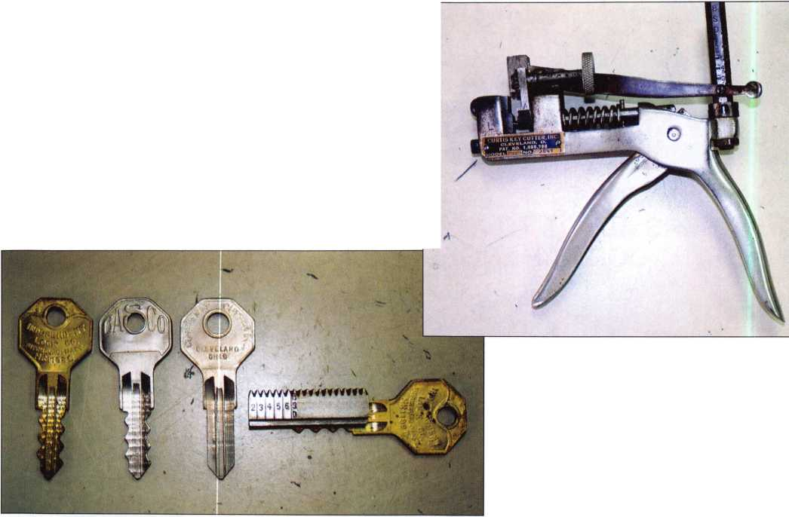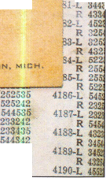

key charts that Vera had sent me (photo). I then looked in the code book for #4136 and found exactly what I was looking for (photo).

It is interesting to note that the lock for the 1934 Chevrolet truck is a true double bitted non- reversible key which is not found in most modern automobiles due to the inconvenience of the key inserting one way only (photo). What seemed to be a simple task could not have been accom­plished without the help of my fellow colleagues, and I was finally able to cut a key by code for a lock that was made twenty-three years before I was born!

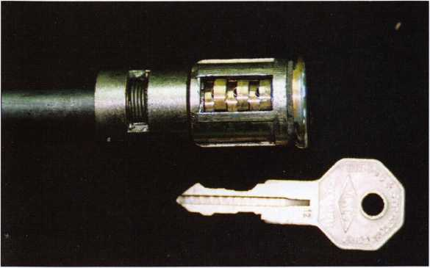

Oh yeah, the lock was then shipped back to Ray D’Adamo in Fort Collins and his customer now has a key for his pride and joy.

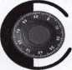

US

Howard Sales

Celebrating 20 years as your distributor for:

earn*

SARGENT AND GREEN LEAF'

ARM A DOR

Check our dealer specials at:

[www.howardsales.com](http://www.howardsales.com)

Phone: 800-456-4625 Fax: 915-833-7770  
Email: [info@howardsales.com](mailto:info@howardsales.com)

Keynotes • July/August 2005



Up Close with the 2005 ALOA Scholarship Recipients

We've done it again. For yet another year, the ALOA Scholarship Foundation has dug deep to provide free locksmithing instruction to those aspiring locksmiths who otherwise would have been unable to attend the biggest show of them all - ALOA 2002. The good people you are about to meet are the benefactors of ALOA Scholarship gifts representing thousands upon thousands of dollars.

Jeff Burby

I have been a locksmith in the Merrill, Wisconsin area since 1985. In those twen­ty years I have been active in my commu­nity in two chapters of the Locksmith Association, a chairman for one and an active participant in the other. I have also offered my services to any locksmith asking for help on a project if I have the knowl­edge and the tools to be of assistance, and have willingly driven across Wisconsin to lend a helping hand.

I am applying for the scholarship because I feel I can learn more from this year's con­vention and workshops. I am a small busi­ness owner and am in need of assistance in order to attend the convention this year.

I believe the more I learn the more I offer to my community as well as fellow lock­smiths.

William M. Barry

I have worked in the locksmith field in a family owned business since was 9. I did leave the trade for a few years and decid­ed that the locksmith profession was where I needed to be. Prior to working for my current employer, Avenel Locksmith, I worked for two years out of state as an automobile locksmith. Now my experience covers residential, commercial, industrial, institutional, government and I do have some electronic and safe penetration expe­rience as well. I need to expand my knowl­edge in these two areas so that I can be a better locksmith and a more valuable employee. My goal is to assist my employ­er in long term expansion of his business.

I am applying for a scholarship because education is very important. A scholarship would help me attend the convention, meet new people, network, and be more of an asset to my company. My employer is a regular attendee at conventions across the country and sends his employees when he

can, although this year he cannot. He is a supporter of the benefits that ALOA educa tion has to offer, and had many former employees receive scholarships, which benefited his business and his employees. Thank you for your consideration.

Peter M. Ballotta, CML, CPS

I have been in the industry since 1974, and I am the owner of Avenel Locksmith. I started my business in 1977.

I am applying for a scholarship to gain knowledge in the areas of access control and CCTV. I want to expand my business in these areas and require the hands on training that ALOA is known for. Over the years ALOA has been very gracious in helping me to educate at least five of my employees. Unfortunately the high cost of living makes it difficult for me to send any of my employeegpfffs year. Now I need some addition^ education and a scholar­ship would make this financially possible for me. Thank youjJlyour time and con­sideration. W

Nathan Mersch

Michael Hutchinson, Jr.

I have been actively involved in the lock-

smith trade for the past five

years with my wife.

When she started in the  
business, it seemed like  
an interesting career

path to follow. Now it is a

passion after searching for

many years for the "right" career. Despite  
the fact that I have certain disabilities  
which limit what I can do, working in the  
trade is a perfect fit.

I want to attend the classes this year to  
expand my knowledge and gain a more in  
depth education so I can serve our cus-  
tomers in more varied ways. Thank you for  
this opportunity.

David Kindley

I firmly believe that continuing education is  
vital to the professional image of our  
industry and that is one of the reasons why  
I would like to be considered for a scholar-  
ship this year. I currently perform lock and  
safe deposit work for two banks in my  
area. I plan to use what I learn at ALOA  
not only to expand my company's service  
to my clients, but also to offer additional  
services to other banking institutions in the  
area. By increasing the quality of service I  
can professionally and confidently offer my  
customers, I can also reflect a positive  
image of the locksmith industry as a whole.  
Thank you for your time, attention, and  
consideration.

I am submitting this application for scholar-  
ship assistance because I am very eager to  
further my skills in the locksmithing trade. I

have been employed as a

locksmith since 1994 and

have had the opportuni-

ty to learn many new  
skills. If I get awarded a

scholarship it will give me  
the rare opportunity to

attend classes that I feel will be very bene-  
ficial to my career and my family's future.  
Thank you for your consideration.

Ricky Raney



i more >nal oppor-

>mers

Ken Mason

I have been a locksmith  
for 16 years, and last  
year I opened a store-  
front. Employers, fellow  
locksmiths, the

job trainingjsave awarded

me most of my

painfully av

knowledge I need,

tunity that ALOA offers will I

in my success to meet my <  
in a professional manner. ^

am

Bradley Small

I have dedicated my practice to serving my  
customers in a prompt, courteous and pro-

fessional manner, and networki

local area locksmiths. This

year, I joined ALOA in

hopes of increasing my  
value as a locksmith. I

nesc£ Mthe quality of classes

and information presented

would benefit myself, my colleagues, and  
the strong client base I have worked hard  
to establish. Education is one of the great-  
est resources we have and can share. A  
locksmith can loan his tools but if he teach-  
es another locksmith, he has given some-  
thing no one can take away.

I was determined to find a

career I could do on my

own where I could not  
only make a decent  
salary, I would have a

different challenge every

day. I decided that the locksmith profession  
was the way to go. It has the level of chal-  
lenge I craved and the appeal of leaning  
new things throughout your career, so I  
attended Cothron's School of Professional  
Locksmithing in 2004. I was very excited  
about the field and considered opening up  
my own business. I went to go work for  
Don Probasco of A-l Lock and Key to  
learn what would be invaluable experi-  
ences. I know I have only scratched the  
surface, and I grow more excited about the  
locksmith profession every day. It is my  
commitment to do everything in my power  
to attend as many ALOA conventions as I  
can while keeping abreast of the latest  
technology and locksmithing practices.

Jeremy Easter

I am a full time locksmith

seeking continuing edu-  
cation, specifically to  
attain my CRL certifica-  
tion. I feel this certifica-

tion will set me apart from

the rest, and will compliment the working  
experience and add expertise to the servic-  
es I currently provide. I have had several  
mentors in the field, and all have had the  
same advice in regards to education and  
experience, and I strongly believe they go  
hand in hand. I appreciate you consider-  
ing me for this scholarship. My long term  
goal is to be an advocate for ALOA and  
certified locksmiths promoting confidence  
and professionalism for the trade.

Don Schultz

I became an apprentice locksmith in  
January 2005. Wes Sugden of Seahorse

Safe and Lockout

graciously taken on the  
role of employer and

mentor to help guide

to become a qualified

locksmith. My desire is to

use the exceptional knowl-

edge from the ALOA Convention is not  
only to supplement my job skills it is to pro-  
vide a quality service to customers in an  
established community. Thank you for your  
consideration.

Earl Karsikas

Learning to be a locksmith was a natural

transition from my back-  
ground as a commercial  
and residential carpenter.

In the last five years, I  
specialized in doors  
and related hardware.

Education is invaluable. I

always taken every opportunity to learn and  
expand my skill set, either through training  
classes, hands on experience, or the exten-  
sive library I have compiled.

I very much want to become a more-profi-  
cient locksmith. The classes offered at ALOA  
would be a giant step in that direction.  
Excellence in doors and hardware are only  
part of the overall picture. Locksmithing is  
something I have a passion for, and I hope I  
am awarded this opportunity.

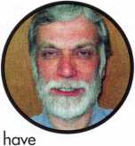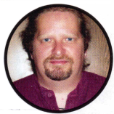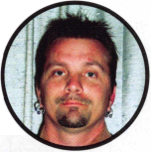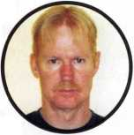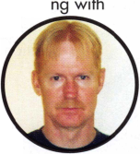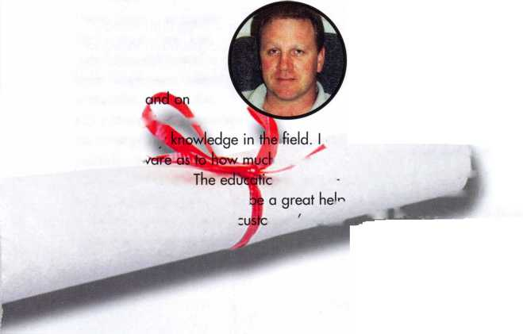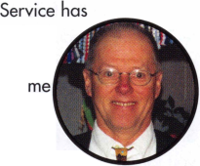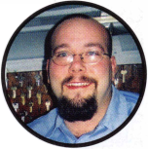

Jeremy Reeder, CRL

One of my long term goals.

is to be a highly quali-  
fied safe technician in  
southwestern Europe,  
and for now I will be

relocating to Los Angeles to

work for Firstline Security. Just as I have  
studied language for the European country  
I will eventually relocate to, I also see the  
need of further education. Training classes  
with ALOA will give me an edge above the  
rest while showing my competency and  
expertise in the field. Thank you for the  
consideration and the opportunity.

Joseph Laughhunn

I am a working locksmith for

St. John's Hospital and  
Medical Center. I want  
to attend the ALOA  
classes to broaden my

knowledge in the field. I

feel as though education is a

continuing process and never ends. I like to  
help people and would use my knowledge  
for the benefits of the patients and staff at  
St. John's as well as my community. Thank  
you for your consideration.

Doug K. Martin

I am applying for this schol-

arship to expand my

knowledge and capabil-i

ities as a locksmith. I  
really love this trade. It's  
not a job-it's an adven-

ture! I want to be able to do

more with my skills and ALOA Education is  
by far the best training next to having a  
mentor in the field. Thank you for your  
consideration.

Cory M. Dolley

I am currently an apprentice for Kathy  
Zaniolo, CML. I would like to be consid-

ered for an ALOA scholar-

ship because I like deliv-

ering excellent customer i

service and working

with my hands. The craft'

of locksmithing is an

important one. A locksmith is,

all at once, a craftsman, security expert,  
and a businessperson. There are many  
facets to the work and I want to learn  
more. I am seeking and wide and varied  
knowledge of locksmithing and I feel this  
scholarship will aid me in reaching my  
goals. Through the training program that  
ALOA offers, I feel that I can use this schol-  
arship to learn from some of the finest  
locksmiths in the nation.

Andy Phelps, CRL

I have been in the locksmithing industry for  
1 3 years. I started my own company in

Martin, TN in 1992 as a

part-time locksmith open-

ing cars. Over the next  
9 years, my business

began to grow and I left

my job as a police officer

to pursue locksmithing full time. For 2  
years, I struggled to make ends meet in a  
small community with no other locksmith to  
ask for help. I became a member of ALOA  
in 2001 in the hopes of gaining the knowl-  
edge needed to make my business grow.  
With limited income, the training needed  
was difficult to obtain.

In 2003, I moved my family to Nashville,  
TN in hopes of obtaining the much-needed  
training to advance my career. I have been  
subcontracting for 2 locksmiths in the area  
until my customer bases grows. Since the  
move, I have become a member of the  
Middle Tennessee Locksmiths

Association and the Tennessee

Organization of Locksmiths. Through these 2 organization, I have gained additional knowledge and have had the opportunity to participate in the PRP program and obtain the designation of CRL.

If fortunate enough to be chosen for a scholarship for the 2005 convention in Rosemont, ll., I will use the knowledge gained to better serve my customers and to help increase the professionalism of lock­smiths in Nashville. In addition, I would like the opportunity to share my new skills with other locksmiths since I know firsthand how valuable this information can be.

Blair Pumphrey

I would like to broaden my knowledge of  
the lock, access control and electronics

trade. Currently, I am an  
apprentice with 2 years

experience at Cops, Inc.

Security Solutions.

Through the work, I

have found a trade that I

enjoy and can offer

advancement opportunities. I am a single  
high-school graduate with a background in  
sound engineering and electronics.

Andrew Littlejohn

I would like to broaden my knowledge of  
the lock, access control and electronics

trade. Currently, I am an  
apprentice with 2 years  
experience at Cops, Inc.

Security Solutions.

Through the work, I have

found a trade that I enjoy

and can offer advancement

opportunities. I am a singe high-school  
graduate with a background in industrial  
a*ts and mechanics.

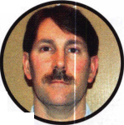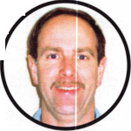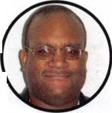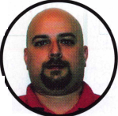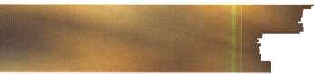

Amber Engle

I started in locksmithing by duplicating  
keys in an ACE Hardware store in  
Colorado. ACE employed only one road

technician and we talked  
daily. These conversa-

tions stirred my curiosity  
and soon I wanted to

gain more knowledge of

all aspects of locksmithing.

Two years ago, I moved to Alaska in the hopes of creating a better life for my fami­ly. I found immediate employment as a waitress. I contacted my current employer at that time and they soon offered me a position as a shop technician. Through on- the-job training with my company, I am now on the road in a service van.

The area in which I live, limits my personal and professional growth. It is also very costly to attend formal training due to trav­el costs and time away from work. The for­mal training certification offered through ALOA will allow me to further develop my skills and abilities. We all have goals in life and I wish to someday be a person who is respected within the industry for her knowl­edge and expertise. I have read many pos­itive comments from those fortunate to attend ALOA training. A fellow technician who attended in Las Vegas stated, "I wouldn't be where I am if not for the train­ing I received". I wish to relay a similar message with my training is complete. Thank you for your consideration.

Callie Jagels

I have been locksmithing for over 3 years  
and am still pleased to be learning new  
techniques and technologies every day. I  
have watched the locksmithing field grow  
rapidly, allowing me to expand my knowl-

edge in hardware, software

and electronics. I am con-

stantly seeking new skills

and techniques. I have  
challenged myself on a  
daily basis in order to

expertly advise customers

about their security needs. I am eager to  
attend ALOA training.

In my primary duties I assist the general  
manager of the region with all aspects of  
business operations. I have branched off  
into banking and electronics but lack the  
formal training I need to excel. My current  
location in Fairbanks, Alaska limits my  
options as well.

Dewayne A. Heidemann, CRL

I have been a member of the locksmithing  
community since 1994. Prior to this, I  
worked for 20 years as a Senior Process  
Operator in a corn processing plant. I left

due to a labor dispute after

union members were  
locked out by the com-  
pany. During the lock-  
out. I found a job with

Schuerman Lock and Key*

and found that I really

enjoyed the work. When the labor dispute  
was settled, I stayed with Schuerman Lock  
and Key. As a single parent, the schedule  
change was a welcome relief from rotating  
shifts and the plant. In 2002 Schuerman  
Lock and Key closed its doors when the

owner took an institutional job at a col­lege. One of my customers, provided me with the financial backing to start Decatur Lock and Key. After taking the PRP and getting my CRL designation in Texas, I was ready to open my doors for business. Since then, I have been fortunate to hire another locksmith to focus on automotive work.

I have really enjoyed my years in the lock­smith industry and would like to learn as much as I can to offer my customers the best service possible. Since my business has only been open a little more than 2 years, we do not have the funds to attend classes at convention. I thank you for this opportunity and pray that I am selected for a scholarship.

Linda Bogart

I have been an employee of the Facility Operations Department of our local hospi­tal for 8 years. The last 6 years have been spent working solely in lock system appli­cations for all facilities within this health­care system. I handle recommendation of lock systems, installation of locks, mainte­nance of inventory, implementation of lock systems, and the maintenance of key logs.

Our main facility is constantly expanding and renovating. This these changes comes the need for advanced lock systems and specific systems that will enhance the safety and security of our patients, visitors, and staff. As a member of ALOA since 2001, I wish to continue to remain an intricate member of our facility through knowledge and skills in locksmithing. I feel a scholar­ship will provide me the opportunity to stay abreast of the trade and enhance my career.

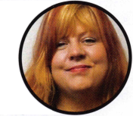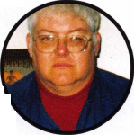

Distributor

**1 st In Hardware, Inc.**

Phone: 866-397-9900 Fax: 866-646-0045 www. 1 stinhardware.com

**Accredited Lock Supply Co.**

Phone: 800-652-2835 Fax: 201-865-0030 [www.acclock.com](http://www.acclock.com)

**Andrews Wholesale Lock Supply**

Phone: 717-272-7422 Fax: 717-274-8659 [www.andrewslock.com](http://www.andrewslock.com)

**Boyle & Chase Inc.**

Phone: 800-325-2530 Fax: 800-205-3500 [www.boyleandchase.com](http://www.boyleandchase.com)

**Clark Security Products**

Phone: 888-784-1311 Fax: 619-718-7333 [www.clarksecurity.com](http://www.clarksecurity.com)

**Cook's Building Specialties**

Phone: 505-883-5701 Fax: 505-883-5704

**Dire's Lock & Key Company**

Phone: 303-294-0176 Fax: 303-294-0198

**Direct Security Supply, Inc.**

Phone: 800-252-5757 Fax: 800-452-8600

**Discount Key Machines.Com/Busch**

Phone: 800-332-8724 Fax: 407-363-4666

**Doyle Security Products**

Phone: 800-333-6953 Fax: 612-521-0166 [www.doylesecurity.com](http://www.doylesecurity.com)

**Dugmore and Duncan, Inc.**

Phone: 888-384-6673 Fax: 888-329-3846

**Ewert Wholesale Hardware**

Phone: 800-451-0200 Fax: 708-597-0881

**Foley-Belsaw Company**

Phone: 800-821-3452 Fax: 816-483-5010 [www.foley-belsaw.com](http://www.foley-belsaw.com)

**Fried Brothers Inc.**

Phone: 800-523-2924 Fax: 215-592-1255 [www.fbisecurity.com](http://www.fbisecurity.com)

**Hans Johnsen Company**

Phone: 214-879-1550 Fax: 214-879-1530

**Hardware Agencies, Ltd.**

Phone: 416-462-1921 [www.hardwareagencies.com](http://www.hardwareagencies.com)

**IDN Incorporated**

Phone: 817-421-5470 Fax: 817-421-5468 [www.idn-inc.com](http://www.idn-inc.com)

**Instant Hardware Delivery, Inc**

Phone: 800-355-1 107 Fax: 800-663-8518

**Intermountain Lock & Supply**

Phone: 800-453-5386 Fax: 801-485-7205 [www.intermountainlock.com](http://www.intermountainlock.com)

**International Electronics, Inc**

Phone: 800-343-9502 Fax: 617-821-4443

**Lockmasters, Inc.**

Phone: 859-885-6041 Fax: 859-885-7093 [www.lockmasters.com](http://www.lockmasters.com)

**Locks Company**

Phone: 800-288-0801 Fax: 305-949-3619

**Locksmith Ledger International**

Phone: 770-886-0800 Fax: 770-889-7703 [www.lledger.com](http://www.lledger.com)

**M. Zion Company**

Phone: 212-349-8677 Fax: 212-964-0495 [www.mzion.com](http://www.mzion.com)

**McDonald Dash Locksmith Supply**

Phone: 800-238-7541 Fax: 901-366-0005 [www.mcdonalddash.com](http://www.mcdonalddash.com)

**Monaco Lock Co.**

Phone: 800-526-6094 Fax: 800-845-5625 [www.monacolock.com](http://www.monacolock.com)

**Omaha Wholesale Hardware**

Phone: 800-238-4566 Fax: 402-444-1664 [www.omahawh.com](http://www.omahawh.com)

**RA-Lock Company**

Phone: 972-775-6301 Fax: 972-775-6316 [www.ralock.com](http://www.ralock.com)

**Security Distributors Inc**

Phone: 800-333-6953 Fax: 612-524-0166

**Security House**

Phone: 905-669-5300 Fax: 905-660-6313 [www.securityhouselock.com](http://www.securityhouselock.com)

**Security Lock Distributors**

Phone: 800-847-5625

Fax: 800-878-6400

[www.securitylockdistributors.com](http://www.securitylockdistributors.com)

**Southern Lock and Supply Co.**

Phone: 727-541-5536 Fax: 727-544-8278 [www.southernlock.com](http://www.southernlock.com)

**Stone & Berg Wholesale**

Phone: 800-225-7405 Fax: 800-535-5625

**The Locksmith Store Inc.**

Phone: 847-364-51 1 1 Fax: 847-364-5125 [www.locksmithstore.com](http://www.locksmithstore.com)

**Timemaster Inc.**

Phone: 859-259-1878 Fax: 859-255-0298 [www.time-master.com](http://www.time-master.com)

**Top Notch Distributors, Inc.**

Phone: 800-233-4210 Fax: 800-854-4146 [www.topnotch.bz](http://www.topnotch.bz)

**Turn 10 Wholesale**

Phone: 800-848-9790 Fax: 800-391-4553

**U.S. Lock Corp.**

Phone: 800-925-5000 Fax: 800-338-5625 [www.uslock.com](http://www.uslock.com)

**Wilson Safe Company**

Phone: 215-492-7100 Fax: 215-492-7104 [www.wilsonsafe.com](http://www.wilsonsafe.com)

Manufacturer

**A & B Safe Corporation**

Phone: 800-253-1267 Fax: 856-863-1208 [www.a-bsafecorp.com](http://www.a-bsafecorp.com)

**ABUS Lock Company**

Phone: 800-352-2287 Fax: 602-516-9934 [www.abus.com](http://www.abus.com)

**Access Security Products Ltd.**

Phone: 905-337-7874 Fax: 905-337-7873 [www.access-safe.com](http://www.access-safe.com)

**Adams Rite Mfg Company**

Phone: 800-872-3267 Fax: 800-232-7329 [www.adamsrite.com](http://www.adamsrite.com)

**Adesco Safe Mfg. Company**

Phone: 800-694-9340 Fax: 562-408-6427 [www.adesco.com](http://www.adesco.com)

**Adrian Steel Company**

Phone: 800-677-2726 Fax: 517-265-5834 [www.adriansteel.com](http://www.adriansteel.com)

**Advanced Diagnostics USA Inc**

Phone: 650-876-2020 Fax: 650-876-2022 [www.ad-mvp.com](http://www.ad-mvp.com)

**All Five Tool Company, Inc.**

Phone: 860-583-1691 Fax: 860-583-4516 [www.all5tool.com](http://www.all5tool.com)

**American Security Products**

Phone: 909-685-9680X1083 Fax: 909-685-9685 [www.amsecusa.com](http://www.amsecusa.com)

**Bianchi USA, Inc.**

Phone: 800-891-2118 Fax: 216-803-0202

**Buddy Products**

Phone: 800-886-8688 Fax: 312-733-8356 [www.buddyproducts.com](http://www.buddyproducts.com)

**CCL Security Products**

Phone: 800-733-8588 Fax: 847-537-1800

**COMPX Security Products**

Phone: 864-297-6655 Fax: 864-297-9987 [www.compxnet.com](http://www.compxnet.com)

**D&D Technologies (USA), Inc.**

Phone: 714-677-1300X292 Fax: 714-677-1299 [www.ddtechusa.com](http://www.ddtechusa.com)

**DETEX Corp.**

Phone: 800-729-3839 Fax: 830-620-6711 [www.detex.com](http://www.detex.com)

**Don-Jo Manufacturing, Inc.**

Phone: 978-422-3213 Fax: 978-422-3467 [www.don-jo.com](http://www.don-jo.com)

**Door Controls International**

Phone: 800-742-3634 Fax: 800-742-0410 [www.doorcontrols.com](http://www.doorcontrols.com)



Keynotes • July/August 2005



**FireKing Security Products**

Phone: 800-457-2424 Fax: 800-896-6606 [www.fkisecuritygroup.com](http://www.fkisecuritygroup.com)

**Framon Manufacturing Company Inc.**

Phone: 989-354-5623 Fax: 989-354-4238 [www.framon.com](http://www.framon.com)

**HY-KO Products Co.**

Phone: 330-467-7446 Fax: 330-467-7442

**Hammerhead Industries, Inc.**

Phone: 805-658-9922 Fax: 805-658-8833 [www.gearkeeper.com](http://www.gearkeeper.com)

**Ingersoll Rand SSA**

Phone: 317-613-8025 Fax: 317-613-8068 [www.schlagelock.com](http://www.schlagelock.com)

**Jackson Corporation**

Phone: 323-269-8111 Fax: 800-888-6855 [www.jacksonexit.com](http://www.jacksonexit.com)

**Jet Hardware Mfg., Co.**

Phone: 718-257-9600 Fax: 718-257-0973 [www.jetkeys.com](http://www.jetkeys.com)

**KABA ILCO Corp.**

Phone: 252-446-3321 Fax: 252-446-4702 www. ka ba-i lco.com

**KEY-BAK/West Coast Chain Mfg.**

Phone: 909-923-7800 Fax: 909-923-0024 [www.keybak.com](http://www.keybak.com)

**Keri Systems Inc.**

Phone: 408-451-2520 Fax: 408-441-0309 [www.kerisys.com](http://www.kerisys.com)

**Knaack Manufacturing Co.**

Phone: 800-456-7865 Fax: 815-459-9097 [www.weatherguard.com](http://www.weatherguard.com)

**LAB Security**

Phone: 800-243-8242 Fax: 860-583-7838 [www.labpins.com](http://www.labpins.com)

**La Gard Inc.**

Phone: 310-325-5670 Fax: 310-325-5615 [www.lagard.com](http://www.lagard.com)

**Lock America, Inc. dba L.A.I. Group**

Phone: 714-373-2993 Fax: 714-373-2998 [www.laigroup.com](http://www.laigroup.com)

**Lucky Line Products, Inc.**

Phone: 858-549-6699 Fax: 858-549-3241 [www.luckyline.com](http://www.luckyline.com)

**M.A.G. Manufacturing**

Phone: 714-891-5100 Fax: 714-892-6845 [www.magmanufacturing.com](http://www.magmanufacturing.com)

**MUL-T-LOCK USA, Inc.**

Phone: 800-562-3511 Fax: 973-778-4007 [www.mul-t-lock.com](http://www.mul-t-lock.com)

**Major Mfg, Inc.**

Phone: 714-772-5202 Fax: 714-772-2302 [www.majormfg.com](http://www.majormfg.com)

**Maxcess Card Systems Ltd**

Phone: 949-492-5964 Fax: 949-492-0415 www. maxcess-ca rd .com

**Medeco Security Locks**

Phone: 540-380-5000 Fax: 540-380-5010 [www.medeco.com](http://www.medeco.com)

**ROFU International Corp.**

Phone: 253-922-1828 Fax: 253-922-1728 [www.rofu.com](http://www.rofu.com)

**Rutherford Controls Int'l Co.**

Phone: 757-427-1230 Fax: 757-427-9549 [www.rutherfordcontrols.com](http://www.rutherfordcontrols.com)

**STRATTEC Security Corp.**

Phone: 414-247-3415 Fax: 414-247-3692 www. stra ttec .com

**Sargent & Greenleaf, Inc.**

Phone: 800-826-7652X201 Fax: 859-885-3063 [www.sargentandgreenleaf.com](http://www.sargentandgreenleaf.com)

**Sargent Manufacturing Co.**

Phone: 800-727-5477 Fax: 888-863-5054 [www.sargentlock.com](http://www.sargentlock.com)

**Schwab Corp.**

Phone: 765-447-9470 Fax: 765-447-8278 [www.schwabcorp.com](http://www.schwabcorp.com)

**Securifort Inc**

Phone: 819-359-2226 Fax: 819-359-2218 [www.securifort.com](http://www.securifort.com)

**Securitron Magnalock Corp.**

Phone: 775-355-5625 Fax: 775-355-5636 [www.securitron.com](http://www.securitron.com)

**Security Door Controls**

Phone: 805-494-0622 Fax: 805-494-8861 [www.sdcsecurity.com](http://www.sdcsecurity.com)

**Security Solutions**

Phone: 405-376-1600 Fax: 405-376-6870 [www.securitysolutions-usa.com](http://www.securitysolutions-usa.com)

**Townsteel, Inc.**

Phone: 626-858-5080 Fax: 626-858-3393 [www.townsteel.com](http://www.townsteel.com)

**UCA Inc**

Phone: 972-312-0599X12 Fax: 972-692-7056 [www.ibuttonlock.com](http://www.ibuttonlock.com)

**Videx Inc.**

Phone: 541-758-0521 Fax: 541-752-5285 [www.videx.com](http://www.videx.com)

**YSG Door Security Consultants, Inc.**

Phone: 800-438-1951 Fax: 800-338-0965

Service

Organization

**Allstate Insurance Company**

Phone: 800-859-0247 Fax: 847-326-7509 [www.allstate.com](http://www.allstate.com)

**Cross Country Automotive Services**

Phone: 800-541-2262 Fax: 781-393-0256 [www.argosi.com](http://www.argosi.com)

**Massglass & Door Service**

Phone: 888-742-8837 Fax: 805-497-2255 [www.massglass.com](http://www.massglass.com)

**Webster Safe & Lock Co., Inc.**

Phone: 901-332-2911 Fax: 901-332-2878 [www.webstersinc.com](http://www.webstersinc.com)

Keynotes • July/August 2005

STATE OF THE ASSOCIATION

ALOA continues to offer you more for your money by working smarter for you

By Charles W. Gibson, Jr., CAE, Executive Director

The Board of directors requires  
that I report to the Membership  
annually concerning the state of  
the association and its financial  
condition. Last year I reported  
to the Membership using a for-  
mat similar to the reports that I  
give to the Board. I have done  
that again this year. This report  
does not, however, contain as  
much detail as the reports ren-

dered to the Board. The Board has established "Ends", or  
goals, for the association. The staff then determines and  
carries out the "Means" to achieve these Ends. The Board  
has established five Ends. I have listed these and the activi-  
ties that we conducted toward the achievement of these  
Ends during 2004. For a better understanding of the man-  
ner in which the association is governed, members are  
invited to read the Boards Governance Policy. The policy is  
available on line at [www.aloa.org](http://www.aloa.org). You may also request a  
copy by contacting the ALOA office at (800) 532-2562.  
Copies will be available at the ALOA Booth during the con-  
vention in Rosemont.

END Is LEGISLATION - A positive legislative environ­ment for ALOA members.

In order to effectively represent members' interests all over the country, we actively participated in the process of many different laws. During 2004 we worked on;

Electrical contractors' issues in California, Alabama, Idaho, Missouri, Pennsylvania, Texas, Washington and Arkansas...Alarm issues in Florida, Maine, Texas and Mississippi...the possible implementation of the Maryland Security Systems Board...Taxpayer credits for locksmith equipment in Mississippi, Rhode Island and New York....A bill making the possession of lockpicking tools illegal in North Carolina.... We have also worked on the fine tuning of our flagship Illinois licensing law. Three bills have come up in the Illinois state legislature, all regarding technical changes to the locksmith licensing act. ALOA has effectively monitored and conveyed our position on these pieces of legislation. This work is in addition to the Federal govern­ment, where we have worked on various bills, including our work with a coalition to support Association Health Plan Legislation. We worked closely with the National Burglar and Fire Alarm Association to forge a lasting relationship and cut down on future harmful legislation. We worked in

the fight for access to key code and PIN information for automobiles. We recently engaged a law firm in Washington D.C. to communicate with General Motors. We have asked for a full explanation of GM's policy concern­ing the release of information to locksmiths.

END 2: EDUCATION - A educated membership, pre­pared for the future.

The ALOA Continuing Education Program (ACE) conducted 153 full day and 39 half-day ACE classes & seminars at 30 locations for 2004. It should be noted that in an effort to bring ACE classes closer to the members, 82 of these full day classes were conducted away from the ALOA convention at sites that included Vancouver, BC, Portland, OR, Casper, WY, Galveston, TX, Birmingham, AL, Atlanta, GA, Omaha, NE, Kalamazoo, Ml, Sturbridge, AAA to name a few.

We have contracted ACE classes in 2005 for LSA(1), Michigan(6+), MLANJ(21), Minnesota Chapter of ALOA(6), Boston(2), Colorado (6) Alabama(2), Vermont(2), Georgia (3 events), Northern lndiana(2), PLA( 17) & YANKEE(9) .

We have proposals out to 8 additional potential sponsors for 2005.

In 2004 we conducted training in the areas outlined in the ends statement (E-1 -A) as follows:

|  |  |  |
| --- | --- | --- |
| 14% Automotive | 23 classes | 555 students |
| 16% Electronic Security | 31 classes | 521 students |
| 13% Safe and Vault Servicing | 20 classes | 279 students |
| 52% Mechanical Security | 107 classes | 1615 students |
| 6% Business | 11 classes | 102 students |
| Total number of student class days | 3072 |  |

Status of the ALOA Proficiency

Registration Program

(PRP, A component of Education)

1. We administered the PRP at 44 regular sittings with 654 participants in 2004.
2. In addition there were 50 ACE classes that provided after class PRP exams. There were 472 students that chose the option to take the after-class PRP's. The pass rate for these exams is 90%.
3. Currently there are 694 CML's, 646 CPL's, 2703 CRL's and RL's (646 grand fathered RL's).

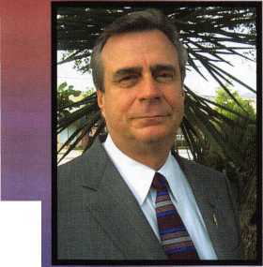

1. There are 3570 registrants in the program who have taken but not passed some portion of the CRL require­ment.
2. There are a total of 7676 participants in the PRP data­base at this time.
3. ALOA also administers the SAVTA STPRP. There are 11 CMST's, 195 CPS’s and 1 88 who have taken and not passed the CPS or CMST exam.
4. The pass rate for the 36 PRP categories continues to improve in the last year by 15 - 52% depending on the category. This is attributed to the after-class PRP exams, update of several categories and the revision of several ACE classes to include information that is being tested.

END 4: COMMUNICATION

The two continuous forms of communication available to the membership are Keynotes and the web site. Both of these vehicles routinely feature information about products, tech­niques and industry news. The web site was redesigned late in 2004. Convention provides the members with direct access to the manufacturer, both on the show floor and in classes. There were 178 exhibitors at the 2004 convention, many of these were manufacturers. Many of the seminars and half-day classes at convention were taught by manu­facturers.

END 5: PROFESSIONALISM

END 3: RECOGNITION

We are working with the Financial Security Products Association (FSPA, formerly NIBISA) to create a training program for locksmiths working in banks. A certification program and training facility are envisioned. We have also worked with NBFAA, ASIS and DHI on a variety of proj­ects, mostly legislation and education. ALOA is recognized by these groups as a viable professional organization. ALOA has had reciprocal arrangements with DHI regard­ing convention attendance at member rates. ALOA also has an agreement with DHI for providing training materials to members at a discount. ALOA exchanged VIP passes and convention promotional material with the National Cargo Security Council that had their convention at BWI on July 18 - 20, 2004. ALOA is promoting the 2005 ALOA con­vention to the following industry groups: International Facility Managers Association (IFMA), Financial Security Products Association, Building Owners & Managers Association (BOMA) and Association for Facilities Engineering (AFE). We continue to work closely with SHDA on legislation. I attend SHDA Board meetings and the Legislative Manager attends the SHDA convention. The US Department of Labor through the Bureau of Apprenticeship and Training has certified the updated ALOA National Apprenticeship Standards for Locksmiths. We have written the proficiency test for Locksmith Licensing in North Carolina. We will grade the tests and maintain the data­base for the state. ALOA has been approved by the Texas Department of Public Safety as a Locksmith/Security train­ing facility.

The Code of Ethics is distributed to all new members. In  
signing the application for membership, members agree to  
abide by the code. The code is on our web site in the area  
that can be accessed by the general public. We have noti-  
fied members in states where there are licensing laws to  
furnish the license number as a condition of continued  
membership.

ALOA has participated with several industry groups on

many issues. ALOA is represented on the UL Stc

Technical Panel for Physical Security Devices, (STP <

which this last year updated the standards for UL291

Automated Teller Systems, UL 437 - Key Locks, UL608 -  
Burglary Resistant Vault Doors and Modular Panels, UL786  
- Key Locked Safes, UL771 - Night Depositories, UL887 -  
Delayed Action Time Locks, UL1034 - Burglary Resistant  
Electric Locking Mechanisms in addition that panel worked  
on and received ANSI approval for UL 291, UL771 as well  
as UL1034. Currently they are working on a proposed  
High Security Electronic Locks Standard - UL2058. ALOA  
participated in the Security Industry Association's (SIA)  
World of Electronic Access Control course development.  
This work has been completed and because of our partici-  
pation, our members will soon be able to take the courses  
online at a discount.



FINANCIAL REPORT

The financial records of ALOA for 2004 were audited by the firm of Sutton Frost Cary. The Board of Directors reviewed and approved this report earlier this year. Parts of the report, the "Statement of Activities (Profit and Loss) and the "Statement of Financial Position" (Balance Sheet) are included with this report to the membership. The auditing firm found that ALOA's financial records fairly and accurately portray ALOA's financial position.

ALOA is a "not-for-profit" corporation. However, ALOA must consistently have more revenue than expense to remain capable of providing member services. This is the first time in many years that ALOA has made a "profit" for three consecutive years.

So far 2005 looks good financially. In addition to the expected revenue above expense for operations, ALOA will show a profit from the sale of its head­quarters building. The old building was purchased in 1972 and an adjoining lot was purchased later. Earlier this year the property was sold for $1,200,000. A new building was purchased for $650,000. After "make ready" of the new building is complete; moving, legal and realtor fees are paid, ALOA should have a profit on the sale of at least $250,000. The details will be in next year's report.

The new ALOA building is considerably larger and newer than the old building. There is, in fact, enough space for classes to be conducted. ALOA will start holding regular classes in the new training facility in August of this year.

ALOA is financially capable of providing the services specified by the Board of Directors and expected by the membership.

ASSETS

STATEMENT OF ACTIVITIES

|  |  |  |  |  |  |
| --- | --- | --- | --- | --- | --- |
|  | 2004 | 2003 |  | 2004 | 2003 |
| Current assets: |  |  | Revenues |  |  |
| Cash | $537,850 | $541,610 | Membership dues and services | $941,087 | $984,936 |
| Certificate of deposit | 66,183 | 65,302 | Convention | 768,535 | 890,465 |
| Accounts receivable | 243,418 | 217,599 | Management fee | 126,000 | 138,000 |
| Inventory | 62,796 | 41,909 | Legislative Income | 146,930 | 38,020 |
| Prepaid expenses | 140,935 | 108,801 | Advertising | 88,188 | 77,820 |
| Dues from affiliates | 62,721 | 22,811 | Promotional programs | 49,376 | 37,201 |
| Current portion of notes |  |  | Interest | 18,281 | 21,069 |
| receivable from affiliates | 17.891 | 21.001 | Educational programs | 91,224 | 89,943 |
| Total current assets | 1,141,794 | 1/019,033 | Miscellaneous | 12,933 | 3,969 |
| Property and equipment: |  |  | Total revenues | 2,242,554 | 2,281,423 |
| Land | 79,836 | 79,836 | Expenses |  |  |
| Building and improvements | 307,352 | 302,516 | Administrative | 1,230,939 | 1,248,275 |
| Furniture and equipment | 526.893 | 511.320 | Convention | 345,098 | 389,224 |
|  | 914,081 | 893,672 | Keynotes magazine | 171,363 | 174,814 |
| Less accumulated depreciation | (724.443) | 1700.565) | Building operations | 76,906 | 64,301 |
| Property and equipment, net | 189.638 | 193.107 | Member services | 60,876 | 85,866 |
| Note receivable from affiliate, |  |  | Depreciation | 23,878 | 29,630 |
| less current portion | 120.504 | 138.395 | Promotional programs | 23,951 | 29,564 |
|  |  |  | Educational programs | 120,255 | 140,673 |
|  | $1,451,936 | $1,350,535 | Committee | 5,704 | 11.255 |
|  |  |  | Total expense | 2,058.970 | 2,173.602 |
| LIABILITIES AND NET ASSETS | | | Increase |  |  |
|  |  |  | in net assets | 183/584 | 107,821 |
|  | 2004 | 2003 |  |  |  |
| Current liabilities: |  |  | Net assets at beginning of year | 137.351 | 29.530 |
| Accounts payable | $60,737 | $96,936 | Net assets |  |  |
| Accrued expenses | 43,139 | 41,516 | at end of year | $320,935 | $137,351 |
| Current maturities of long-term debt | | 7,060 |  |  |  |
| Prepaid dues | 587,300 | 663,622 |  |  |  |
| Prepaid exhibit fees | 439.825 | 404.050 |  |  |  |
| Total |  |  |  |  | x |
| liabilities | 1,131,001 | 1,213,184 |  | ( ) |  |
| Net assets- unrestricted | 320,935 | 137,351 | ik |  |  |
|  | $1,451,936 | $1,350,535 |  | A _ |  |

**68**

Keynotes • July/August 2005

Classes are hands-on

Class sizes are limited, so register early

by

IE3 LAJGARD

Visit **LA GARD’S booth #1005,** at ALOAand  
register to participate in one of our **free seminars.**You can even earn a certificate for each seminar

attended. Seminars will take place every hour

and will cover a different product.

Take one or take all five.

Each of our classes is being offered

Certificates and a thank you gift will be given out to every student

Products covered include LGBASIC", LGCOMBO, LPAUDIT, SMARTLINC and the new Group Mechanical



♦ %

%



**One Company... Endless Solutions**

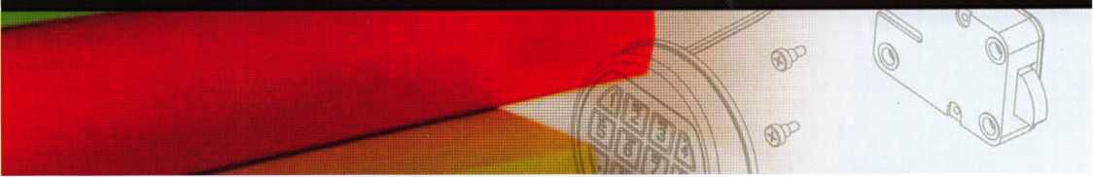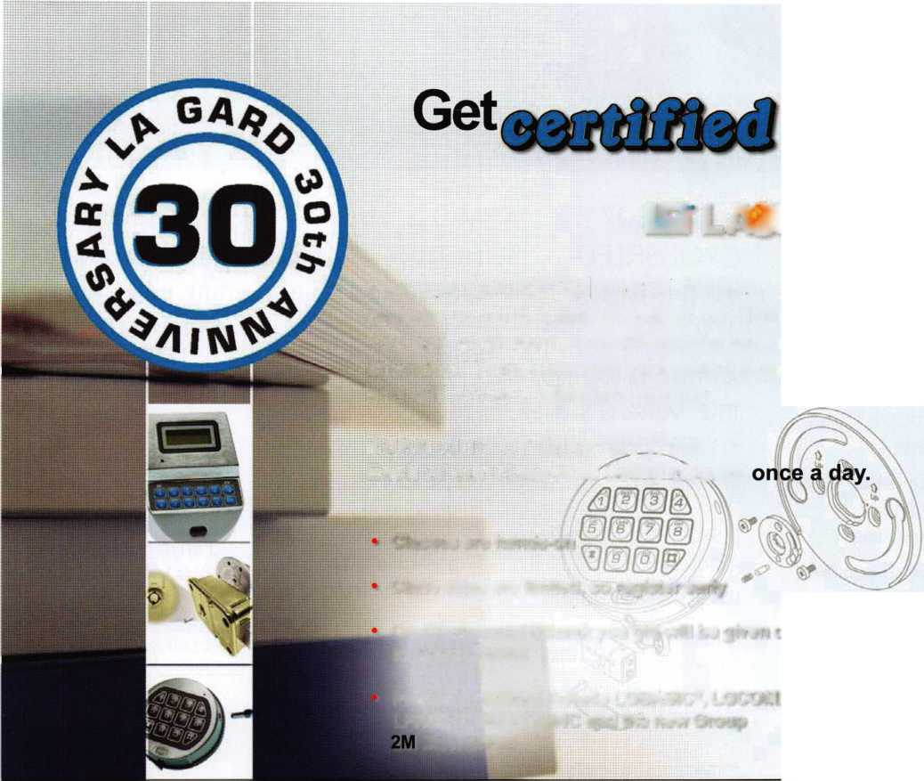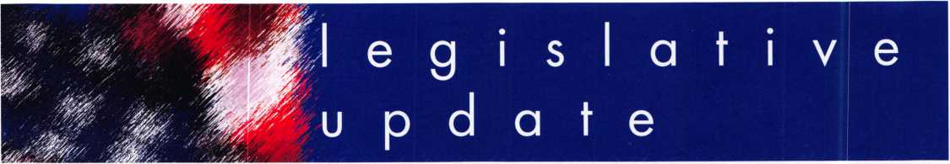

IN H 1361

AUTHOR: Brown C (D)

TITLE: Locksmith Registration

INTRODUCED:

01/13/2005

DISPOSITION: Failed - Adjourned

LOCATION: House Public Safety and Homeland Security

SUMMARY: Requires locksmiths to be regis­tered; requires the state police department to administer the registra­tion program and con­duct a national criminal history background check for each registra­tion applicant.

STATUS:

* 01/13/2005 INTRODUCED.
* 01/13/2005 To HOUSE Committee on PUBLIC SAFETY AND HOMELAND SECURITY.

MD H 207 CROSSFILED WITH: MD S 105

AUTHOR: Hubbard (D)

TITLE: Maryland Security Systems Training Board

INTRODUCED:

01/24/2005

DISPOSITION: Failed - Adjourned

LOCATION: HOUSE

SUMMARY: Establishes the Maryland Security Systems Training Board; requires the Secretary of State Police to adopt regulations to implement training requirements for security systems techni­cians developed by the Maryland Security Systems Training Board; provides for the composi­tion of the Board and the terms, removal, and compensation of the members of the Board; authorizes the Board to set specified fees; requires the Board to set training requirement.

STATUS:

* 01/24/2005 INTRODUCED.
* 01/24/2005 To HOUSE Committee on ECONOMIC MAHERS.
* 02/21/2005 From HOUSE Committee on ECONOMIC MAHERS: Reported unfavor­ably.

MO S 1 86 MSS 2356

SPONSOR: Loudon (R) AUTHOR: Mettetal |D)

TITLE: Electrical Industry Licensing Board

INTRODUCED:

01/18/2005

DISPOSITION: Failed -

TITLE: Burglar Alarms

INTRODUCED:

01/13/2005

DISPOSITION: Failed LOCATION: Died

Adjourned

LOCATION: Senate Financial and Governmental Organization, Veterans' Affairs and Elections Committee

SUMMARY: Establishes the Missouri Electrical Industry Licensing Board and describes their pow­ers and duties.

STATUS:

* 01/18/2005 INTRODUCED.
* 01/24/2005 To SENATE Committee on FINANCIAL, GOVERNMENTAL ORGANIZA­TIONS, AND ELECTIONS.

SUMMARY: Burglar alarms; license and regu­late installation.

STATUS:

* 01/13/2005 INTRODUCED.
* 01/13/2005 To SENATE Committee on BUSINESS AND FINANCIAL INSTITUTIONS.
* 02/01/2005 Died in commit­tee.



NJ A 3943

SPONSOR: Johnson (D)

TITLE: Electronic Security Systems

PREFILED: 03/14/2005

INTRODUCED:

05/02/2005

DISPOSITION: Pending

LOCATION: Assembly Regulated Professions and Independent Authorities Committee

SUMMARY: Exempts cer­tain businesses from licensing requirements for those engaged in burglar alarm, fire alarm and electronic security system installations.

TN S 2024 SAME AS:

TN H 1731

AUTHOR: Cooper (D) TITLE: Locksmith Licenses

INTRODUCED:

02/16/2005

LAST AMEND: 04/28/2005

DISPOSITION: Pending - Carryover

LOCATION: HOUSE

SUMMARY: Requires locksmiths to be licensed; requires licens­es to be obtained from the commissioner of com­merce and insurance.

STATUS: STATUS:

* 03/14/2005 FILED.
* 05/02/2005 INTRODUCED.
* 05/02/2005 To ASSEMBLY Committee on REGULATED PROFESSIONS AND INDEPEN­DENT AUTHORITIES.
* 02/16/2005 INTRODUCED.
* 02/23/2005 To SENATE  
  Committee on GOVERNMENT  
  OPERATIONS.
* 03/30/2005 From SENATE  
  Committee on GOVERNMENT  
  OPERATIONS: Recommend  
  passage.
* 04/28/2005 In SENATE.  
  Amendment No. 1 (SA0172)  
  adopted on SENATE floor.
* 04/28/2005 In SENATE.  
  Amendment No. 2 (SA0173)  
  adopted on SENATE floor.
* 04/28/2005 In SENATE.  
  Amendment No. 3 (SA0304)  
  adopted on SENATE floor.
* 04/28/2005 In SENATE.  
  Amendment No. 4 (SA0407)  
  adopted on SENATE floor.
* 04/28/2005 In SENATE.  
  Amendment No. 5 (SA0408)  
  adopted on SENATE floor.
* 04/28/2005 In SENATE. Read  
  third time. Passed SENATE.  
  *****y0 HOUSE.

TX H 2243

AUTHOR: Jackson (R)

TITLE: Regulation of Locksmiths and Locksmith Companies

INTRODUCED:

03/08/2005

LAST AMEND:

05/16/2005

DISPOSITION: To Governor

LOCATION: To Governor

SUMMARY: Relates to the regulation of lock­smiths and locksmith companies under the Private Security Act.

STATUS:

* 03/08/2005 INTRODUCED.
* 03/14/2005 To HOUSE Committee on LICENSING AND ADMINISTRATIVE PROCE­DURES.
* 04/06/2005 From HOUSE Committee on LICENSING AND ADMINISTRATIVE PROCE­DURES: Reported favorably with substitute.
* 04/14/2005 Committee report printed and distributed.
* 04/29/2005 Amended on HOUSE floor.
* 04/29/2005 Passed HOUSE. *****To SENATE.
* 05/03/2005 To SENATE Committee on BUSINESS AND COMMERCE.
* 05/16/2005 From SENATE Committee on BUSINESS AND COMMERCE: Reported favor­ably with substitute.
* 05/16/2005 Committee report printed and distributed.
* 05/24/2005 Passed SENATE. *****To HOUSE for concur­rence.
* 05/26/2005 HOUSE con­curred in SENATE amendments.
* 06/02/2005 *****To GOV­ERNOR.
* 06/18/2005 Signed by GOV­ERNOR

TX S 1365

AUTHOR: Armbrister (D) TITLE: Alarm Systems

INTRODUCED:

03/10/2005

DISPOSITION: Failed - Adjourned

LOCATION: Senate Intergovernmental Relations Committee

SUMMARY: Relates to the regulation of alarm systems and alarm sys­tems companies.

STATUS:

03/10/2005 INTRODUCED. 03/21/2005 To SENATE Committee on INTERGOVERN­MENTAL RELATIONS.

PA H 1653 PN: 2080

AUTHOR: Raymond (R) TITLE: Vehicles Code PREFILED: 06/06/2005

INTRODUCED:

06/07/2005

DISPOSITION: Pending

LOCATION: House

Transportation

Committee

SUMMARY: Amends the Vehicles Code. Provides for duplicate vehicle keys. Prescribes a penalty.

STATUS:

* 06/06/2005 FILED.
* 06/07/2005 INTRODUCED.
* 06/07/2005 To HOUSE Committee on TRANSPORTA­TION.

Keynotes • July/August 2005



Classifieds

EMPLOYMENT

RELOCATE TO ALASKA "THE LAST FRONTIER"

Action Security, Inc. is a 42 year old security company that is interested in hiring you. Its services include electronic security; bank/credit union security; wholesale prod­ucts; hollow metal fabrication; contract hardware; retail security centers; and pro­fessional locksmith services. We have three retail locations and offer statewide service. We currently are in need of locksmiths, AHC's, CDC's, EHC's, electronics and bank technicians. Opportunity and profes­sional growth is encouraged. Ideal candi­date must be neat in appearance, people orientated, self motivated and hard work­ing. Applicants must possess a good driv­ing record and pass drug testing. We will train the right candidate. Action offers full benefits package; competitive wages, med­ical insurance, paid vacation & sick days, continuous education, and profit sharing. Please send resume or email [info@actionsecurity.com](mailto:info@actionsecurity.com) if interested.

EXPERIENCED LOCKSMITH NEEDED

for outside service work - Commercial, Residential and Auto. Top pay, plus paid vacation, insurance, sick leave, holidays and retirement plan. 2 locations, 5 service trucks. Send resume to Bill - Bills's Lock and Safe, Inc. - PO Box 1041 - No. Little Rock, AR. 72115 - 1-800-374-4604 - Fax: 1- 501-376-0046

LOCKSMITH WANTED

Immediate opening at one of Columbus Ohio's largest locksmith companies. If you are a locksmith with three years of com­mercial experience and want to work 8:30 ti 5:00, come join our team! We are a full service security center. Excellent benefits

include 401 K, health insurance, paid vaca­tion, sick leave, and continuing education. Contact Bill or Tim at Golden Bear Lock and Safe, Inc. 614-733-5625, fax 614- 733-0004, or email [goldenbearlock@cs.com](mailto:goldenbearlock@cs.com).

LOOKING FOR POSITION

I am a junior locksmith who is currently working for the Federal Government as a Computer Specialist. I am planning to retire from the Federal Government and would like to work for a lock company or a lock shop that specializes in the installation of computerized electronic locks, such as VIDEX. I can be immediately productive for my new employer by doing the computer programming and doing some standard customer installation. My long-term goal is to become a journeyman locksmith. I live in Northern California. My first preference would be the San Francisco.San Jose peninsula. My second preference would be the San Joaquin Valley or Sacramento. I can, however, relocate anywhere in the world. Phone James Feinstein at 650-793- 5363 or 800-0165.

POSITION WANTED

Japanese locksmith seeks position in U.S., preferably in Los Angeles. Eight years experience in Codes and Code Equipment, Various Cylinders Servicing (For example, GOAL V-l 8 Cylinder), Key Blank Identification, Key Duplication, Key Impressioning (KABA Cylinder),

Professional Lock Opening Techniques (Disk Cylinder, Pin Cylinder, Rotary Disk Cylinder, Lever Tumbler, Tubular Key Cylinder, KABA, Me deco, and others), Lockset Functions, Lockset Servicing,

Lockset Installation, Master Keying,

Cabinet, Furniture and Mailbox Locks, Automobile (Benz, BMW, Porsche 928, Citroen, and and many Japanese models), Door Closers, Basic Electricity, Keyless Mechanical Locks (Nagasawa Keylex series),

Safe Combination Locks (I can do manipula­tion and often use a sidescope), Safe Opening and Servicing, Detention Locking Systems, Security Camera and Security System Contact: 164-00122-19-7-302 Hon­cho, Nakano-ku, Tokyo, Japan - Tamotsu

Yoshioka E-mail [nbj_yoshioka@ybb.ne.jp](mailto:nbj_yoshioka@ybb.ne.jp)

LOCKSMITH W/INTEGRITY NEEDED

Experienced Locksmith needed immediately. 20+ year old company with 100's of commer­cial accounts seeks qualified individuals willing to re-locate to Tulsa, OK. Experience in all aspects of field desired. Salary+benefits. Send Resume to Tulsa Lock and Key, Inc. 10318 E 21 st - Tulsa, OK - 74129 - or email to [tulsa- lock@cox.net](mailto:tulsa-lock@cox.net).

LOCKSMITH WANTED

Elgin Key & Lock Co. in Elgin Illinois is seeking an experienced locksmith with at least one year of experience required in automotive locks, access control, commer­cial & residential hardware, safes and door closer applications. Benefits include health insurance & HSA, vacation pay & Simple-IRA plan. Please contact Clark Houghtby at 847-742-7006 or fax resume to 847-742-1315

LOCKSMITH NEEDED

We are a 40 year old rapidly growing company in need of experienced lock­smiths. We provide all the tools, a brand new Van, key machines, uniforms, the works. Salary is dependant upon experi­ence and skill, very competative wage and benefits package. Paid Vacation, 401k, Medical, cross training in our Electronic security division and much more. We know how to treat good employees well. Please send resume or inquiry to [paulbrandon@lockguys.com](mailto:paulbrandon@lockguys.com) or call

253-839-3443

RELOCATE TO COLORFUL COLORADO

Buffalo Lock & Key is looking for an experienced lock­smith to service commercial, residential, and automotive accounts. The ideal candidate is customer focused and a team player. We are Boulder's oldest and most reliable locksmith. Come join our team. We offer benefits and continuing educational opportunities. Please contact Cindy at 303-494-0707 and fax resume to 303-494- 0706.

WANTED TO BUY/SELL

FOR SALE

A-l Auto key punch set with case (MS 10) $400.00 Keedex Vats interrogator mini $40.00 Kent-Moore Vats key interpreter $75.00 Try out keys Aero-lock TO-1, TO- 2, TO-3, TO-4 $50.00 each Try out keys Baxter #35,

36, and 74 $50.00 each A1 GM 10 cut service kit $25.00 HPC general code book 1A $40.00 Reed Code Book set, vols. 1-14 with index $400.00 Reed Code Book #5: Padlocks $50.00 Baxter code books: 1, 5,

11, 19, 20, 22, 23, 24, 27, 28, 29, 30, 31, 34, 35, 36, 37, 38 Updated through 2003 $400.00 for the set ASP Auto Cap Assortment #A0-002 $80.00 (plus extra caps) Don-jo 8X34 Kick plates 6 US32D and 4 US3 $120.00 for lot High tech car opening set with manuals through 2002 $75.00 Inventory of dead bolts, lock sets, etc. Listing sent upon request. All shipments F.O.B. Narvon, PA All other inquiries: Byron Rohrbach 2543 School House Lane Narvon, PA 17555-9004 Phone (717) 445-1240 email: [BARLOCKS@peoplepc.com](mailto:BARLOCKS@peoplepc.com)

BUSINESS FOR SALE

Lock and Safe company in North Central TX. Fully stocked van, computer, HPC code max machine along with several others. Business in same area since 1976. Will help through owner transition And introduce to commercial accounts, call 903 340 5958

FOR SALE

Mounted Samples for Sale Locknetics CM5190MGKx626 mounted on oak asking $100.00. ILCO's Learn Lok - Mortise Lock Complete with Programming Cards Asking $100.00. Both samples together $175.00. Contact: Kishjohn@softhome.net- Telephone: 412400-5900

SAFE DEPOSIT BOX LOCKS,

PARTS AND MORE

Wholesale prices. Reconditioned and new locks. All manufacturers; Diebold, Herring Hall & Marvin, llco, Lefebure, Mosler, S & G, Security Corp & Precision. Also available new replacement locks. We have a large stock of parts - doors, bond boxes, hinges, key blanks, full sections and more. Call WBI (954) 484-2404

LOCKSHOP FOR SALE

Successful shop in gorgeous Port Angeles, Washington for sale. For more details about this great opportunity and for contact information, go to [http://home.com- cast.net/~bystra/Lockshoplnfo.html](http://home.com-cast.net/~bystra/Lockshoplnfo.html)

WHOLESALE SAFE DEPOSIT LOCKS

Diebold, Herring Hall Marvin, llco, LeFebure, Mosler, Precision, S&G, Security Corp, Yale. Now available Safe Deposit Boxes Sections, Doors, Hinges and Bond Tins. Vault Doors, Safes, Night Depositories, Vault Lockers and One Inch Plate Steel are also stocked items. Call WBI (954)484-2404 or [Sales@WBI.US](mailto:Sales@WBI.US).

BUSINESS FOR SALE

Mom and Pop Locksmith, Glass and Screen Business for sale in Golden Valley, Arizona. Health forces retirement. Golden Valley is in fast growing Mohave County and located between Kingman, Arizona and Laughlin, Nevada. Our Dodge Ram Van and garage-shop are both well equipped. $65,000 plus in equipment and inventory is included in the asking price of $48,900. Home and property can be sold as a package deal with business. Home is 3 bedroom, 2 bath. Home and garage on 1.17 acres. Lot has enclosure, 2/3 fenced.

All reasonable offers will be considered. Call 928-565- 2294 or email at [lmburks@ctaz.com](mailto:lmburks@ctaz.com).

FOR SALE

Key Machines 1200 Blitz, HPC 3333, PCH 14, 11 Sets Tryout Keys, 16 Determinators Sets, Pics, Entry Sets, Much More/Inventory 602 291 3500 [chevieman@aol.com](mailto:chevieman@aol.com) - package only.

Classified Advertising Policy

Classified advertising space is provided free of charge to ALOA members and for a fee of $2.00 per word, $40.00 minimum for non members. Classified ads may be used to advertise used merchandise and overstocked items for sale, "wanted to buy" items, business opportunities, employment opportunities/positions wanted and the like. Members or non members wishing to advertise services or new merchandise for sale may purchase a "Commercial Classified Ad" for a fee of $4.00 per word with a minimum of $100.00. Each ad will run for two issues. For blind boxes there is a $10.00 charge for members and non members. All ads must be submitted in writing to the Advertising Sales Department via fax at 817-645-7599 or through an email to [adsales@aloa.org](mailto:adsales@aloa.org) by the fifteenth of the month two months prior to issue date. ALOA reserves the right to refuse any classified adver­tisement that it deems inappropriate according to the stated purpose of the classified advertising section.

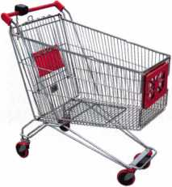

keynotes

UYER

t

**Marketplace**

Punch SARGENT Blanks to Factory Specifications.

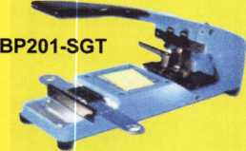

Try it hands on **@** ALOA  
in Rosemont, IL

Available Exclusively from:

**Locksmithing, UNL. LLC  
302**-**575-0993**

**[www.locksmithingunl.com](http://www.locksmithingunl.com)**

Broken/Cracked  
door jamb??

Don't replace.  
Don't rebuild!!

"Kwik Jam"

[www.PEBent.com](http://www.PEBent.com)

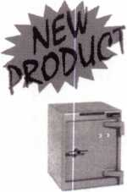

FROM A & B SAFE CORP.

A & B Chest  
Model WS-0

Equipped with dual key,  
combination or  
electronic locking  
slot optional

A & B SAFE CORPORATION

171 S. Delsea Dr.  
Glassboro, NJ 08028-6237  
856-863-1186 Fax 856-863-1208



Keynotes • July/Aug 2005

‘§SmWmk%

of Our Titles...

Learn About Basic Electricity 29.95

Spacing and Depths, vol 1 19.95

Spacing and Depths, vol 2 19.95

Filing for Dollars 29.95

Antique Padlocks 29.95

VATS Made Simple (Revised) 29.95

Guide to Transponders 79.00

2000 Transponder Update 45.00

Bread & Butter 85.00

Locks and Lockmakers of America 19.95

Learn About Electronic Locking Devices 29.95

The Best of Locksmithing, vol 1 19.95

Logical Lock Diagnostics 29.99

How to Pick Lever Locks 19.95

Fundamentals of Master Keying 55.00

Guide to Electronic Locksmithing 39.95

Security Solutions Locksmith Marketing Program 89.95

The Ultimate Techtips Collection 39.95

PRP Resource Guide 25.00

Locksmithing from Apprentice

to Master 27.00

Wafer Lock Reading 19.95

HpFjT Door Lock Encyclopedia 39.95

Jm Lock Repair Manual 14.95

^ JMF Interchangeable Core Cylinders 34.95

iSF Picking & Impressioning 45.00

The Lure of the Lock 29.95

High Security Safes, vol 1 175.00

High Security Safes, vol 2 175.00

Safeman's Guide, vol 13 9.95

Safe Deposit Depth and Space Manual 99.00

Safe Technician's Reference Manual 155.00

Gun Safes 1 10.00

Modern Safe Opening 59.95

Dave McOmie on Vault Doors, vol 1, Bank Vaults 1 10.00

Dave McOmie on Vault Doors, vol 2, Fire and Plate Vaults 1 10.00

Modern Safe Locks 95.00

Drilling Safes 95.00

Safe Deposit Box Service 39.95

Foreign Car Impressioning Book 29.95

Impressioning Ford and GM Side Bar Locks 29.95

Automotive Lock Servicing Update #1: GM 10-Cut Locks 29.95

Automotive Lock Servicing Update #2: GM 10-Cut Locks 29.95

Automotive Lock Servicing Update #3: GM 8-Cut Locks 29.95

GM Locks: Perfect for the Beginning Locksmith! 29.95

Ford Locks: Pin Tumbler and Ten-Cut Systems 29.95

Chrysler Pin Tumbler Locks 29.95

Chrysler Double-Bitted Locks 29.95

Toyota Split-Tumbler Locks 29.95

Basic Door Panel Servicing 29.95

Advanced Door Panel Servicing 29.95

Motorcycles on CD 99.00

The Guide to Motorcycles 99.00

Japanese High Security Auto Servicing 29.95

Revised GM Steering Column Course 1 15.00

Foreign & Domestic Auto Service 69.95

Auto Lock Service 14.95

The Sieveking Auto Key Guide & Illustrated Cross Reference 27.00

Servicing Interchangeable Cores—Sargent 25.00

Servicing interchangeable Cores—Arrow, Best,

Eagle, Falcon, and Lockwood 25.00

The Ultimate CCTV Program on CD Rom 595.00

**Visit the new-and-improved ALOA Store to view more available titles.  
Place your order online or by phone today!  
[www.aloa.org](http://www.aloa.org) • (214) 827*1701 • Please allow 3-4 weeks for delivery.**



**KEYNOTES AD INDEX**

|  |  |  |  |  |  |  |
| --- | --- | --- | --- | --- | --- | --- |
| Allstate Inside Front Cover. 1 | | Hinge Doctor | 27 | American Lock |  | 53 |
| Gradient Lens | 1 | Masterlock | 29 | Inkas |  | 55 |
| ALOA Training | 3 | CCL | 31 | UCA Inc. |  | 56 |
| Sodium Halogen | 7 | UltraLift | 39 | Maxcess |  | 57 |
| ELF | 13 | Kaba llco | 37 | Howard Sales |  | 59 |
| A&B | 74 | Adesco | 38 | LaGuard |  | 69 |
| Lectro Truck | 15 | Ultralift | 39 | LocksmithUNL |  | 74 |
| Professional |  | Clearstar | 42 | Kwik Jam |  | 74 |
| Business Products | 16 | Masterlock | 43 | Compx | Inside Back Cover | |
| LockC raft | 17 | D&D Technologies | 45 | Hickok | Back Caver | |
| Lockmasters | 19 | Top Notch | 47 |  |  |  |
| Keedex | 24 |  |  |  |  |  |
|  |  | HPC | 51 |  |  |  |
| CIA | 25 |  |  |  |  |  |

**Automotive**

Fox Chase

is dedicated to serving you.

locked Relaying Emergency Openings Medco High Secuity Locks Key Control Systems and much more.

**View Our Services**

Fox Chase

**HOME | ABOUT US | CONTACT US { SERVICES**

**Lock&Key**

Fully operational

lock, safe and security company

We are a fully operational lock safe and security company that has earned a sterling reputation for quality work. Our tradition is one of excellence. Our clients include hundreds of America's finest corporations and retail businesses, federal agencies, and thousands of homeowners. We are comfortable working with all levels of complexity, from residential homes to the largest office building complex.

We are a stocking dealer of a multitude of security hardware including MEDECO High Security Locks for maximum protection against picking, prying, and unauthorized duplication of your keys. We sell, install, and repair various types of safes intended to protect their contents against fire, robbery and burgulary, as well as gun safes to keep fire arms protected from the wrong hands. If we don’t stock a particular item, we will get it.

Of course, we stand behind everything that we sell with our ironclad

satisfaction guarantee

Fox Chase Lock & Key 7936 Oxford Avenue Philadelphia, PA 19111 2225 (215) 745-5007 fax (215) 745-2002

HOME | ABOUT US | CONTACT US | SERVICES

^ Just Another Client?

No.

Another Satisfied Client.

SodiumHalogen just finished work on their latest site for Fox Chase Lock and Key. You can see it now at [www.foxlock.com](http://www.foxlock.com).

Then visit us at [www.sodiumhalogen.com](http://www.sodiumhalogen.com) to see what we can do for you.



interactive, design.

phone: 972-839-8913

email: [bryan@sodiumhalogen.com](mailto:bryan@sodiumhalogen.com)

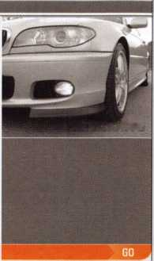

Shirley, 23 years Lock Assembly A

Alberto, 11 years Machine Operator

***SECURITY PRODUCTS***

Raymond, 4 years Accounting A

Mary, 8 years ^ Customer Service

We represent the 500 employees • of CompX Security Products.

Hardworking. Reliable. Dedicated.

And it shows in the products we make.

Is it any surprise that, year after year, you the locksmith community, choose to partner with us?

Made in America does matter to you, and it matters to us. Through our four US facilities, we will continue to provide you with the high quality products you have come to expect from CompX Security Products.

*Cbm*®C

|  |  |  |
| --- | --- | --- |
|  | M | I | j| f MiJLmj |
|  | 'i n | w ■ J ™ |

|  |  |  |  |  |  |
| --- | --- | --- | --- | --- | --- |
| m |  | ■  ■  ■ | ■p.*—■—-——  ■F |  |  |
|  | #|i |  | ' i IIP |  |

NATIONAL

FORT TIMBERLINE

CHICAGO

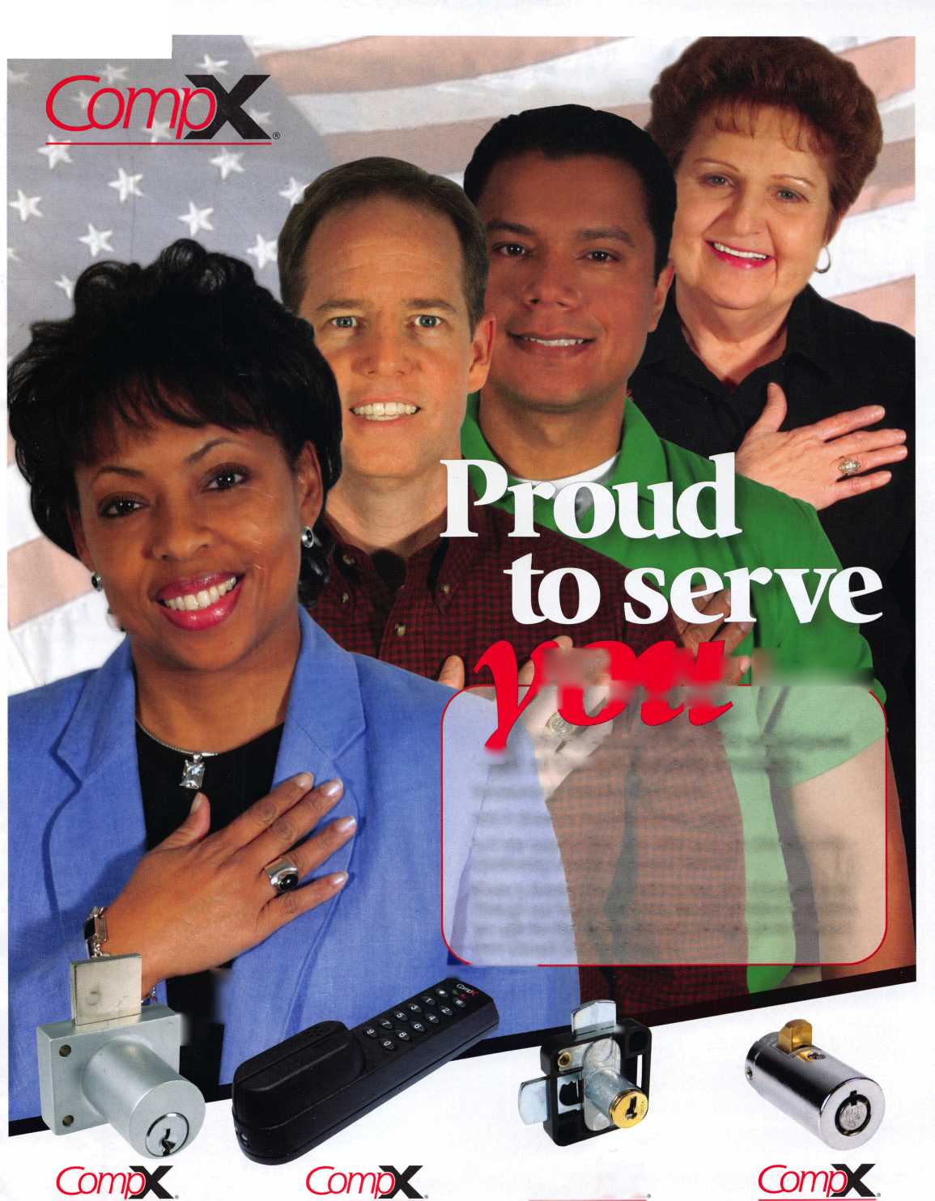

**CANCEL**

8008LXLC

81201L

**Mazda Transp**

**The most reliable unit available for transponder key programming and PATS system diagnostics on ALL Ford Lincoln/Mercury and Mazda* vehicles.**

air

lURUjQLSS

NGS XL CAN

Locksmith 8008LXLC

ith Kit 8008LXLC

mith VIM

NGS XL CAN Lock

* NGS XL Tester and Li
* NGS XL CAN VIM
* 1996-Current Model Year Ford Transponder

PATS Reprogramming Software

* FREE - 2 Additional Years of Software
* 81204 - CAN Vehicle Interface Cable
* 81205 - CAN Power Cable
* 800N - OBDII/EEC-V Cable
* HI 05-00100 - Central Security Module Cable
* NGS/Locksmith/PATS Instruction Manual
* Key Blank/System Quick Reference Card
* Transponder Marketing Support Pack
* Blo-molded Carrying Case
* 13 Month Warranty

|  |  |  |
| --- | --- | --- |
|  | mmmmammmmamm |  |
| NGS CAN VIM Kit | 81201L |
| 1 • NGS CAN Vehicle Interface Module (VIM) | |  |
| • 81204 - CAN Vehicle | Interface Cable |  |
| • 81205 - CAN Auxiliar | y Power Cable |  |
| • 2003-2005 CAN Soft | ;ware Card |  |
| * 2005 Non-CAN Softw * Operator's Manual | 'are Cards |  |
| • Key Blank Quick Refer | ‘ence Chart | ■II |

**CAN Vehicle Interface Module**

**Model Software Update now aviil§Blg**

***wm} TOLL FRLEumuppm*** **HICKOK**

800/342-5080 INCORPORATED

CAN VIM

81201L

m

*mm*

